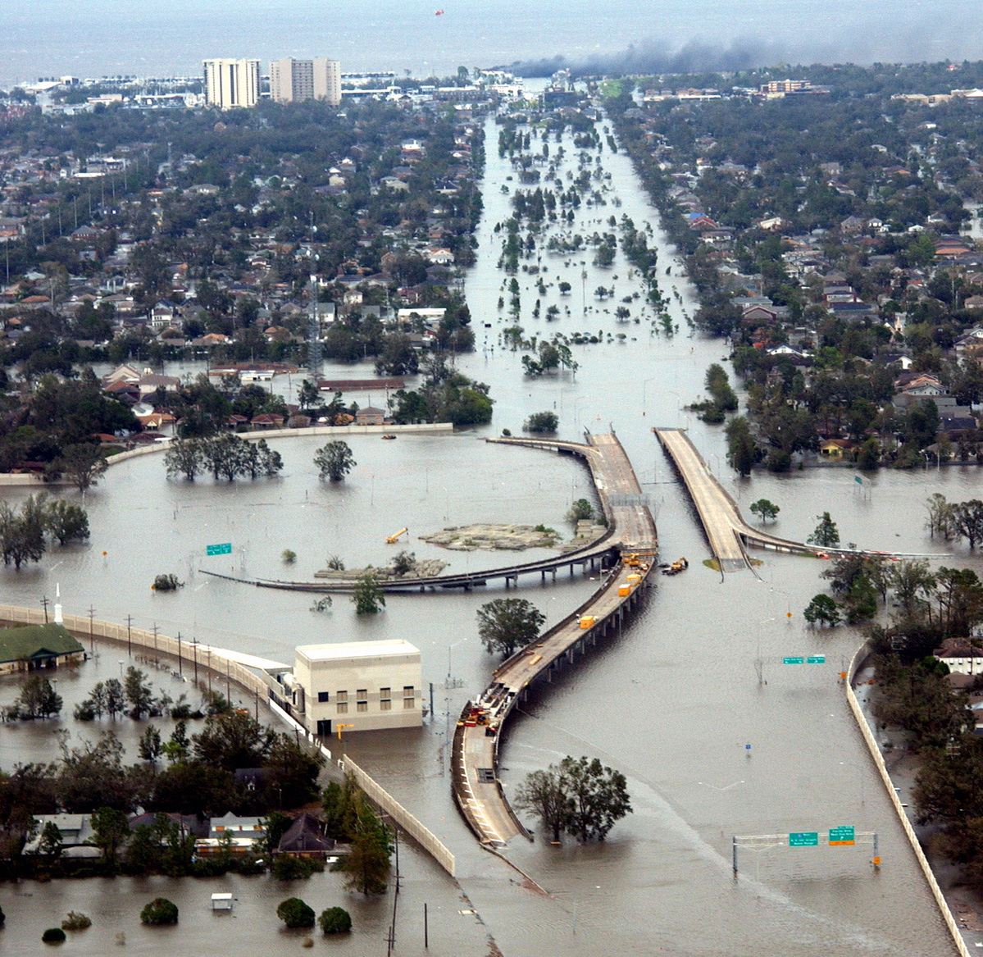UNIV 300I: Hurricane Katrina and its Aftermath
Spring 2006—Tuesday & Thursday, 9:30 – 10:45, MM 100

Dr. Patricia-Anne Johnson Dr. Christine M. Rodrigue
Office: 428 Psych Bldg. Office: LA4 106
Office hours: MW 10 a.m. to noon Office hours: T 2:30-4 p.m., W 3:30-5 p.m.
Phone: 562.985.2127 Phone: 562.985.4895
Email: pjohnso2@csulb.edu Email: rodrigue@csulb.edu

Dr. Tim Caron Dr. Dan O’Connor
Office: MHB 408 Office: AS 127
Office hours: T Th 11 a.m. to noon Office hours: Th 11 a.m. to noon; & by appt.
Phone: 562.985.4233 Phone: 562.985.4228
Email: tcaron@csulb.edu Email: oconnor@csulb.edu

Course Description:
The course will examine one of the most important events of our lives: Hurricane Katrina and its impact upon the Gulf Coast and the rest of the nation, with a particular emphasis upon the city of New Orleans. Drawing upon the fields of cultural studies, literature, political science, race and gender studies, and geography will provide students with a number of perspectives from which to examine this recent catastrophe. Members of this learning community will acquire a complex understanding of Hurricane Katrina not just as a severe meteorological event but as an event with very real implications for what is arguably the most unique city in America.

To better understand the events surrounding Hurricane Katrina, students will first learn something of the history and culture of New Orleans so that they realize what has possibly been lost in the recent floods. The next unit is an in-depth study of how both the physical and human geography of New Orleans combined to make Katrina such a devastating storm. In order to put a human face on devastation in New Orleans, students will next examine the aftermath of Katrina through the lens of critical race and gender studies. Finally, students will gain knowledge of both will study the political and policy decisions that contributed to the destruction of the city.

This class fulfills the interdisciplinary capstone course credit for GE category C2 or D2.

Prerequisites:
Completion of the General Education Foundation courses; junior standing.

Course Organization and Structure:
This is a team-taught interdisciplinary course. There will be occasional guest lecturers and/or media presentations during the semester, but the primary method of instruction will be a blend of lecture and discussion in order to facilitate both an in-depth and broad understanding of the issues raised in the class. Faculty members will also hold a couple of panel discussions throughout the course, allowing for immediate interaction between and among the various disciplines of the faculty. Each individual faculty member is responsible for approximately one fourth of the semester’s class meetings and will design and assess an assignment that measures students’ engagement with the course material.

To meet the University requirements for IC (interdisciplinary) capstone courses, the course will include substantial writing, as well as introducing students to at least two disciplines.

Course Objectives: After successfully completing this course, students should be able to…
*Describe the unique culture and history of New Orleans
*List examples of geographic features of the Gulf Coast and the Mississippi River wetlands
*Detail the nature of policy decisions made by civic, state, and national government agencies, both before and after Katrina
*Explain the challenges presented by the reconstruction effort
*Offer several case studies of the social justice issues confronting the citizens of New Orleans in the aftermath of Katrina
*Improve thinking, reading, comprehension, and analytical skills.
*Utilize critical thinking skills in order to develop compelling and logical arguments for class
*Improve library research skills, including use of electronic databases from several different disciplines
*Reflect on their own values when confronted with extreme human suffering
Grades:
Everyone’s concerned about grades—or you ought to be. This is a large lecture class in which we will try to involve as many students as possible in the discussion; therefore, you should have completely read the assignments listed below by the date they will be covered in class. Your participation is vital to the success of this class.

Grading Scale:
Grade | Points | Assessment
A | 90 – 100 | An outstanding and memorable performance.
B | 80 – 89 | Very good work, with only minor errors or problems.
C | 70 – 79 | Adequate performance of the assignment with some weaknesses, either in design or execution, in your central argument.
D | 60 – 69 | Less than adequate performance, meeting only minimal requirements.
F | 0 – 59 | Fails to meet minimum course requirements.
Your written work should be grammatically sound, clear, concise, and supportive of a central argument.

Policies:
Attendance and participation are crucial to your success in this class; therefore, you should be ready to make a substantive contribution to each and every class discussion; you must come to class, read the assignments, and complete your written assignments on time. It is better to show up late for class than to not show up at all. Four or more absences will result in a significantly lower grade for the class. If you miss a class, ask a classmate what you missed. In class assignments cannot be made up. Make sure your assignments are ready on the day that they are due. Late assignments will be penalized a full letter grade for every class period they are late. Be sure to consult the University Schedule of Classes regarding deadlines and procedures for dropping classes.

Assignments:
Students will complete four exams, each worth 22.5% of the semester’s grade. Each exam will come at the end of each of the four sections taught by the respective faculty members. Each exam, however, will be cumulative. In other words, students will be tested on the final exam on material presented throughout the entire course. The final 10% of the student’s grade will be determined through attendance and participation.

Course Schedule:

Week #1:
1/26: Introductions, Overview, & Welcome

Week #2:
1/31: Faculty panel #1: “How does the course all fit together?”: Personal Disciplinary Reflections

I. A Sense of What Was Lost: The Unique Culture, Character, and Climate of New Orleans

2/2: Welcome to the City of Dreams
Readings, “My City My Wilderness” & “Se Habla Dreams,” Andrei Codresceu

Week #3:
2/7: Lesbians, Pederasts, Commies, etc.: The Sediment that Settles in New Orleans
Readings: selections from A Confederacy of Dunces, John Kennedy Toole

2/9: The Lure of the City
Micro-essay due: Reflecting on the Power of Place
Readings: William Faulkner, selections from New Orleans Sketches

Week #4:
2/14: The Streetcar from Desire Is Now a Bus
Readings: A Streetcar Named Desire, Tennessee Williams

2/16: The New Orleans the Tourists Didn’t See
Readings: Poems by Thomas C. Dent & Brenda Marie Osbey

Week #5:
2/21: Exam #1

II Race, Gender and Class Implications of the Effects of Hurricane Katrina

2/23: Introduction to the Section on Race, Gender and Class
Readings: Mary Elizabeth Hobgood, “Dismantling Privilege: An Ethics of Accountability” p. 1-62, Richard Delgado and Jean Stefancic, “ Critical Race Theory: An Introduction” p. 1-35

Week #6:
2/28: Guest Lecture on Media Interpretations of Race in the Aftermath
Carla Yarbrough, Department of Journalism

3/2: Classroom Exercise: Deconstructing Whiteness
Assisted by professorial team teaching the course
Readings: Hobgood, p. 63-106, Delgado and Stefancic, p. 37-86

Week #7:
3/7: Guest Lecture on “The Psychological Effects of Hurricane Katrina on the African American Family” Dr. Piper-Mandy, Department of Black Studies
3/9: "A First Hand Account of the Aftermath: I was There...." "Photo-lecture" by Ms. Aida Alston.
Readings: Hobgood, p. 107-153, Delgado and Stefancic, p.87-137

Week #8:
3/14: Faculty Panel #2: Paradigm Shift (?): Moving from the Humanities to the Social and Natural Sciences
3/16: Exam #2

III. And then something happened…The Geography of New Orleans and Katrina
Week #9:
3/21: What is a natural hazard? What is a disaster? (Hurricanes)
National Geographic. 2005. Katrina: Why it became a man-made (sic) disaster, where it could happen next. Special edition. National Geographic, read all. Abbott, Patrick L. 2004. Excerpt from “Hurricanes and the coastline,” Ch. 11 of Natural Disasters, 4th ed., pp. 302-333. Boston and other places: McGraw Hill Higher Education, read pp. 302-321.

3/23: Flooding: riparian, lacustrine, coastal
Abbott, Patrick. L. 2004. “Floods,” Ch. 12 of Natural Disasters, 4th ed., pp. 334-364. Boston and other places: McGraw Hill Higher Education, read pp. 334-364.

Week #10:
3/28: Hazard perception and risk assessment science
Rodrigue, Christine M. 2003. Excerpt from “Representation of the September 11th terrorist attacks in the online edition of the Los Angeles Times.” Ch. 20 of Beyond September 11th: An Account of Post- Disaster Research, ed. Jacquelyn L. Monday, pp. 521- 588. University of Colorado Natural Hazards Research and Applications Information Center Special Publication 39, read “Review of media-analytic literature,” read pp. 521-524. Available at <http://www.colorado.edu/hazards/sp/sp39/sept11book_ch20_rodrigue.pdf>

Fischer, Henry W., III. 1999. Hurricane Georges: The experience of the media and emergency management on the Mississippi Gulf Coast. Quick Response Report 117 (University of Colorado Natural Hazards Research and Applications Center). Available at <http://www.colorado.edu/hazards/qr/qr117.html>

3/30: How agencies behave during a disaster
Mileti, Dennis S. 2001. Influences on the adoption and implementation of mitigation. Ch. 5 of Disasters by Design: A Reassessment of Natural Hazards in the United States. Washington, DC: Joseph Henry Press.

Week #11:
4/4: Risk and vulnerability
Cutter, Susan L. 2005. The geography of social vulnerability: Race, class, and catastrophe. Understanding Katrina: Perspectives from the Social Sciences. Social Science Research Council Web Forum. Available from <http://understandingkatrina.ssrc.org/>.

4/6: Exam #3

Week #12:
4/11: Spring Break
4/13: Spring Break

IV. The Policies and Politics of Katrina

Week #13:
4/18: Why This Matters
Reading: “Unnatural California,” Davis, Mike. (1998) Ecology of Fear, pp. 3-56, 93-148.

4/20: Disaster Management: Federalism as a Model
Reading: Steinberg, Ted. (2000) Acts of God, Selections.

Week #14
4/25: Revisiting the Timeline: The Response
Readings: Cooper, Matthew. (2005) “Dipping His Toe Into Disaster.” Time. Anderson, John Lee. (2005) “Leaving Desire.” New Yorker Magazine.

4/27: The Ideology and Politics of Disaster: Ideological Critiques and Defenses
Readings: Lowry, Rich. (2005) “What Caused the Flood.” National Review. Factor, Mallory. (2005) “Unleash a Liberty Zone.” National Review. Factor, Mallory. (2005) “Tax Cuts Are Katrina Relief.” National Review. Remnick, David. (2005) “Under Water.” New Yorker Magazine. Davis, Mike and Fontenat, Anthony. (2005) “25 Questions About the Murder of New Orleans.” The Nation Magazine.

Week #15
5/2: The Future of Disaster: The U.S. and Global Disaster
Reading: Steinberg, Ted. (2002) “Planet U.S.A.” Down to Earth, pp. 262-281.

5/4: Faculty Panel #3: Looking Ahead: What will New Orleans look like? What does this event mean for us here in southern California?

Week #16:
5/9: Review
5/11: Review

Final Exam: May 16



