Two Branches off Charmelee Potrero Road and Ocean View
Where did we go?
Our group was assigned Study Area 3 within Charmlee Park. Two branches off trails were examined. The first branch was off of the Ocean View Trail. This trail branched in a northern direction. The second branch was south of the Reservoir Trail, where a large firebreak was dug into the area during the 2003 fires. These firebreaks were put into place by firefighters to help their efforts in containing the fire. These breaks stayed after the fire was put out and visible via satellite until 2006.

Why?
The study groups sent out to Charmlee Park were to investigate where California Sage Scrub was growing in the area. The initial thought was the firebreaks aided in the recovery California Sage Scrub in areas of the park that are dominated by mustard. It has been suggested that the allopathic compounds were removed from the areas where the firebreaks were placed. With these compounds away from these areas, California Sage Scrub was able to take advantage of the opportunity to gain a foothold in the mustard dominated area. Our group was one of the teams that went out to Charmlee Park to gather data on whether this idea was supposed by what is currently growing in Charmlee Park.

What did we find?
In the field we found mostly dead black mustard (Brassica nigra), Dead litter, and a few California Sage Scrub species (CSS). The CSS species we found were California sagebrush (Artemisia californica), Black sage (Salvia mellifera), and Ashyleaf buckwheat (Eriogonum cinereum). We found that our northern transects contained little to no CSS species and mostly dead black mustard, while our southern transects contained a few CSS species scattered throughout. We found multiple species that we were unable to identify in the field, we took samples of these home with us and later identified them. We determined that they were not CSS species. The species we found were California fuchsia (Epilobium canum), Heartleaf Keckiella (Keckiella Cordifolia), and Bush lupine (Lupinus chamissonis).

Significance
These results are significant because they were not what we expected to find. From previous studies conducted on CSS I firebreaks, it is most commonly believed that CSS will thrive and inhabit these firebreaks while other species, such as mustard will more than likely not be so common. When we were headed out to our field site, we expected to find the areas almost completely dominated by CSS species. After completing our transects we were quite surprised to find that most of our transects were not dominated by CSS. Since our northern and southern transects were slightly different, we have two different results. For our northern transect we found more surprising results than in our southern transect. In the northern transect only one or two of our sixty-three readings were CSS species, the remaining was overwhelmingly dead mustard. In our southern transect, it was more of a mix between CSS species and dead litter. The most common CSS species found in the south transect was black sage. We concluded that the reason the northern transect contained almost all dead black mustard while the southern transect was a mix of CSS species was because the southern transect contained a much steeper slope. The northern transect was flat terrain with the exception of the far end which became very steep very quickly. CSS thrives in areas with steep terrain, which is most likely why our southern transect and our northern transect findings differ so greatly.

Methods
We took six transects--each 20 m long--between the two branches. The north branch off Ocean View Trail was identified with relative ease due to its location on top of a hill. What was a straightforward process for the first three transects immediately became much more complicated once we stepped down into the canyon where the second firebreak is located. We located the two end points of both branches using an aerial photograph and our handheld GPS units. After some time we found the northern end of the transect after hiking through heavy brush and unstable soil. From there it became easier to locate the other end however our team was unable to reach the very end due to a steep escarpment preceding the end point. For this reason, we did our best to line up the new endpoint. When transecting we made note of any unidentifiable species, photographed them, and took a sample for later.

Results
With our data collected, we used nearest down neighbor Chi-squared test on four out of seven species found. This is because only these four species has sufficient number to be evaluated. Chi-squared is suitable because it can work with frequency count data. We set the alpha standard to be 0.05 so that there is a right balance between the danger of making a type I error and making a type II error. The chi squared critical value was set to 3.841, degrees of freedom value of 1. If we take a look at the results on figure 1, Artemisia californica was found to have 40% of its NN (nearest neighbor) to be itself, and 60% to be other than itself. Artemisia has a chi squared calculated value of 0.95, Probability value of 0.33, and power of 0.164. Brassica nigra has 70% of its NN to be itself, and 30% to be all but Brassica. A chi squared calculated value for Brassica was found to be 2.116, probability is 0.146, and power is 0.307. Eriogonum cinereum was found to have 28.6% of its NN to be itself, and a 71.4% chance to be all species except Eriogonum. A calculated chi squared value of 3.247 was found, probability value of 0.072, and a power of 0.438. Salvia mellifera has 66.7% chance of having a NN to itself, and a 33.3% chance of having a NN of nay species except itself. Salvia has a chi squared calculated value of 0.09, probability value of 0.764, and a power of 0.06.
Discussion
We focused on our evaluation at Brassica nigra only because other species has only 5-7 total number of data collected where Brassica has 40. If we look at figure 1 again, we see that Brassica nigra has calculated value of 2.116 which is less than the critical value of 3.841. This means that we have an insignificant data. The probability value of 0.146 is more than our alpha of 0.05 which let us conclude that we fail to reject null hypothesis . Finally the low effect size of 0.133 tells us that more research with larger sample is needed. We also have a very low power of 0.307 which we can clarify that it is very small magnitude.
Comparism
For further evaluation, we created 2 pie charts; one for our northern transect and another for our southern transect. If you look at figure 2, we can compare the two transect and see what species mainly dominate each location. We can see that northern transect is mainly dominated by Brassica nigra and southern transect has 50% Brassica nigra and 50% California Sage Scrub (CSS) species such as Salvia mellifera, Eriogonum cinereum and Artemisia californica . This shows that on southern transact, CSS is slowly growing back on the fire breaks. However, northern transect is still mainly dominated by Brassica nigra.
If we look at figure 3, we did a comparison with past GEOG 442 students’ data. In the past data, Artemisia californica was the dominant specie but now Brassica nigra has taken over the land. This might be because Brassica nigra allelopathic effects where they inhibits the growth of other plant species around them.
Conclusion
From the data collected and chi-squared test performed in this experiment, it was found that we were unable to reject our null hypothesis which means that firebreaks tended to facilitate CSS restoration as opposed to other forms of disruption that prevent regrowth of CSS. However, if we look at our pie charts in figure 2, our northern transect shows that firebreaks did not facilitate CSS restoration while the southern transact shows that firebreaks did kind of facilitated CSS restoration. Since there is a 0.05% chance of getting a false positive result, we do encourage our peers to support our finding by collecting more data and repeating similar test to help eliminate errors.
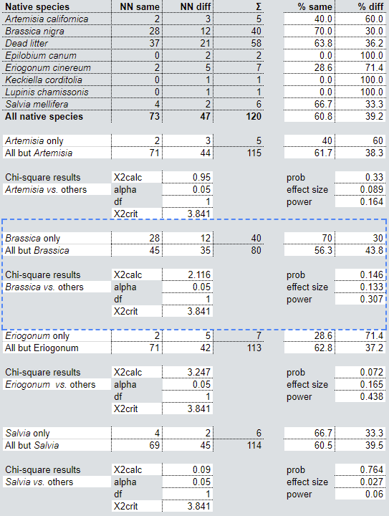
Figure 1
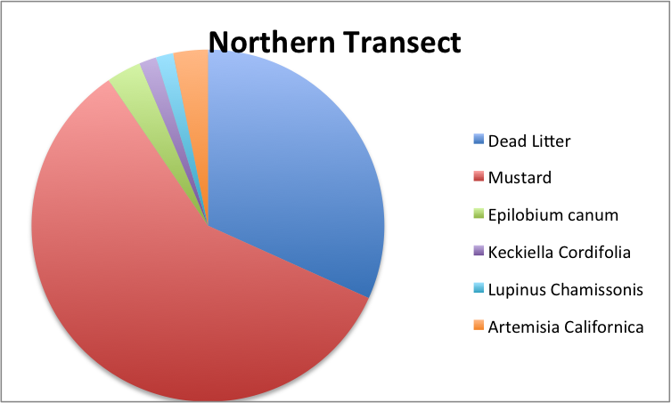
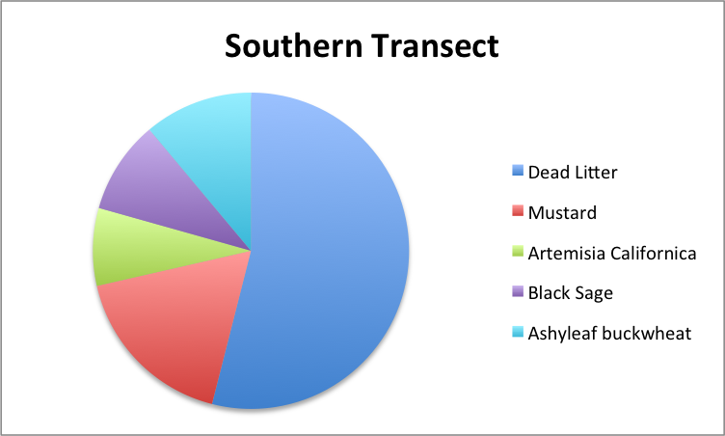
Figure 2
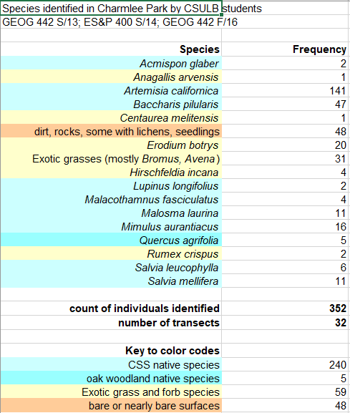
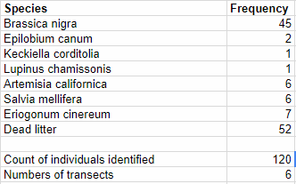
Figure 3

References
CSULB California Ecosystems Lab by Dr. Rodrigue

