Group B
Indy Chavez
Keith Cunningham
Alex Paz
Dominique Vitti
Charmlee Wilderness Park: Vanguard Species
Abstract:
Invasive grasses made home to many of Southern California’s coastal sage scrub (CSS) and chaparral areas, creating a competitive environment for the native shrubbery. Charmlee Wilderness Park in Malibu, California is an area of particular concern with large fields of invasive grasses covering much of the terrain. In order to document the extent of mechanical disturbance incurred on coastal sage scrub species, we set out to observe the rate of growth of CSS in specific areas of Charmlee Park that have been blanketed with invasive grasses. In this field study, we documented individual sprouting or maturing samples of CSS to measure how well individual species could survive in a patch of grass. We then compared these results to data that was collected in 2014 and 2016. By sampling a large majority of the CSS species within the grass patches, and comparing this data to the original samples, we gathered a general idea of how well each of these species fared in competitive invasive grass patches. Overall, several species of CSS showed a propensity to reproduce in invasive grass patches, while other’s success showed to be inconclusive due to their limited sample size.
Introduction:
Charmlee Wilderness Park is located in the westernmost area of the Santa Monica Mountains and is home to a wide variety of native plant displays, a nature center, and 8 miles of hiking trails. The Santa Monica Mountains are home to 12 different vegetation communities which includes coastal sage scrub. However, with the encroachment of Europeans and increased economic activity over the last several centuries, native species are under considerable threat from foreign invaders. There is currently an ongoing ecological battle being waged in these mountains within ecosystems and between plant species, particularly invasive grasses and shrubs and naturally occurring shrubs and forbs.
“Vanguard” is a military term that can be used colloquially to describe native species that are at the forefront of the fight against invasive grasslands. Determining the Vanguard CSS species is important for future restoration efforts in these areas, because it can determine which species make for the best “ground troops”. After decades of overgrazing and invasive species, CSS restoration must continue in order to preserve species richness, balance and diversity.
Methodology:
On November 15th 2017, during the late dry season of Southern California (which happened to be particularly dry, as fires began some weeks after our visit in the same vicinity), we set out to the Charmlee Park region of Malibu and arrived just before noon. Our study commenced in two large grass patches off of Portrero Road. Rather than using transects or quadrats, we used a random sampling method, in which we traversed the area and sampled CSS species that were sprouting and growing individually within invasive grass patches. To be certain that the species were indeed CSS, we took about 3 images with varying apertures of specific plants and later identified them using comparative software and search engines. In total we gathered about 90 species, while recording various data about these plants e.g. height, elevation, longitude, and latitude. There were 45 samples taken in the North Grass Patch, which was on a particularly steep incline facing northwest, and about 45 within two concentric circles on the South Patch which was generally flat, with small changes in elevation.
The comparative hypotheses that we used were:
H_{null}: California Sage Scrub species cannot tolerate conditions out in the grasslands.
H_{alt.}: California Sage Scrub species can tolerate conditions out in the grasslands.
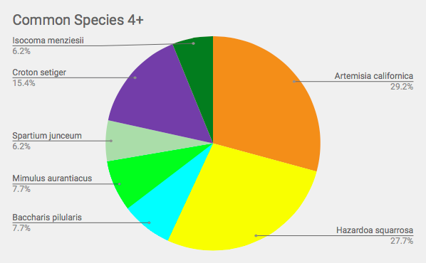
We chose this standard because the degree of mechanical disturbance would indicate whether or not the CSS species could “tolerate” such conditions and be able to thrive and reproduce in these areas.
The data that we gathered in and of itself couldn’t tell us if CSS was successful in overcoming mechanical disturbance, so we compared our data with an amalgamation of two prior sample studies, one in spring of 2014 (30 samples) and another in spring of 2016 (90 samples). We then compared the combined 120 samples with our 90 samples using a Chi-Square analysis, in which we used the top seven species that were most analogous to the prior sample groups. They were as follows: Eriogonum fasciculatum var. Foliosom, Artemisia californica, Baccharis pilularis, Isocoma menzeissii, Croton seitgar, Mimulus auranticus, and Salvia mellifera.
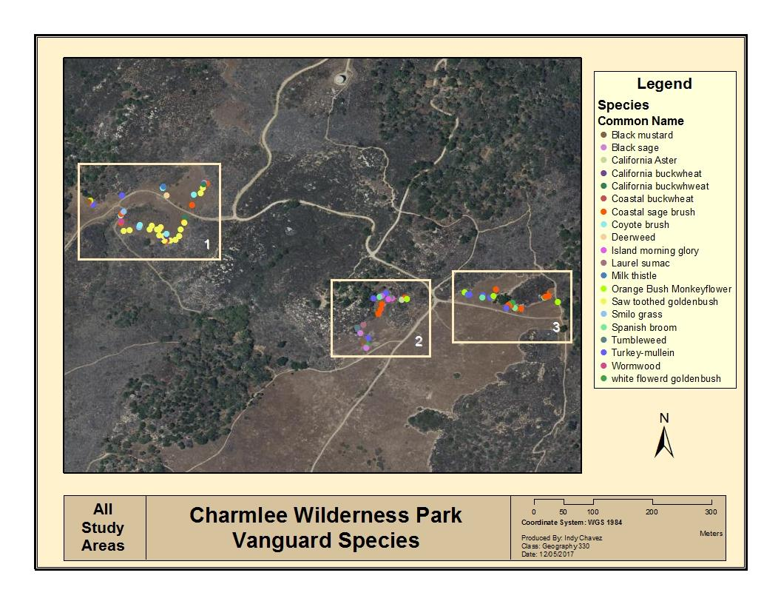
Results:
The California CSS species that proved to be tolerant to the mechanical disturbance of invasive grasses were: Eriogonum fasciculatum var. Foliosom (California buckwheat), Baccharis pilularis (Coyote brush), Isocoma menzeissii (White flowered goldenbrush), and Mimulus auranticus (Orange bush monkeyflower). The chi-square analysis helped us determine this by demonstrating the chi-squared calculated value along with the chi-squared critical value, which was done on a species by species basis in comparison to both previous collections and other total combined species. In the samples above, all calculated values were greater than critical values (X²_{Calc} > X²_{Crit} ). We would like to note that a slight error was made in these tests because the previous group from 2014 and 2016 did not use integers when computing the analysis. The CSS species that did not prove to significantly tolerate the mechanical disturbance of invasive grasslands were: Artemisia californica (Coastal sagebrush), Croton setigarus (Turkey-mullein), and Salvia mellifera (Black sage). In these results, the critical values were greater than the calculated values indicating that they were not statistically significant.
Discussion:
It should be noted that because we collected our data in the dry season our occurrence of CSS may be underestimated compared to the two prior studies due to the rainy season in California being more conducive to species identification. Although, Artemisia californica was one of our highest samples collected, this species did not prove to significantly tolerate grasslands, likely because the previous samples from 2014 and 2016 were much larger. In the north grass patch there were more monospecific patches of Hazardia squarrosa (Saw toothed goldenbrush), but because this species was not analogous to the original study, these observations were not accounted for.
Conclusion:
Overall, there is definitely strong evidence that certain species (particularly: Eriogonum fasciculatum var. Foliosom, Baccharis pilularis , Isocoma menzeissii, and Mimulus auranticus) are to be able to tolerate competition from invasive grasses. For future studies, we do recommend doing a larger sample size and at least 120 species to increase the power of the samples. Other species such as Artemisia californica, while showing high sample number, would need even higher numbers in future studies to show a strong power. We also recommend, twice annually conducting Vanguard sampling in both the rainy and dry seasons of Southern California, to eliminate variability and human bias associated with visual sampling (humans are inclined to spot visually pleasing green plants over dry brown ones). We also recommend that patches be repeatedly studied, particularly in the North Patch, where north facing inclines have varying sunlight and wind exposure. To avoid underestimation of species richness, future studies should strive to sample every individual plant species in a particular area, without concern for redundancy. It may be monotonous, but it is more conducive to accurate results and will actually make the calculations simpler in the long-run.

