David Pineda
Amanda Benas
Christopher Chavez
Lamiya Hoque

ESP 330 Project: Transecting the Sepulveda Dam

Introduction: Our group went to the Sepulveda Dam where a wildlife conservation area is located behind it with a large pond for waterfowl and restoration of riparian woodland and scrub and California sage scrub. This is an area of CSS and CA plant restoration. We have noticed before that CSS has trouble recovering from mechanic disturbance. The south reserve was supposed to foster native plants, but there were many plants that were bulldozed by the US Army Corps of Engineers behind the dam, south of Burbank Blvd., in 2012. Our job was to monitor the plants in the area to see which survived and which couldn’t thrive in the bulldozed environment.

Research question(s)/Hypothesis: After observing the transect areas we noticed a good amount of vegetation difference between the South Reserve and the North Reserve. Our research question is, in comparison to the North reserve and previous states of the South reserve, how were native species able to recover and how much non-native species were able to invade the bulldozed areas in the South Reserve?

Data and methods: The data collecting started off in the USACE-bulldozed South Reserve of the Sepulveda Dam around the plowed area of 34.170840° -118.471300°. We set out to plot twelve 10 m transects. We Identified plant species per each 1 m of each 10 m transect a flora species or soil type, if no flora was present. We set to record the twelve 10 m transects in a pattern that will continue south from our first plotted trancents. We alternated plotting our transects horizontally (west & east), while still vertically heading south after each transect we plotted in the south reserve of the Sepulveda Dam. After transecting our data we used archival data from transects done in prior semesters, both in the north and south side. We inputted the data into a chi-squared test that aligned with our hypothesis. We tested the south current state versus the south of previous semesters. And we tested the cumulative south with the data we had for the north.

Results: Our chi-square test yielded extremely significant. In both comparisons we reject the null hypothesis. Our calculated value exceeded our critical. The current state of the south part of the dam has been more compromised than what was transected in prior semesters. Additionally, the overall state of the south side continues to be in a more damaged state than the north, in regards to its success as a native habitat. The north is fostering a much more healthy native plant community. The south side is struggling to recover after being bulldozed. We often came across large patches of weeds. While there are native trees and shrubs in the Wildlife Reserve, there are very few native annual plants. Many of the common species we came across were Johnsongrass, Castor Bean, and Black Mustard. As for native plants, they are planted in different areas with the hope that they will survive, thrive and produce viable seed that can disperse and spread the distribution of appropriate native plants. The most productive plant seemed to be coyote brush. However, only certain species can survive because of the heavy clay soil and occasional flooding.

In the graphs below we have graphed the averages calculated for each group. In both cases the difference between native species and invasive is greatest in the South. Furthermore, it is important to note that on average, a little over 9 of our 11 transect points came from invasive species.

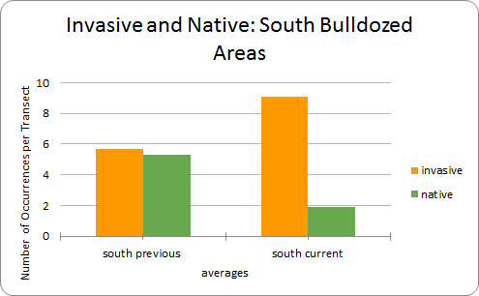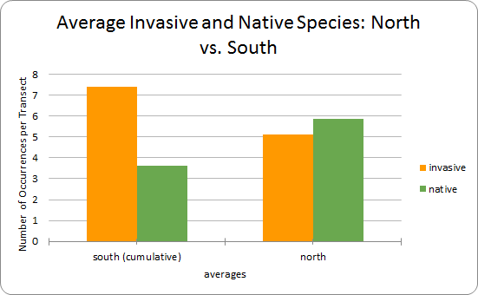

South VS North Chi Results

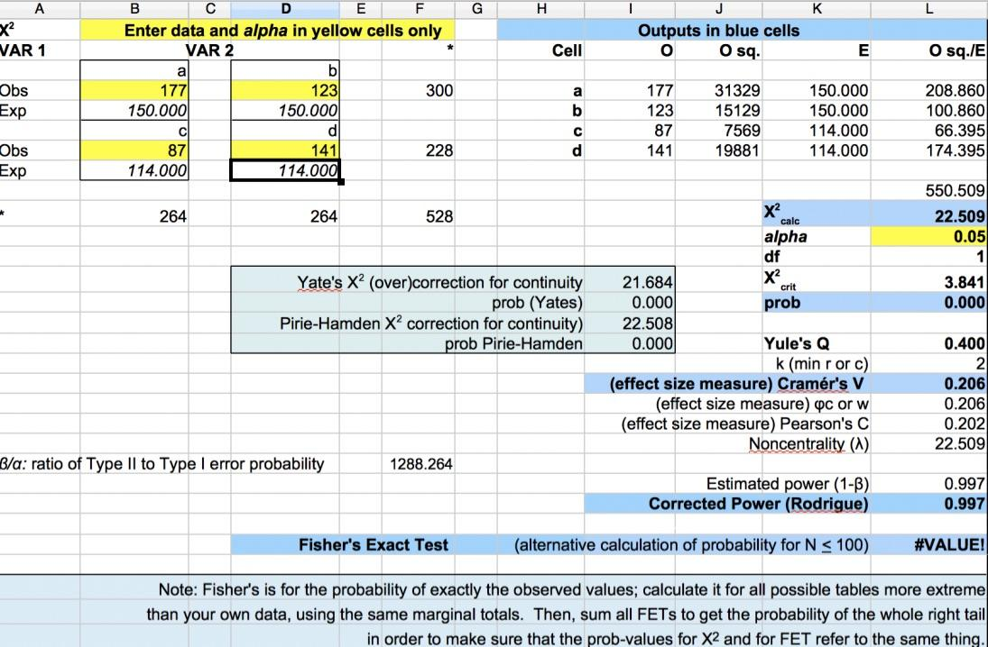

South Previous VS South Current Chi Results

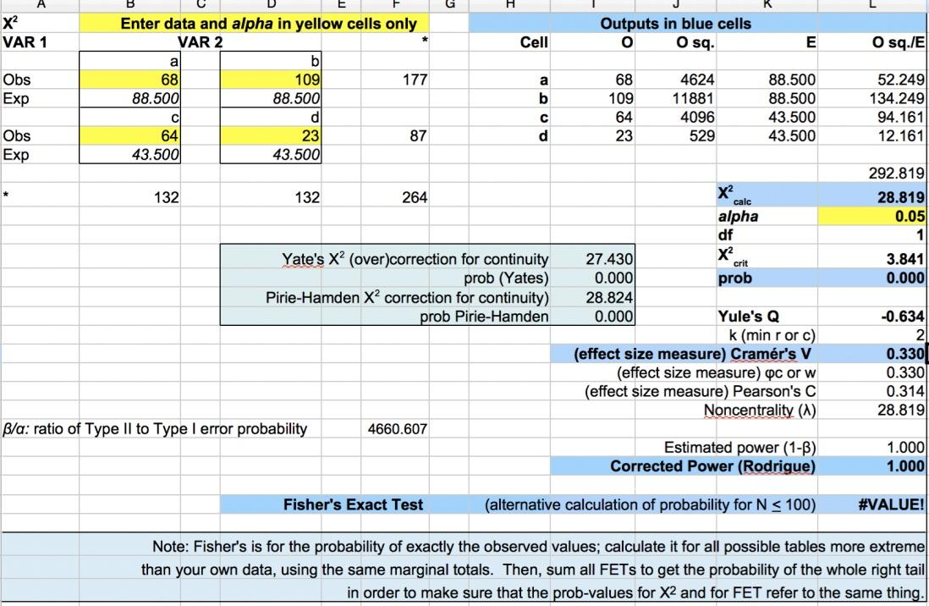

Discussion: It’s important to understand why transecting is significant. It allowed for a general survey of the once natural California habitat. Many believed that the purpose of bulldozing the reserve was to preserve the capacity of the dam due to flood control. Too much vegetation would reduce the water capacity dam. Others believed that as the reserve got populated with more homeless people, they needed to bulldoze the vegetation being that many lived within it. Regardless of the reasoning it is clear that the mechanical disturbance has damaged native plant habitat. Furthermore, almost every transect area had some form of invasion (trash or plant species). What was interesting to us was that there were no public meetings in regards to bulldozing the area, which is unfair because people have a say in these pubic reserves. There should have been more consideration to the possible environmental consequences prior to the midnight bulldozing. Our data reflects some of the prior consequences.

Conclusion: One of the purposes of the bulldozing was supposedly to help native plants recover in an area that is prone to flooding. From what we observed, after bulldozing the area, it seemed to make it more susceptible to an invasion. The area contained more exotic and weed species than it did native plants. Any native species that survived were ones that ones that have a deep rooted system like the red willow. The invasive plants seemed to be the most opportunistic when it came to advancing towards open areas. Aside from the species invasion there were other problems that occured from bulldozing, the area was largely scattered with trash and many homeless people settled in the area. The Sepulveda Dam management plan must address many issues going forward. It is also our recommendation for land surveys to continue to be done to track the development of coastal sage scrub. For example, the continual studying of coyote brush as a vanguard species. The dam provides a unique case study of different levels of disturbed native habitat and should continue to be analyzed.

