Arianna Campuzano
Dana McConnell
Justin Connors
Abraham Ayala
Sepulveda Dam North Write-Up
Introduction:
The North Reserve of the Sepulveda Dam is an area that historically had been heavily used for agriculture. However, after the construction of the Dam began until it was finally completed in 1989, the United States Army Corp of Engineers (USACE) began using it to create the waterfowl pond. (Los Angeles District) Almost as soon as the farming ended, coyotebrush moved into the abandoned fields and has been expanding ever since, especially on the Western and Southern sides of the reserve. Coyotebrush can serve as a vanguard species in helping to establish grasslands and can act as a nursemaid species that can help to facilitate the establishment of other CSS species. Because of this relationship that coyotebrush has with other plant species it is important to look at the relative age of the patches in order to be able to compare species establishment and identify characteristics that may harm or promote CSS growth. Using our preliminary research our hypothesis became: In Sepulveda Dam North, CSS native species are showing up under the older patches of coyotebrush while non-native species are showing up under younger species of coyotebrush (Baccharis pilularis).
Data and Methods:
We went out to Sepulveda Dam North and took quadrats under several of these coyotebrush patches, and by sampling both older and younger species, we were able to see if other CSS inhabitants were starting to grow under them. A total of eight quadrats were taken, four under older patches and four under younger patches. In addition we also kept an eye out for rabbits and were able to find several rabbits underneath the older patches demonstrating a growing and healthy ecosystem. By looking at the preliminary data gathered by the quadrats it already seemed apparent that CSS was having a more successful rate of establishment underneath the older coyotebrush patches versus the newer patches which had a larger percentage of bareground and exotic grasses within the taken quadrats. In order to process our data we performed a z-test by averaging the percentages between the old and new patches and then converting those percentages to proportions. Once the z-test was performed we were able to conclude that CSS establishment among older patches was more established and successful and contained less bare ground and exotic grass species than younger patches. Our data closely matches the past data of Charmlee Park that was provided to us by Professor Rodrigue. This shows that both areas had more exotic and non-native species under the younger patches while there were more native species growing under the older patches. Similarly to our data tables, we also created some pie charts that showed statistical significance as well. This also backed up and supported our original hypothesis statement. We did however find a shortcoming in our study. Our data was showing to be underpowered. We think that by increasing the number of quadrats in future studies this issue could be lessened.

Data Tables:
Diff of Prop | 1 vs. 2 | St Err | 1 vs. 2 | Z of diff of | 1 vs. 2 | prob-value | 1 vs. 2
 | -0.08 |  | 0.24 |  | -0.33 |  | 0.37
(numerator) | 0.41 | (denominator) | 0.25 | proportions | 1.67 |  | 0.952
 | 0.13 |  | 0.19 |  | 0.69 |  | 0.754
 | 0.21 |  | 0.20 |  | 1.02 |  | 0.847
 | 0.07 |  | 0.13 |  | 0.55 |  | 0.708
 | 0.00 |  | 0.01 |  | 0.04 |  | 0.518
 | 0.02 |  | 0.07 |  | 0.27 |  | 0.605
Effect size | -0.24 |  | 0.21 | (Z calc) | -1.12 |  | 0.132
 | -0.55 |  | 0.25 |  | -2.21 |  | 0.014
 | -0.01 |  | 0.06 |  | -0.23 |  | 0.411
 | 0.04 |  | 0.09 |  | 0.39 |  | 0.653
 |  |  |  | Z critical 2-tailed for alpha
 |  |  |  | α = 0.10 | -1.64
 |  |  |  | α = 0.05 | -1.96
 |  |  |  | α = 0.01 | -2.58

GROUP 1 PIE CHART (older)
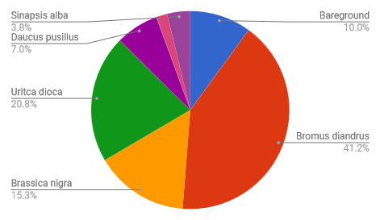

GROUP 2 PIE CHART (newer)
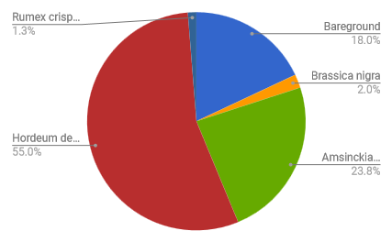

Conclusion:
By sampling both older and younger patches in the Sepulveda Dam Basin, we were able to tell if other CSS species were showing up under them and if the patches were currently being used by rabbits as shelter. We were able to spot several rabbits underneath the older patches while we were collecting data. This shows that the North Reserve of the Sepulveda Dam is healthy and that the CSS is growing, because these plants may provide shelter and motivation for the rabbits to venture out to feed on other grasses and food sources. All of our data supported our hypothesis that CSS native species would be growing underneath the older patches of coyotebrush, while there would be more of the exotic and non-native species growing underneath the younger patches of coyotebrush. For future studies performed in this area, we suggest that more quadrats be sampled and in a wider area. However, with the data that we were successful in collecting, we were able to see that the CSS and coyotebrush species in the area were healthy and thriving. If we were to go back in future years and perform this study again, we hypothesis that we would see and even bigger and healthier area inhabited by CSS species.

References:

“LOS ANGELES DISTRICT.” Los Angeles District, www.spl.usace.army.mil/Missions/Asset-Management/Sepulveda-Dam/.

U.S. Army Corp of Engineers. “Sepulveda Dam Basin Master Plan and Draft Environmental Assessment.” U.S. Army Corp of Engineers.
http://sepulvedabasinwildlife.org/pdf/Final%20Sepulveda%20Dam%20Master%20Plan.pdf

