Jillian Malone
Samantha Ishak
Elijah Purtee
Vincent Ibarra
Coastal Sage Scrub in Forrestal Reserve, Palos Verdes

Introduction
Coastal Sage Scrub is a type of vegetation native to the Southern California region, usually classified into three categories: Venturan, Riversidian, and Diegan. CSS has been threatened by many factors such as the takeover by invasive species as well as urban and agricultural development for decades. According to scientific studies, only 10-15% of its original range remains. Due to the longstanding maintenance of CSS in the Forrestal Reserve, the area could be an example of more widespread vegetation elsewhere in the peninsula if it had not been heavily impacted by development. Because of this, our hypothesis is that the trails we censused in the Forrestal Reserve are significantly different from other parts of Palos Verdes. Our null hypothesis is that the trails we censused at the Forrestal Reserve are not significantly different from other parts of Palos Verdes.
Data and Methods
We censused CSS plant species the Forrestal Reserve and added the data we collected to historical data. This data has been collected from prior Geography 330 and 442 courses since 2008 from varying areas around the Palos Verdes peninsula. The census we conducted was along four trails: Fossil Trail, Canyon View Trail, Vista Trail, and Exultant trail. Data was gathered from fifteen transects using transect tape, a phone (with GPS and a species list), and a field notebook. Each transect was 10 meters long, with three transects conducted on Fossil Trail and four transects conducted on Canyon View, Vista, and Exultant trails.
A Chi-square analysis was done between the five most abundant species in Portuguese Bend and the Forrestal Reserve. These species were: Artemisia californica, Encelia californica, Eriogonum cinereum, Rhus integrifolia, and Salvia leucophylla. We set our alpha standard at 0.05, allowing a 5% chance of error. We inputted the alpha and populations numbers of both areas into a X² 2 x 5 model to get our results.
Results
Our census conducted at the Forrestal Reserve left us with the following transects around the four trails. The yellow stars indicate starting points while the blue star indicates ten meters down the trail as the end point.

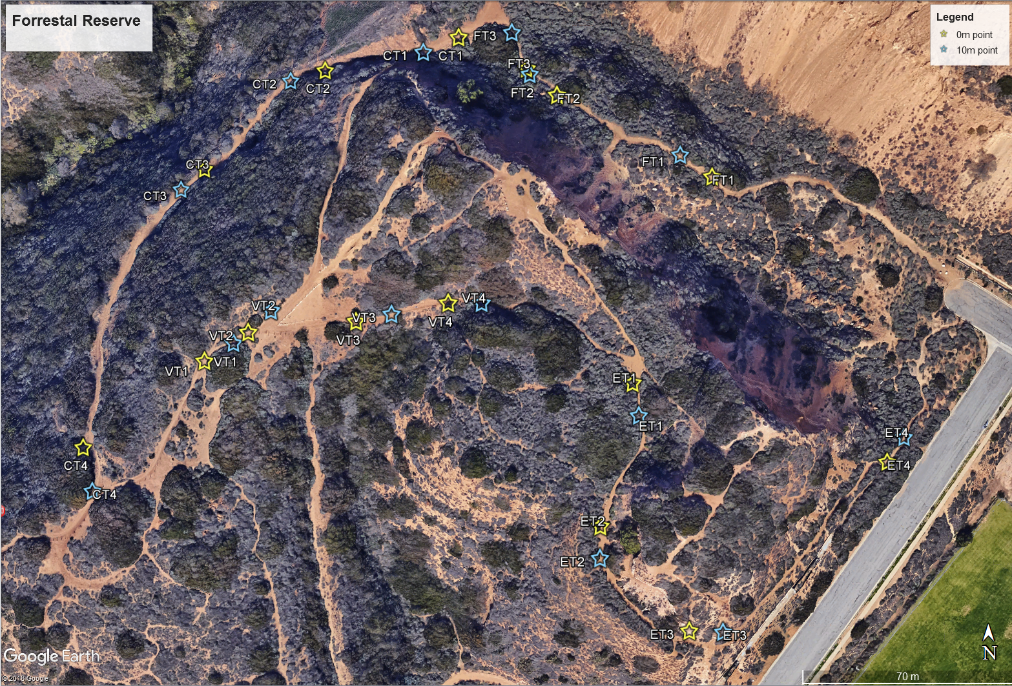
The comparison was done between the Forrestal Reserve and the Portuguese Bend. These two locations are adjacent to each other and a short 2 miles apart. The teal dot represents each location with the Portuguese Bend in the top left corner, and the censusing sight in the Forrestal Reserve at the bottom right corner.
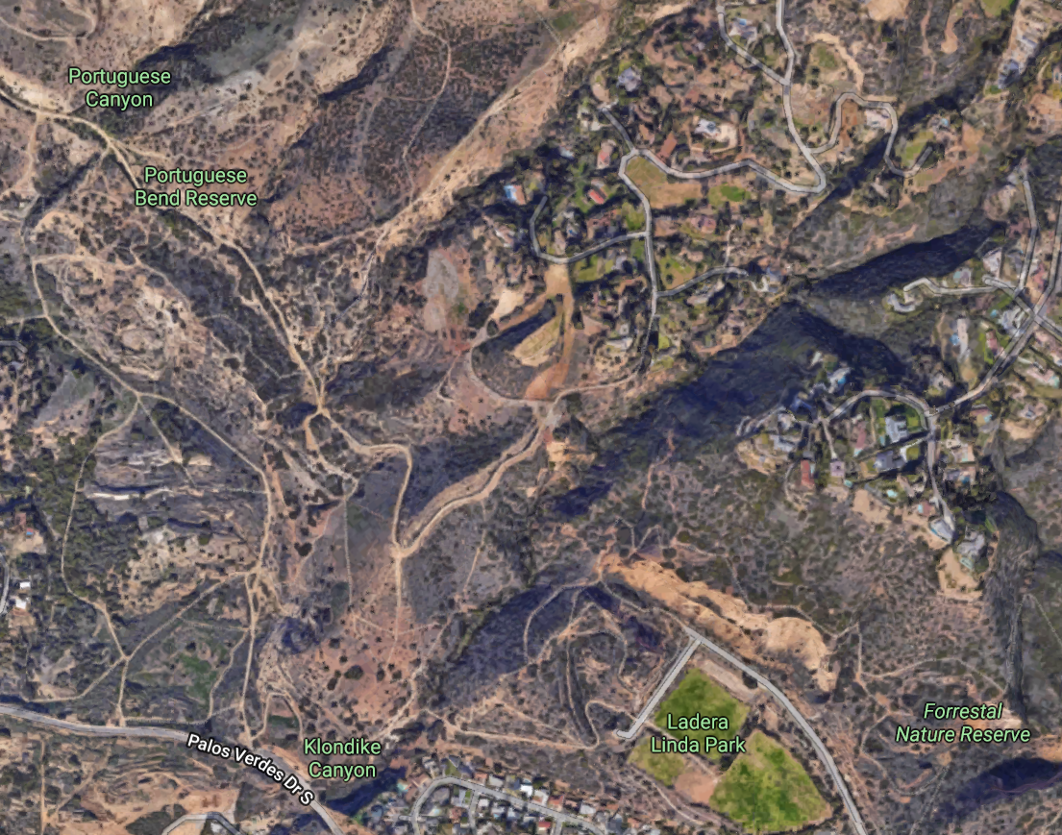

Using the X² 2 x 5 model, we plugged in the amount of the five most abundant species found between Forrestal Reserve and Portuguese Bend.
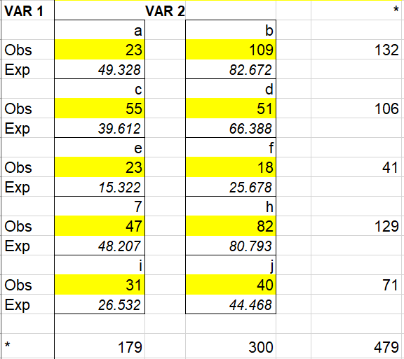

VAR 1 includes the species sum from Forrestal Reserve while VAR 2 has the species sum from Portuguese Bend.

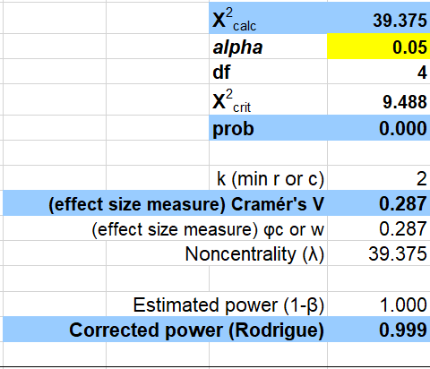
The Chi-square calculations concluded that there is a highly significant difference between CSS species in Forrestal Reserve and Portuguese Bend. The effect size is .287 so the comparison is considered to have a weak effect size. However, the corrected power for the census was .9999 which is strong. The p value was 0.000 which is also a very strong value. A strong power and p value means a low chance of accepting a null hypothesis that is false which strengthens our rejection of the null hypothesis. The result is interesting because Forrestal Reserve has very healthy CSS, yet the adjacent Portuguese Bend differs greatly from its neighbor.

The following pie graphs show a visual comparison of the difference in the five most abundant species:
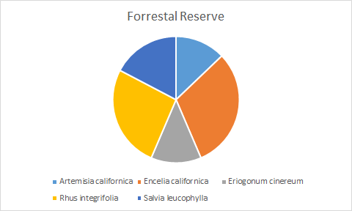
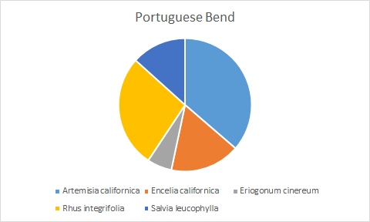
One noticeable difference is the species richness of Artemisia californica at Forrestal Reserve compared to Portuguese Bend. Artemisia californica presence at Portuguese Bend is more than double the amount seen in Forrestal Reserve. Another large difference between the two is the presence of Encelia californica. At Forrestal Reserve, the amount nearly doubles that seen at Portuguese Bend. These two species are clear drivers for difference in our data analysis.

Discussion
After examining the results from the five most abundant CSS species in the Forrestal Reserve compared to surrounding areas in Palos Verdes, we did a Chi-square analysis. Our Chi-square analysis led us to find a calculated value of 39.375, which is greater than the critical value of 9.488. This calculation brought us to reject our null hypothesis and accept our alternate hypothesis.
From the results we collected and analyzed, we found that there is a significant difference between the populations of CSS in the Forrestal Reserve compared to the surrounding areas in Palos Verdes. After observing these results, the significant difference between the two areas shows that the vegetation in the Forrestal Reserve is much healthier than that of the surrounding areas.
Conclusion
The weak effect size suggests a larger sample size is needed for a more solid results. The data collected is already substantial. However, increasing the minimum of fifteen transects to twenty would get better results. Overall, we can conclude that we will reject our null hypothesis and accept our hypothesis: that the trails we censused in the Forrestal Reserve are significantly different from other parts of Palos Verdes The research is important in determining the health of CSS in the region so continuing this work with a stronger effect size is important.

