Marika Gotschall
Jesse Soria
Danny Mallagana
Brian Maka
Charmlee Park
Intro
Charmlee Park in Malibu, California was originally a 300 acre cattle ranch owned and operated by Fredrick and May Rindge. The ranch was sold to Leon and Charmain Schwarts, who renamed the ranch “Charmlee” by combining parts of their first names. In 1978, a wildfire burned down the entire ranch. A few years later, the county dedicated the ranch as Charmlee County Regional Park and became a day use park for activities such as hiking and horseback riding (Lwin). In Southern California, California sage scrub (CSS) has declined down to an estimated 10-15% of its original range due to things such as construction, residential landscaping, air pollution, and changes in fire regimes (Rodrigue). As CSS is lost, habitat for different species of animals is also lost (Roach). The importance of this study is to see if the native CSS plants were able to reclaim the grassland and if they were, which species were able to reclaim the area the best. The null hypothesis is that there is no significant difference between the total census of species found in the vanguard area and the species found in the stable/expanding areas of Charmlee park. If we fail to reject the null and there is no significant difference between the total census in the vanguard and the species found in the stable/expanding area, it would suggest that the native CSS species are capable of reclaiming the grassland. If we reject the null and there is a significant difference between the vanguard and the stable/expanding area, we would hope to identify a few species that can be used to restore the CSS in the grassland.
Data & Methods
Data was collected by going to assigned areas in Charmlee park and surveying roughly 30 plants in each area, taking GPS coordinates at the location of each plant surveyed. The number of each species was tallied, and the totals were used along with data collected from Dr. Rodrigue’s "Save the CSS" project group in ES&P 400 in Spring 2014, GEOG 442 class, Charmlee vanguard in Fall 2016, and GEOG/ES&P 330 class, Charmlee and Kouba vanguard project in Fall 2017 and used in a chi squared test. One issue that was discovered with the data was that the data collected this semester seemed to yield significantly different data from what was collected in previous years. This may be due to different areas of Charmlee Park being surveyed by different groups that went out into the field. For our tests, we looked at Artemisia californica, Baccharis pilularis, Salvia leucophylla, and Silvia mellifera.
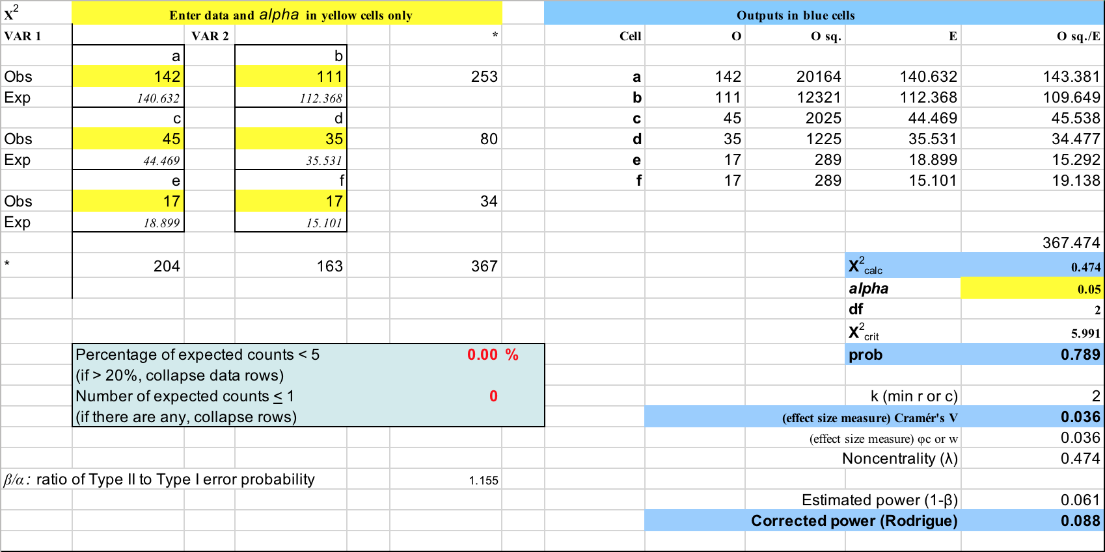
Figure 1: Chi-squared for Total Census Data versus Stable/Expanding Census Data

Results
Since the p-value of the chi squared test was 0.789, the data concluded that there was no significant difference between the CSS species found in the vanguard area verses the species found in the expanding and stable areas at an alpha value of 0.05. The effect size was weak at 0.036 and the power was low at 0.088.
Discussion
Based on the results, we were unable to reject the null hypothesis and conclude that there was no significant difference between the CSS species found in the Vanguard area when compared to the expanding and stable areas of Charmlee. The effect size of 0.036 is weak due to a small sample size. The power at 0.088 is extremely low, which can lead to a type II error, claiming a false negative and further reinforces our results. These results suggest that native CSS species that are found in the stable/expanding areas in Charmlee Park are able to reclaim the grasslands in the Vanguard area.
Conclusions
In conclusion, based on the data found in Charmlee park from this semester and previous years, we failed to reject the null hypothesis and concluded that there was no significant difference between the vanguard area and the stable/expanding areas in Charmlee Park, meaning that the CSS species are capable of growing back in the grasslands. With the CSS declining in Southern California, there are many species that are losing their habitats. It is important that the regrowth of the CSS is monitored and observed to prevent more habitat loss in these areas. With this information, it would be possible to do future research on how to encourage further growth of all native CSS plants in the vanguard area and what factors contribute to how certain species are able to grow in the vanguard area, as well as what factors make it difficult for other species.
References
Lwin, EiEi (n.d.). 2003. Charmlee Park -- Historical timeline. Retrieved from http://web.csulb.edu/depts/geography/gdep/posters03/mappingcharmlee/timeline.html

Roach, V., & Jindong, W. (2013). Evaluating the Potential Impact of the Proposed Land Development on Coastal Sage Scrub in Northern Orange County, California. California Geographer, 5331-47.

Rodrigue, C. M. (n.d.). 2013. Restoration of California sage scrub. Retrieved from http://web.csulb.edu/~rodrigue/SCAS/

