Cristin Hansen
Mellanie Hidalgo
Sawyer Marks
Kristen Way
CSS Recovery in Clyde Canyon

Introduction
Charmlee Park, by Clyde Canyon Trail, in 2003 suffered a fire where firefighters had to bulldoze into the soil down to the mineral matter in order to create a fire break so the fire would have no organic fuel to continue. As the fire break clearing began to recover we being to see CSS creep into where the fire break was. Although soil disruption usually inhibits the growth of CSS, CSS began to grow and recover in this area. This was probably due to the fact that we have black mustard on site.
The clearing next to Clyde Canyon Trail was an area primarily dominated by black mustard. Black mustard has the characteristic of allelopathy and is the reason for its domination. At our site, black mustard continues to dominate the area, but a few CSS shrubs and exotic annual grasses were able to invade this land. We will compare our data with the CSS that is next to and expanding into grasslands in a different part of Charmlee park to see if the composition of plants is significantly different or not. We will compare the transect lines we got from field work with the secondary data from past students who did transect lines along the stable and expanding boundaries. We hypothesize that the composition of species in our field site will be significantly different when compared to the CSS and grasslands of the Charmlee park data, due to the presence of black mustard.

Hypothesis:
The composition of CSS to grasslands at Clyde Canyon is significantly different compared to stable and expanding boundaries of CSS in Charmlee park.
Null Hypothesis:
The composition of CSS to grasslands at Clyde Canyon is similar to the stable and expanding boundaries of CSS in Charmlee Park.

Literature Review
The article “Differences in California Sage Scrub composition behind stable and recovering boundaries with annual grassland” focuses on what has caused the vegetation in Southern California to decline, and whether or not CSS is recovering by comparing the differences between long-stable boundaries between CCS and boundaries where CSS was recovering. In particular, how air pollution, urban, suburban, exurban development, agriculture, and human induced global warming has caused a loss of California Sage Scrub. Early damages to CSS include fire regimes, residential development, soil nitrogen deposition due to air pollution, ranching, grazing, cultivation, and plowing.
The loss of CCS has had devastating effects on wildlife due to habitat loss, such as the Belding’s orange-throated whiptail lizard, coastal cactus wren, and the Stephen’s kangaroo mouse.
1, 093 transect points were gathered from 7 different sites, 496 were from recovering boundaries, and the remaining 597 from stable boundaries.
There were 9 dominant plant species that were used to analyze differences in the native plant community in 5 different contexts: community behind the recovering boundary, community behind the stable boundary, individual CSS species in the transition area, up to 25 m out from recovering boundaries, individual CSS species in the transition area, up to 25 m out from stable boundaries, CSS individuals found isolated in the middle of grassland (these were not transected but individually hunted and GPSed). The result was that, while CSS is diminishing throughout California, California Sage Scrub does have the ability to self-restore in a few places.

“Preliminary Report: Effects of black mustard allelopathy on the fitness and life history strategies of buffalo gourd in southern California” in 2015 by Diego Rodriguez, Gabriel Casagrande, and Víctor D. Carmona-Galindo also gave us background on the chemicals in black mustard. The report concludes that black mustard inhibits seed growth and plant fitness. While the report only studied buffalo gourd, it is possible that the black mustard affects CSS in the same way.
Data and Methods
The Charmlee data that is compared was collected by Dr. Rodrigue’s geography 442 class in Spring 2013. The class collected transects across stable and expanding boundaries in the Charmlee Park between CSS and grasslands. The Clyde Canyon data was collected through 8, 20 meter transect lines centered on the strip of CSS vegetation. This area is about 10 meters wide and grows through about 5 meters into the grasslands on both sides. The transects started on the eastern side where the CSS was originated and ended on the Clyde Canyon trail to the west. To find the location of our data we used the GPS status and location toolbox app for Android devices. In order to measure the 20 meter transects we used a transect tape borrowed from Dr. Rodrigue.
We combined all exotic shrubs data that was found in Clyde Canyon area and in Charmlee park; such as, the Bromus and Avena species. The black mustard that was found exclusively at our site is in its own category because it is responsible for interrupting the growth of CSS. After the data was collected we used chi squared statistical test that compared nominal data. We input the data into a 3X3 and two 2X3 tests to compare the expanding and stable boundaries to the firebreak recovery.

Results and Discussion
The results of our Chi-Square Tests are shown below. When comparing the Expanding boundary of CSS with our results, we found that we could reject the null hypothesis. Our composition was significantly different when compared to the expanding boundary. Our p-value was zero, and our calculated chi squared value was much higher than our critical value. Our effect size was 0.844, which is strong. Our power also shows that we have a big enough sample size, with a value of 1.00.
When comparing the Stable boundary of CSS with our results, we found that we could reject the null hypothesis. Our composition was significantly different when compared to the stable boundary. Our p-value was zero, and our calculated chi squared value was much higher than our critical value. Our effect size was 0.753, which is moderate. Our power also shows that we have a big enough sample size, with a value of 1.00.
When comparing the our results to both the expanding and stable boundary, we found that we could reject the null hypothesis. Our composition was significantly different when compared to the expanding boundary. Our p-value was zero, and our calculated chi squared value was much higher than our critical value. Our effect size was 0.601, which is moderate. Our power also shows that we have a big enough sample size, with a value of 0.999.

Expanding v. Clyde Canyon
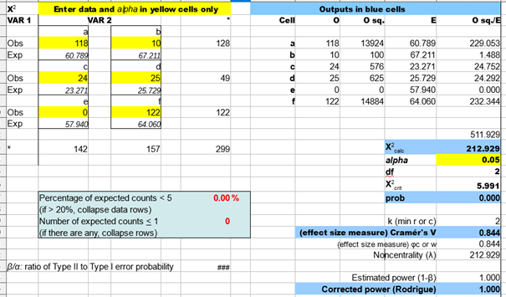

Stable v. Clyde Canyon
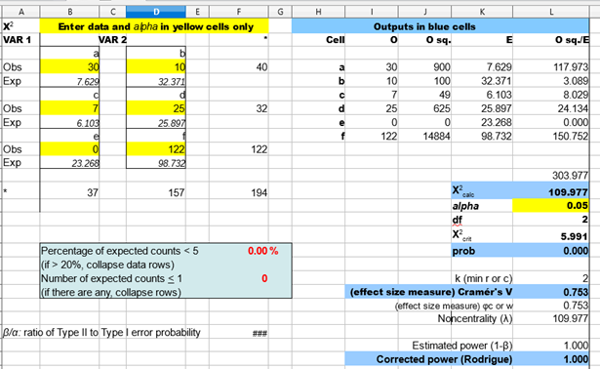

Expanding v. Stable v. Clyde Canyon
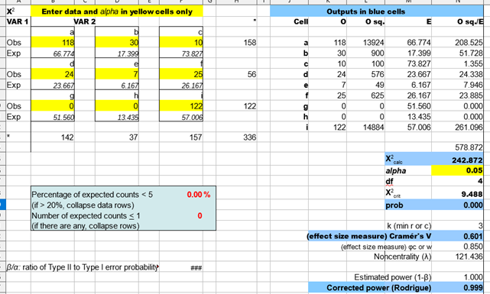

Conclusion
According to our calculations, the Clyde Canyon site has a significantly different composition of species compared to the expanding and stable boundaries in Charmlee Park. Through our chi-square tests, we are able to reject the null hypothesis. We believe that this significant difference in composition is due to the presence of mustard. The allelopathic chemicals have the ability to not only inhibit seed growth, but also to reduce plant growth, according to a research paper in 2015.
The reduced amount and diversity of coastal sage scrub is probably due to the flourishing black mustard that surrounded the strip of recovering scrub.
All of our chi-square tests had significant results for all three of our chi-square tests, all with strong power. While we had a strong effect size when comparing our data to the expanding territory, we only had moderate effect sizes for our 2x2 test with the stable boundary and the 3x3 test. In future work, we should have a bigger sample size to remedy the moderate effect size.

