Charmlee National Park Nursemaid Species

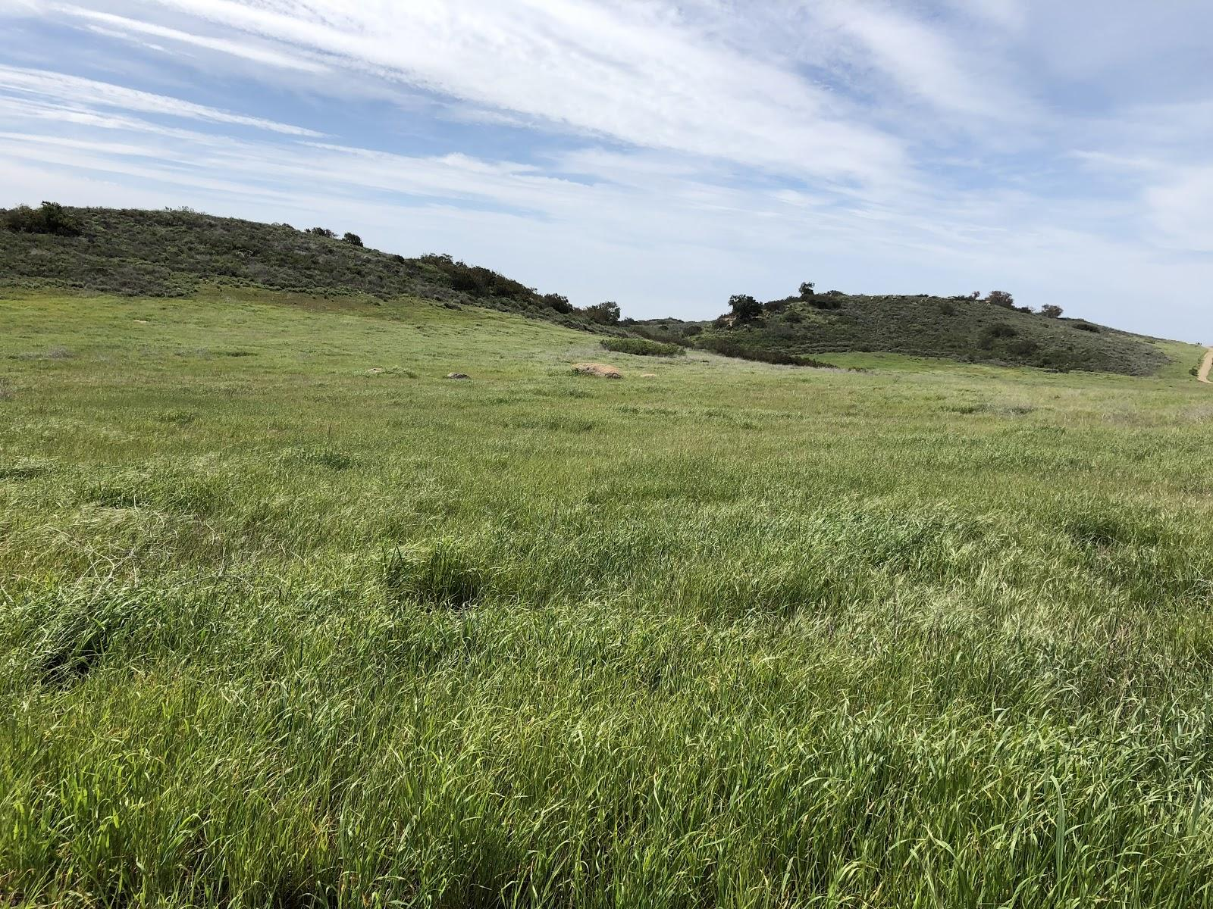

Submitted By:
Andy Aguinaldo, Jeremy George, Mark Hernandez, Nolan Nguyen
Submitted For:
Dr. Rodrigue
Geography/Environmental Science & Policy 330
California State University Long Beach

Introduction

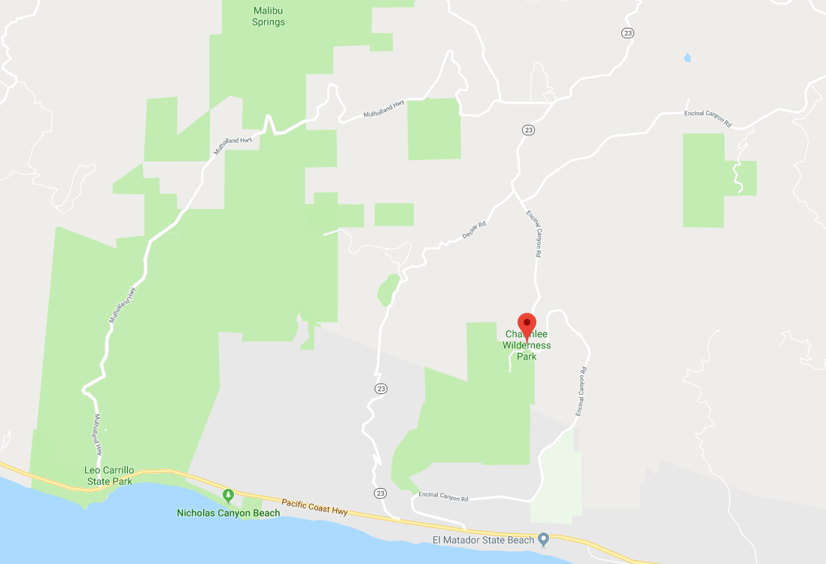
Charmlee Wilderness Park is part of the Santa Monica Mountains National Recreation Area in Southern California. It is home to many plant species including exotic grasses. One particular plant of interest is Baccharis Pilularis, also known as coyotebrush. For our research question we are investigating whether or not coyotebrush is a nursemaid species. The term nursemaid refers to a person who takes care or looks after, for example, children. In our situation it refers to coyotebrush looking after local CSS and native grass species. Our topic is based on Sean Brennan’s article, “Coyote Brush as Facilitator of Native California Plant Recovery in the Santa Monica Mountains”. In Brennan’s thesis, he explains how most areas of Southern California are home to exotic grass species, which have overrun many native coastal sage scrub and grass habitats. The invasion of exotic grasses alters the landscape to the point where it becomes a type-converted landscape that is dominated by exotic grasses. This makes it difficult for CSS and native grasses to recover. However, coyotebrush in particular has been shown to act as a countermeasure in this type of situation because of its unique trait to
(Figure 1)Location of Charmlee Park in Malibu
establish itself in certain types of vegetation, including
grasslands. As a result, coyotebrush acts as a nursemaid species by being able to allow other CSS species and native grasses to grow under it, within the exotic grassland. Sean Brennan investigates this phenomenon by observing the “long-term consequences of coyote brush invasion in a type-converted landscape of Southern California”. He conducts this analysis by transecting plant species that could be under coyotebrush patches. His results show that non-native species are being replaced by coyotebrush, as well as several native plant species over time. Therefore, coyotebrush is a nursemaid species. Again, for our research topic we are investigating whether this is true or not.

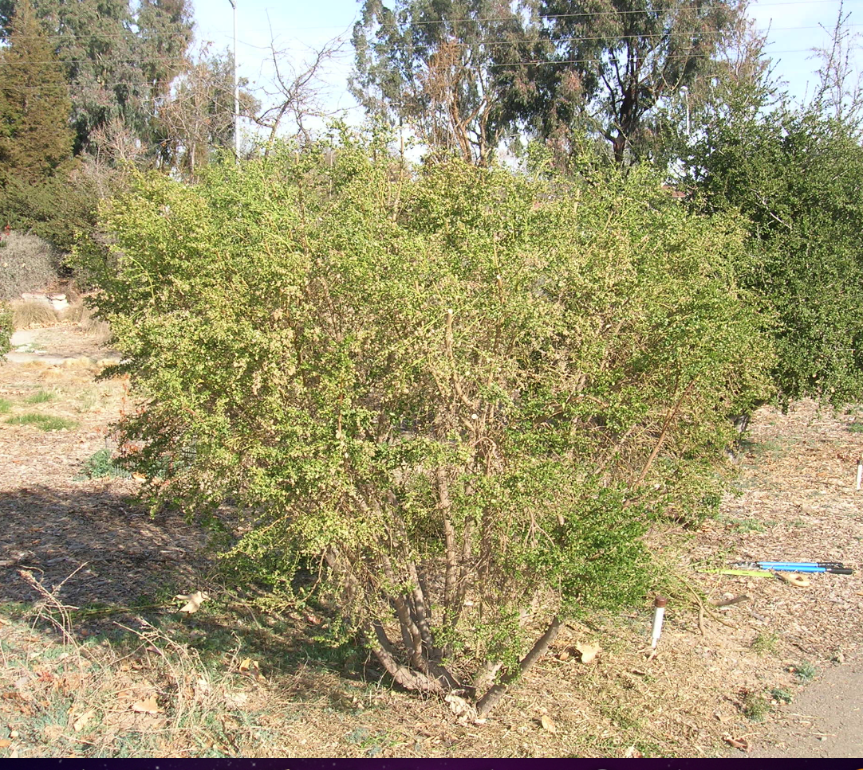
(Figure 2) Baccharis pilularis, Coyotebrush

Methods

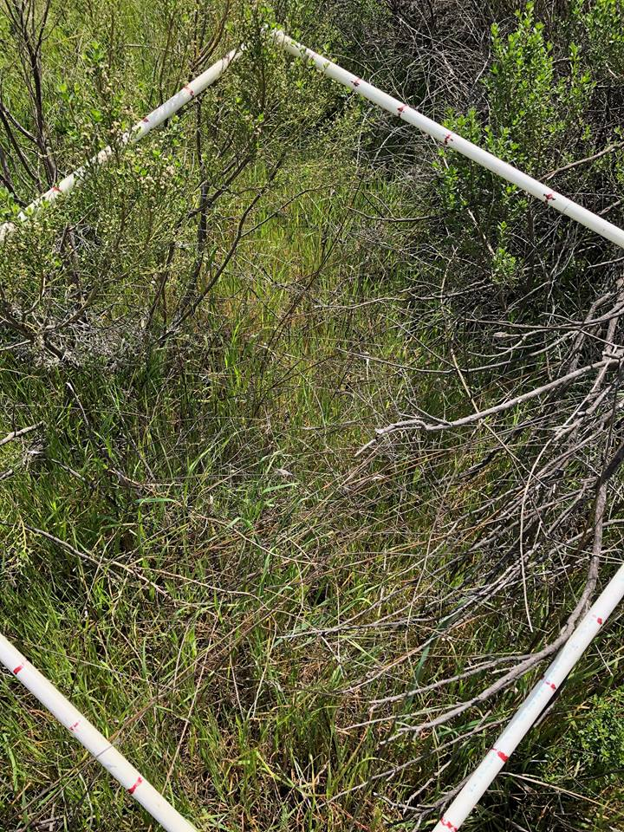
In order to study the the possible role Coyotebrush has as a nursemaid species in the exotic grassland area of Charmlee Park, we conducted an analysis using the quadrat method. The materials needed to conduct this analysis is a 1x1 meter quadrat made out of PVC pipes, and a Garmin GPS unit. The quadrat sampling is a tool used when a census needs to be recorded to study the biodiversity in an area. In our case, we used a series of squares (quadrats) to census the plants living under coyotebrush. The census is done by percent cover, for example; 10%
coyotebrush, 50% bromus diandrus, and 40% bare ground. A percent cover must be a total of 100%. Our group conducted a total of nine quadrats, for three age groups of coyotebrush. The age of coyotebrush sampled were from 1989 (yellow circles), 1994 (green circles), and 2002 (pink circles. We also went to three different locations to determine if old coyotebrush still existed within that location. This method was answered as a yes or no response. All old coyotebrushe still exist in those areas. We relied on the GPS unit as well as the trails to to take us to the nine coyotebrush
(Figure 3) 1x1 Meter quadrat placed on coyotebrush
location. The main trails that we
took were the Botany Trail, East Meadow Trail,
and Potrero Road.

Additionally, every time we collected a percent cover from the quadrat, we recorded the GPS coordinate of where we placed the quadrat in a notebook. This allowed us to create a map of where we found all the coyotebrush within the exotic grassland area. Arcmap was the software used to create all our maps. We also used a floral key and identification sheets to help us determine the species living under the coyotebrush.
Following the completion of our percent cover collection of Charmlee Park’s grassland, we began our data analysis. The first part of our data analysis is comparing the three age groups; Yellow Circles, Green Circles, and Pink circles. The purpose of our our first analysis is too compare the proportions of each group to one another. We recorded the scientific name, common names, and proportion cover of each plant from each group. A z-test is then performed to see the difference of proportions. The second phase of our data analysis was to input our raw percentages of our quadrat, as well as our average percentages according the year of the coyote patch. Our data as well as the data from Fall 2017 were taken into account for this analysis. The purpose of this analysis is to determine whether Coyotebrush is serving as a nursemaid species for Coastal Sage Scrub attempting to grow and expand in the exotic grassland.

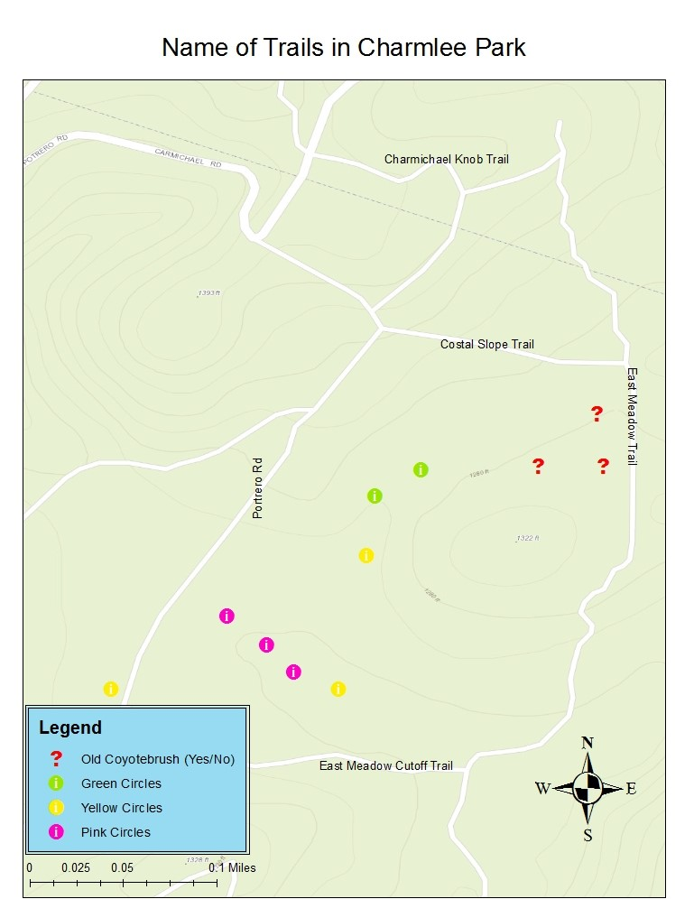
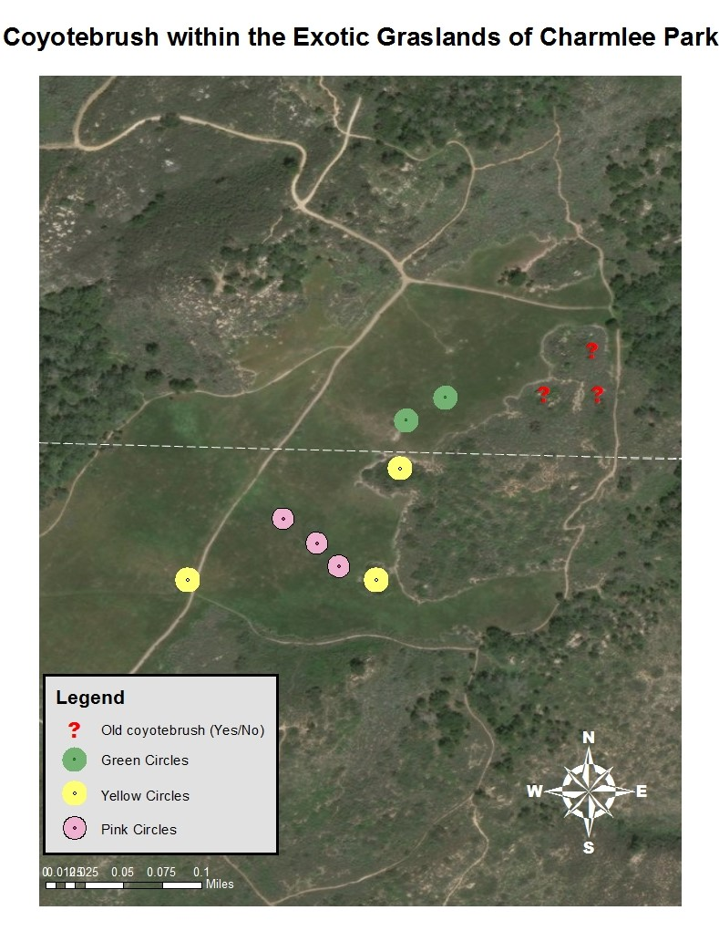
Analysis

In order to collect our data, our group went out to Charmlee National Park in April of 2018. Using Garmin GPS units, we hiked to specific GPS coordinates provided for eight different locations of california sage scrub located in the Charmlee Park meadow area. At each location, we took a 1m quadrat underneath each coyotebrush clump to census the plants below. The plant species were recorded and put into a table showing the percentages of species per quadrat that totaled to 100%. After recording our data, we were able to perform two different statistical tests, a two-tailed difference of proportion z-test comparing three different age groups with each other, and a two-tailed difference of proportion z-test comparing two groups of class data. These tests were used to compare the amounts of species in each group to look for any significant patterns.

Results

The purpose of this study was to determine if there was a significant difference in species between three different age groups of California sage scrub. The yellow group is the oldest clumps of sage scrub from 1989, some of which had been burned in a fire in 2003. The green group is the clumps from 1994, and the pink group is the youngest from 2002.
For our first Z-test difference of proportions, we compared the three different age groups of California sage scrub in Charmlee Park with each other. When comparing the green and yellow groups, the z-calculated values are not able to reject the null hypothesis with a significance level of 0.05. When comparing the green and pink groups, the z-critical values are still not able to reject the null hypothesis. The values for Bromus diandrus did give a larger z-calculated of -0.89 which was much larger than the rest of the species. Again, when comparing the yellow to the pink groups, very low numbers came up for our z-calculated. Our effect size for all parts of this first test was trivial. The p-values we obtained were much too large to reject the null at a 0.05 alpha or even 0.10 alpha level.

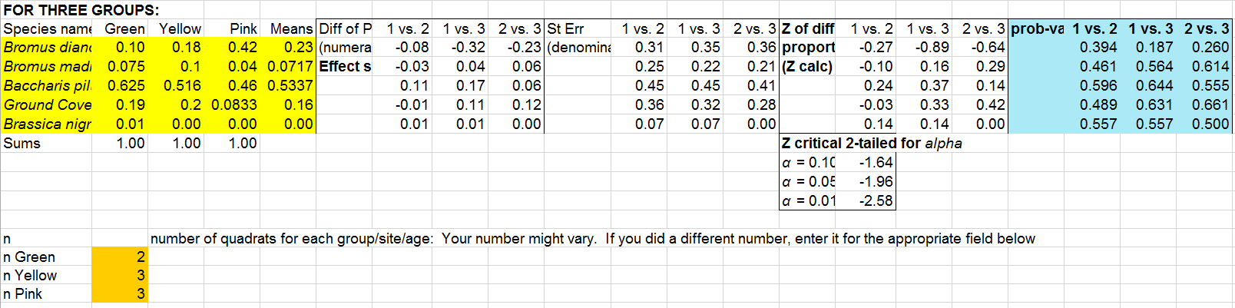
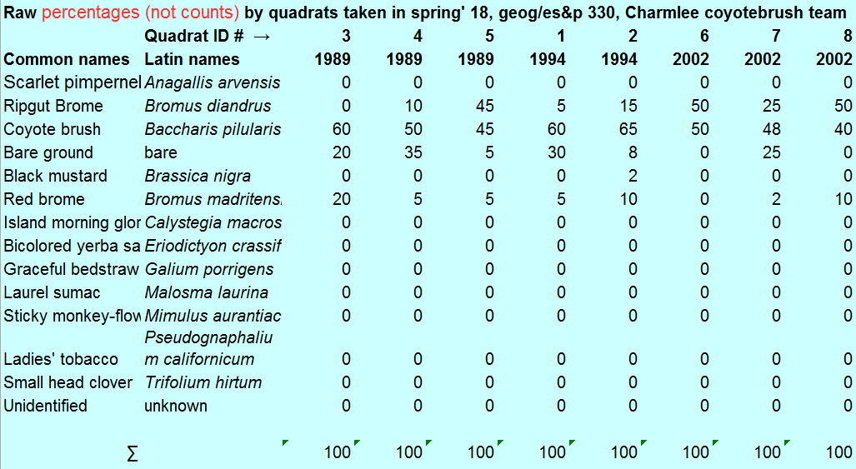
(Figure 4) Z-test

(Figure 5) Raw percentages of cover

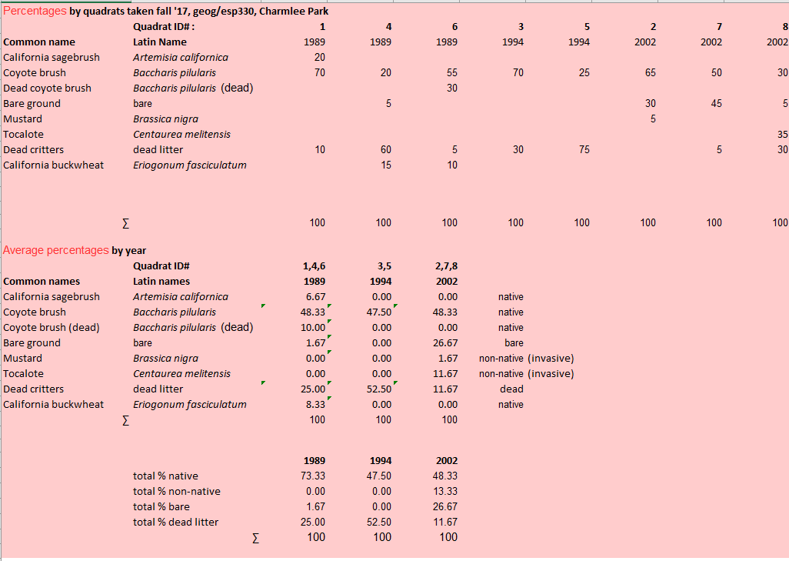
(Figure 6)Data Collected in Fall 2017

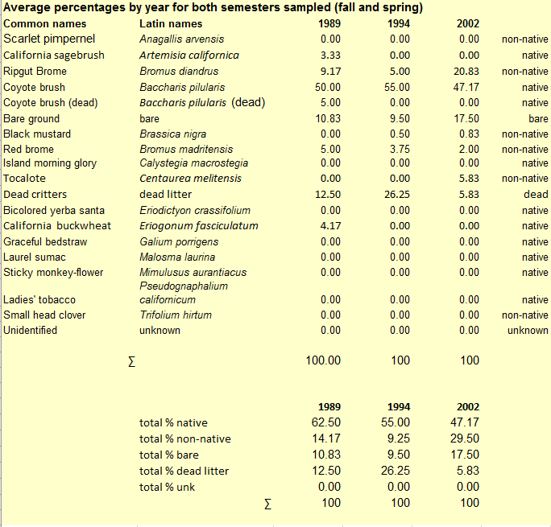
(Figure 7)Data Collected in Fall 2017

Discussion

Through the the use of Z-tests, we chose an alpha value of 0.05, with a z-critical of -1.64. The p-values that we got from the tests in all three age classes lead to the fact that there is a failure of finding any significant difference between the age classes, the “Yellow” group (1989), the “Green” group (1994) and the “Pink” group (2002). Because our data leads to findings going against Brennan’s hypothesis, this may be due to nursemaid species not being applicable on all grasslands. Baccharis pilularis, coyotebrush, could easily enter grasslands through the use of wind dispersal. They grow very dense and tall at the beginning, however, through aging, the tall and dense patches become much more flat and sprawl out. Following their deaths, room is left open for younger CSS species to enter. This can be seen as negative or positive, depending on which perspective being taken because coyotebrush could lead to a decrease in native vegetation and an increase in non-native species. To reach that conclusion, more extensive data must be gathered in other CSS and grassland boundaries through regular intervals.

Conclusion

Based on our data, we have determined that there is no significant difference among the three age classes of coyotebrush.Through the use of quadrats, we have noticed that in all three age classes, the coyotebrush have similar proportions of two non-native grass species, the dead remains, bare ground, Brassica nigra also known as black mustard and younger coyotebrush. The non-native grass species we observed in the quadrats are Bromus diandrus and Bromus madritens, Ripgut brome and Red brome. Since there are similar proportions in each patch, this leads to our conclusion that goes against Sean Brennan’s thesis that Coyotebrush is a nursemaid species that facilitates the establishment of young CSS species under it.

Staff Evaluations
Andy: 4(Jeremy), 5(Mark), 6(Nolan), 7(Andy)
Jeremy: 7(Jeremy), 4(Mark), 5(Nolan), 6(Andy)
Mark: 6(Jeremy), 7(Mark), 4(Nolan), 5(Andy)
Nolan: 5(Jeremy), 6(Mark), 7(Nolan), 4(Andy)
Works Cited

Brennan, Sean. Laris, Paul. Rodrigue, Christine. Coyote Brush As Facilitatators of Native
California Plant Recovery In The Santa Monica Mountains. 2017.

