Pamela Solano, Hannah Robidoux, Yesenia Nuno, Elena Protsenko
Dr. C.M. Rodrigue
ESP 330
07 December 2021
Team Epsilon: Sepulveda Dam Basin
Introduction
Our group is continuing the data collection of the Sepulveda Dam Basin soil and vegetation conditions. As wildfires rip through the area nearly annually, it is important to document if the soil and vegetation are recovering in a timely manner. This research is also crucial to keep track of which species are repopulating, since it is important to conserve species native to California, and it is possible the high frequency of fires might favor invasive species. The research will also indicate how much of the area is still burnt after the most recent fire in 2020.
The research we are conducting can be used to help determine if the area is a flood risk or landslide risk. According to the B.C. Ministry of Forests and Range, “Severe wildfires damage the forest canopy, the plants below, as well as the soil. This can result in increased runoff after intense rainfall or rapid snowmelt, which can put homes and other structures below a burned area at risk of localized floods and landslides.” Knowing the post-hazardous dangers that wildfires bring to the area can help protect the local infrastructure and citizens. As we saw, many people hike, bike, run, and play in the area we were researching. If it was obvious that recovery is not happening it would be important to note in our findings.
These risks will increase as climate change warms the area. Just last year, firefighters fought off a twenty-acre fire at this field during a 114-degree heatwave, barely saving the Japanese Garden (Bik, 2020). This happened to be right in the area we were studying, which had an impact on our results.
We did our research here in the Sepulveda Dam basin, between Haskell Creek, Woodley Avenue, and Burbank Boulevard. We split into two groups and tackled the fifty-point task, taking several hours to complete the observations.
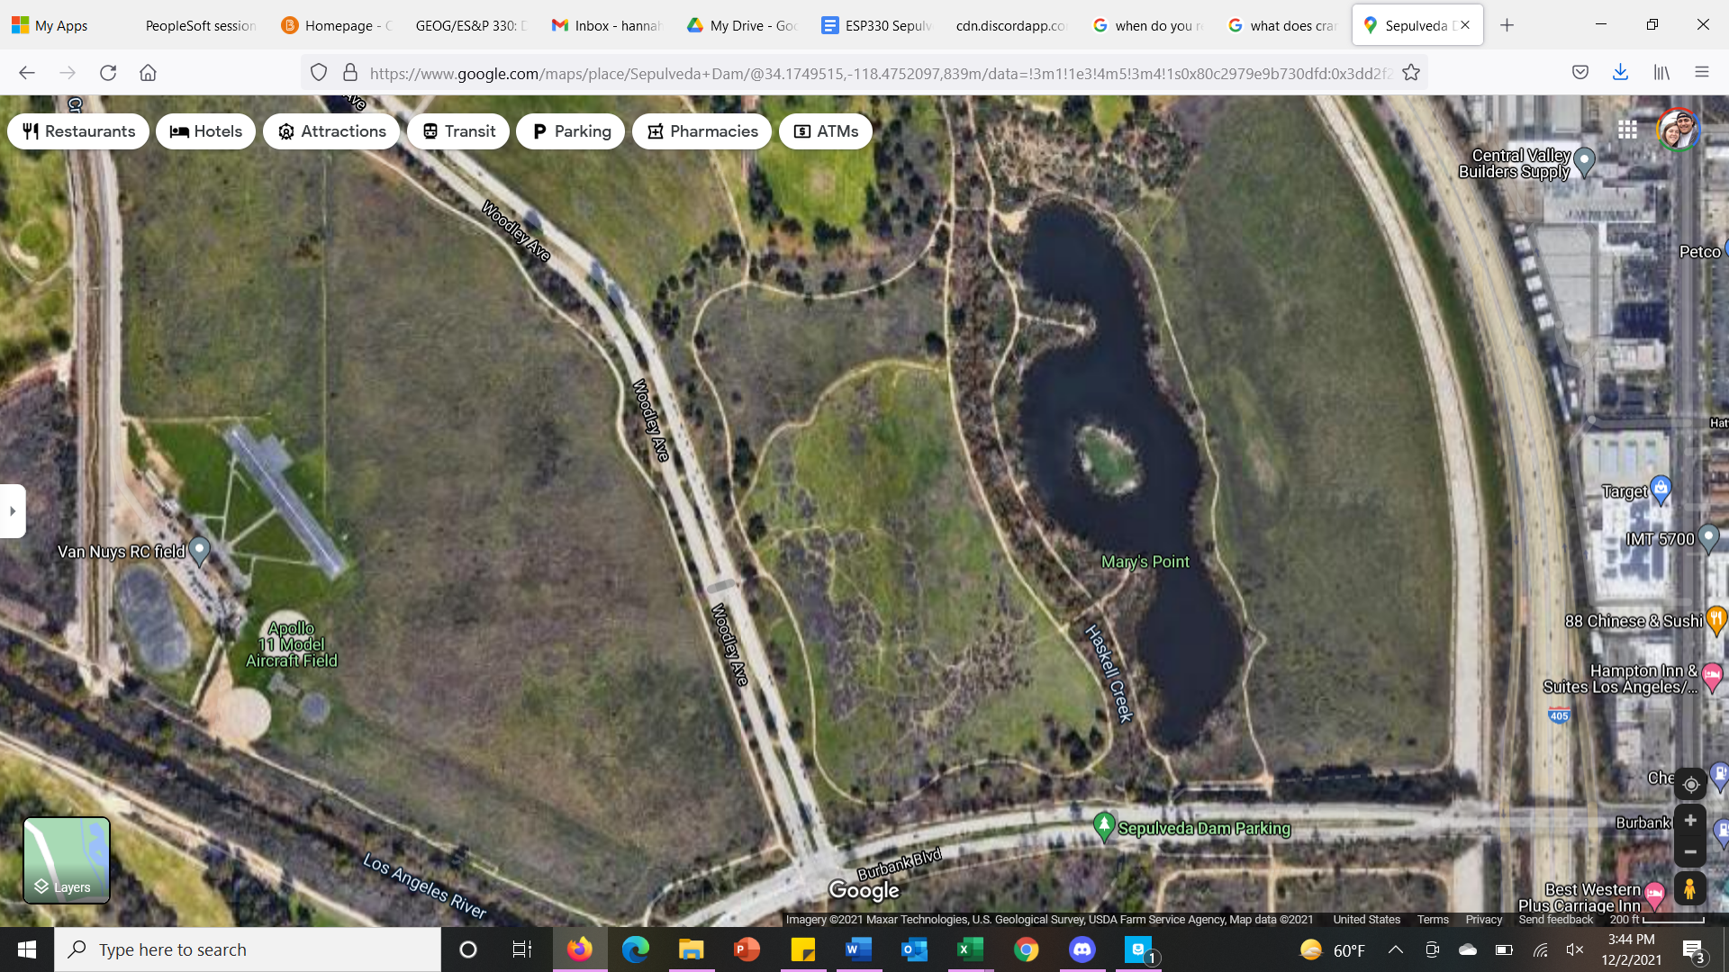
Working hypothesis: There has been a significant change in the soil and vegetation conditions since the wildfire in 2019.
Null hypothesis: There has been no change in the soil and vegetation conditions since the wildfire in 2019.
Our research and analyses will determine if we reject or accept our null hypothesis. Our previous data from 2019 is provided by Dr. Christine Rodrigue and her former students.

Data and Methods
Fieldwork Data Collection
The first step for our data collection was accessing archival data that was collected in the year 2019 by a group of Dr. Rodrigue’s former students. This group of students drove out to Sepulveda Dam a few days after a large fire. There, they collected field data on the soil condition, water behavior, and vegetation condition in designated areas out in Sepulveda Dam, by following specific latitude and longitude coordinates. Using this archival data, our team of students drove out to Sepulveda Dam on November 14th, 2021, and used a global positioning system (GPS) application on our cell phones to relocate the same coordinates. At each set of coordinates, our team documented current soil conditions, current species within one meter of the coordinates, and current vegetation conditions.
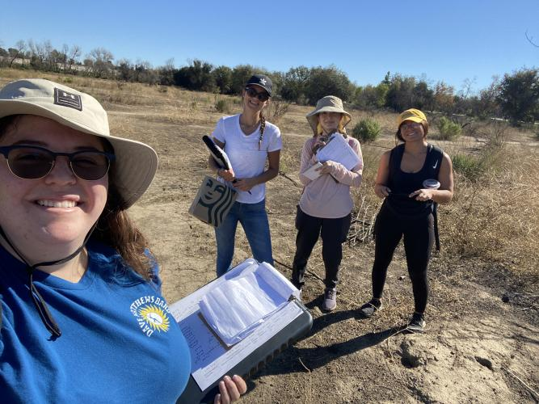
The photograph above is our group out in the ninety-degree weather doing fieldwork at Sepulveda Dam.
On the field, the actual data collection was done manually by observing the soil and vegetation at every coordinate designation. We recorded our observations on printed spreadsheets and later transferred them digitally to an excel sheet, also containing the archived data. The soil conditions were observed and labeled based on their appearance, which were categorized as either ashy, charred, or normal. Vegetation was also observed and categorized based on whether there were any at all, living, visible but burned, or remained only as charcoal skeletons. Our fieldwork differed from that of the work done in 2019 because our group was not able to test the water behavior (as that needs to be done within a few days immediately after a fire), but instead our members were tasked with identifying species of plants within a meter proximity of the coordinates. We identified the species using the Sepulveda Dam species list available on the ESP 330 home course page, and by using prior knowledge from having extensively researched six different species commonly found in this area earlier this year. The species we identified in the area include Helianthus annuus, Heterotheca grandiflora, Hirschfeldia incana, Phalaris aquatica, Centaurea melitensis, Baccharis pilularis, Ambrosia ragweed, Malacothamnus davidsonii, Artemisia california, and others that were not identifiable (such as grass and dead litter).
Below is a small table containing each species name we found in the area with their respective count.

Species found in Sepulveda Dam | Count
Helianthus annuus | 6
Heterotheca grandiflora | 6
Phalaris aquatica | 2
Centaurea melitensis | 5
Malacothamnus davidsonii | 1
Artemisia california | 1
Baccharis pilularis | 5
Hirschfeldia incana | 7
Ambrosia ragweed | 1
As you can see by the table above, many of the species repeat in different coordinates, and some were found only in a single coordinated location.
Data Analyzing Methods
After our team finished collecting the necessary data on the field and successfully recorded the details onto an Excel file, we proceeded to set up what we needed to run the proper analyses. Our program of choice to run analyses on is Excel, and so that is what we used for this research project. Specifically, we set up a chi-square contingency test and used the table version to run our data. Chi-square tests are designed to handle frequency count data, which is perfect for our data because our data is in categories. There are frequency counts within categories, meaning we can cross-tab. This means we can determine the counts or percentages for combinations of categories across two or more categorical values; for this analysis, we grouped two for each category (this created two categories for each chi-square test, for both our soil condition and vegetation condition data). Using this method also helps determine the relationship between our variables. The following showcases our categories for each chi-square test:
Chi-Square Categories: Soil and Vegetation Condition
Soil | Vegetation
1. Normal | 1.Alive/Blackened
2.Burnt | 2.Dead/None

As you can see in the table above, our two categories for soil condition were burnt and normal, and for vegetation condition we merged alive/blackened into one category, and dead/none into a second.
Running a chi-square test serves the purpose of testing our null hypothesis and determining if there are any (significant) effects present. The test also attempts to determine if the sample used in the analysis matches a population. As stated in our introduction, we are testing to determine if the recent wildfires have caused significant changes in the soil and vegetation condition out in Sepulveda Dam since the last data recorded in 2019. To run our test, we chose to use 0.1, or 10%, as our alpha-standard. Originally, we ran our analyses using an alpha level of 0.5, so that we could avoid a false positive without being so stringent we caused a false negative. However, our sample size is limited (fifty observations), so we opted instead for a 0.1 alpha level so that our tests could detect a change using our small sample. There is slightly larger room for an error with this standard, but results are more significant for smaller sample sizes using this level. A working hypothesis cannot be tested, so our null hypothesis is what we are testing.

Results
Chi-Square Table Results for Soil condition comparison of 2019 and 2021:
$X^{2 }$calc | 13.945
Alpha | 0.10
$X^{2 }$crit | 2.706
Prob value | 0.000
Cramer's V effect size | 0.385
Corrected Power | 0.982
Chi-Square Table Results for Vegetation Condition comparison of 2019 and 2021:
$X^{2 }$calc | 6.034
Alpha | 0.10
$X^{2 }$crit | 2.706
Prob value | 0.014
Cramer's V effect size | 0.253
Corrected Power | 0.791
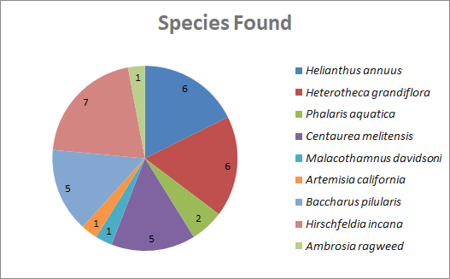
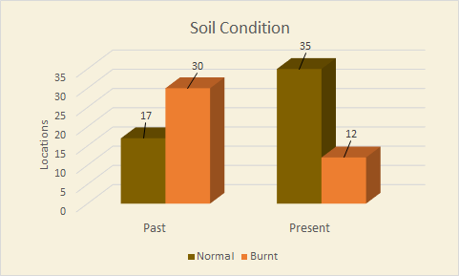
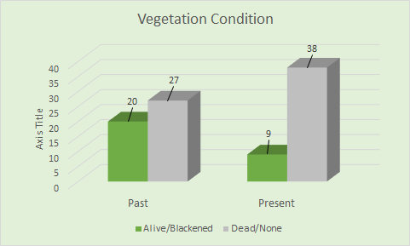
As we analyze the results from our Chi-square calculation, we reject the null hypothesis because in both cases both P-values are less than 0.10. Our findings for soil condition were that we have significant data, strong enough power to avoid a type II error, but our effect size is weak at 0.385 (between 0.2-0.5); this is indicating that our research and data has limited practical applications. The findings for the Chi-Square vegetation condition show us that we have significant data with our probability value being less than our alpha size. The power is close to 0.8 but is slightly less, being 0.791, which we could consider being just powerful enough to avoid a type II error. The effect size for this analysis is also very weak, being 0.253, which also means that our data set is so small that our findings don’t have a practical use in the field. For both chi-square analyses, we had to condense the data to reduce the percentage of expected counts of data to under 20%. The soil conditions were condensed from a 2x3 chart to a 2x2 chart. The vegetation conditions were condensed from a 2x4 chart to a 2x2 chart.
We’ve also included our pie chart and bar charts that show the visualization of the data we’ve collected. The pie chart shows the number of each species of plant we found in the field. The bar charts are showing our data of soil and vegetation conditions compared to the 2019 findings. As is shown, soil conditions have improved since 2019, and vegetation conditions have worsened since 2019.

Discussion

The data analyses show that our findings are significant. Our probability value, or “p-value”, for the soil condition is 0.000. The p-value for the vegetation condition is 0.014. Both p-values mean there is a significant association between fires and the resulting conditions of the soil and vegetation life. Our two analyses’ results disprove the null hypothesis. This means the current conditions are significantly different from those first recorded in 2019, so it is possible both have recovered or changed in some way since then.
In terms of the soil and vegetation regeneration, soil quality has improved since 2019 and vegetation conditions have worsened. This could be a result of soil having the potential to recover in a shorter timespan than vegetation does. Vegetation revival could be minimal due to the lack of water/precipitation in the land we surveyed. According to a study done in Lithuania regarding post-fire short-term vegetation recovery, the speed of recovery for vegetation depends on both the severity of the fire, and rainfall in the area (Pereira 2016). As mentioned earlier, just one year ago there was another fire in Sepulveda Dam under a severe heatwave; it is not too surprising that vegetation conditions worsened since the last study. Most of the vegetation we found alive were along the shaded and watered areas near Burbank Blvd. This could also be due to the time of the year we were out there, which is the end of fall and beginning of winter; most of the species we found were not in the proper season to be green or flowering regardless of their conditions. Vegetation recovery is important not only because of the purposes it serves environmentally, but because Sepulveda Dam is also a recreational and wildlife reserve; many visitors frequent this area to engage in physical activities and enjoy the beauty of nature’s physical appearance.
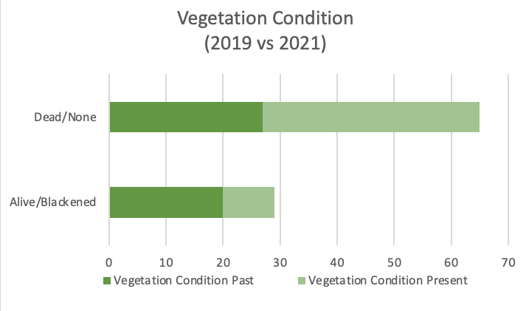
Looking at the bar graph above, it is visible that the ‘past’ data, or the 2019 data, shows there were less areas that had dead or no plants at all. The present 2021 data shows that amount has increased, and the number of alive (whether it be green or blackened) plants decreased. The chi-square calculated value is greater than the critical value (6.034>2.706), so the null hypothesis is rejected regardless. Since 2019, there have been significant changes in the vegetation condition, although it does not seem those changes involved the condition improving. As mentioned in the introduction, keeping track of the vegetation condition’s progress can help to stay informed on the possibilities of Sepulveda Dam ever becoming at risk of floods or landslides. It is possible that the significant changes came from different species of plants growing, or unexpected species. Including the year 2019, there were three fires that ravaged this area, so it is possible the fires were too frequent and not all the usual native species adapted quickly enough to survive. New annuals tend to become better adapted to fire regimes than indigenous species do. To further touch on this point, the species we identified the most numbers of is an invasive species, Hirschfeldia incana, more commonly known as shortpod mustard. It is a perennial herb not native to California. It has been reported that this species accumulates heavy metals and possibly interferes with fire regimes; its seeds are also produced and stored in the soil for years, so it can continue to grow in the future, even after fires, if its seeds are not near the surface (Quiroz 2015). The second species we identified in the most locations was a native annual herb.
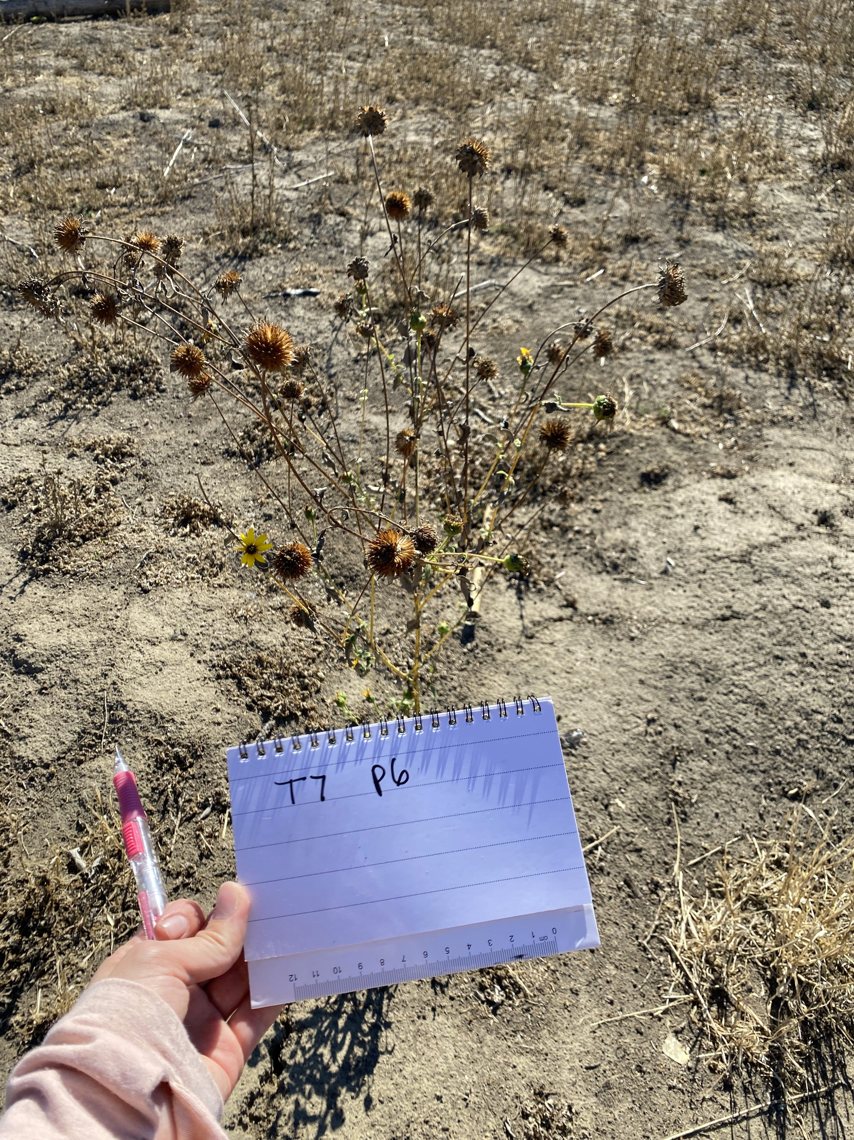
Pictured above, the Helianthus annuus or common sunflower; a native species to California that we found common in Sepulveda Dam (many were in dry or blackened conditions). Overall, more native species were able to repopulate the area than invasive species, but not by much. Here is a chart that visualizes how closely the population counts are:
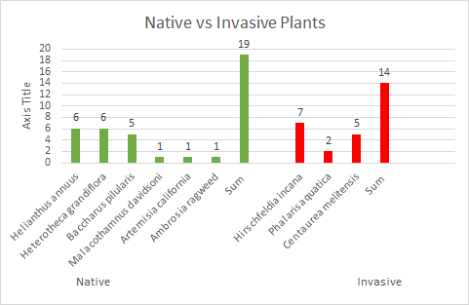
It is important to note that the invasive species that are located within this area can potentially outcompete the native species that are holding on for dear life. As mentioned before, the invasive species Hirschfeldia incana is the individual plant species with the most findings; it is a grass species. Future research can go into seeing how this mustard species is impacting the health of native plants in the Sepulveda Dam Basin.
Soil conditions, on the other hand, have improved since the last study done in 2019 despite there being another two fires in Sepulveda Dam during this time. One of the issues with poor soil condition is that there is a greater risk of runoff in the case there is ever a great rainfall in the area, which could be very damaging to the populated roads surrounding Sepulveda Dam. Our test results show significant findings that the soil condition has been recovering.
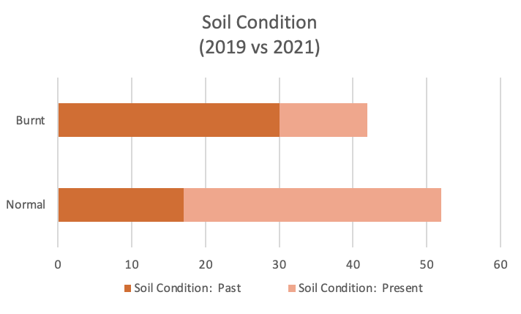
Using the data collected in 2019 and the data we collected in 2021, the bar graph above shows a greater (increased) amount of normal soil conditions in the present. In the past, you can see the burn area was larger than the normal one. To further support this evidence, the chi-square calculated value in our analysis result is greater than the critical value (13.945 > 2.706), meaning we reject the null hypothesis. Our findings do, in fact, support that there have been significant changes to the soil condition since the last wildfire data observed in 2019, and comparing the data in the bar graph above highlights that it has been recovering.
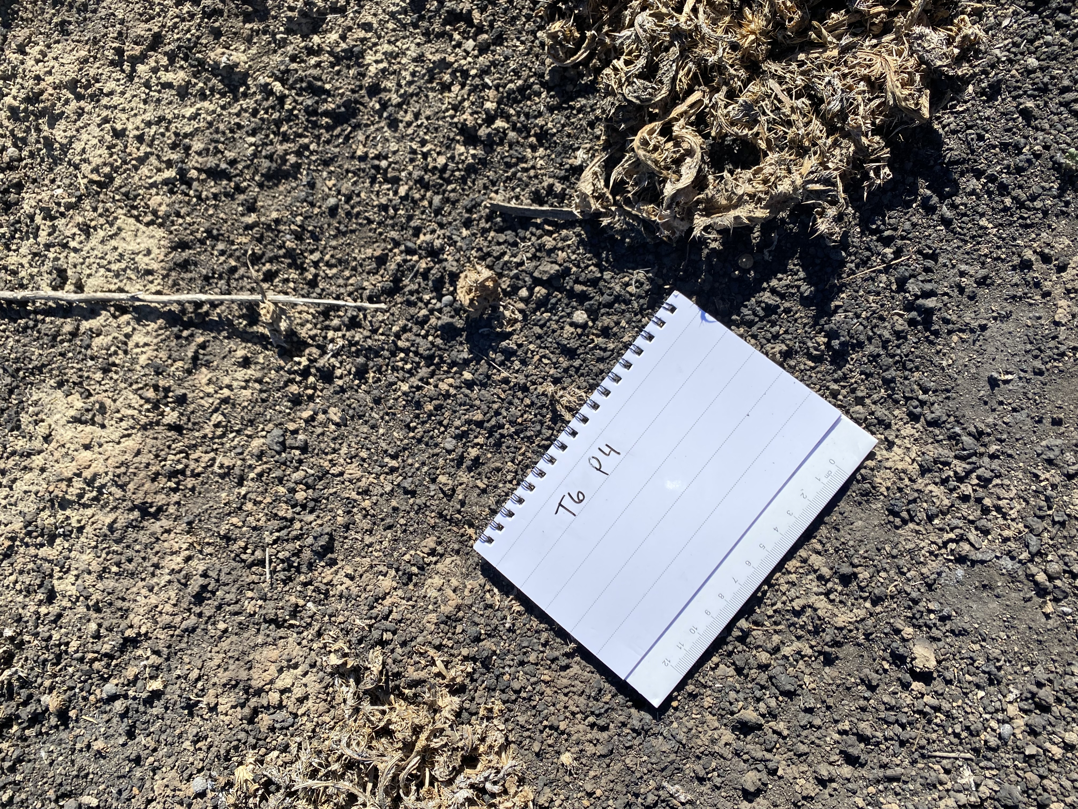
Pictured above although not quite captured with this cell phone image, some visibly burned soil.

Conclusion and Recommendations

In conclusion to our research, we were able to successfully reject the null hypothesis with our chi-square contingency analysis findings. Our research presents the conditions that have changed since 2019; soil conditions show improvement and vegetation conditions show little to no improvement. However, our sample size given to conduct the study was not large enough to use a smaller alpha level, so we agreed on using the larger 10% threshold for our testing. This leaves slightly more room for a Type I error than the smaller 5% does, and slightly increases the probability that the results arose from a “random” chance. To decrease these uncertainties in the future, we recommend increasing the number of students or groups that drive out to Sepulveda Dam for fieldwork, and increasing the number of coordinates to be observed, so that the sample size will increase. Despite using the higher alpha standard, in both tests, our calculated chi-square values are larger than our critical values, resulting in the null hypothesis being rejected regardless. Both p-values were also found to show the findings are significant.
Another inconvenience that arose during this research that might possibly contaminate the work, is unreliability in the technology used during the fieldwork. Our team relied on using cellular phones and GPS applications to find the assigned latitude and longitude coordinates, but we quickly noticed each phone was showing different coordinates using the recommended application even while all standing in the same spot. We resolved this problem by taking the time to search, download, and test out a dozen different GPS applications, and then using two different applications to cross-reference each set of coordinates to make sure they matched in the same areas. Perhaps in the future this problem can be avoided by equipping the Epsilon teams with proper GPS equipment.
To reiterate a bit from our introduction, this fieldwork and research at Sepulveda Dam is important because we need to make sure its soil and vegetation conditions are improving and not declining, especially with the frequency of fires. As climate change worsens and the temperatures increase in Southern California, there needs to be some sort of action taking place so that our native plants are not outcompeted by invasive species which might be harmful to the environment. It is important to plan on having some sort of control for invasive species because they can crowd out key native species, including trees which provide shade and habitat for wildlife (amongst a list of endless positive contributions trees provide for wildlife and humanity). Making sure the soil and vegetation conditions are not degrading at Sepulveda Dam also protects its value and benefits; if we allow those conditions to become too poor, it might affect the local infrastructure. Continuing annual fieldwork and data collection in this area is key so that its progress can continue to be documented and help with the creation of any policies that might be needed in the future.

References
B.C. Ministry of Forests and Range. (2011). Landslide and flooding risks after wildfires in British Colombia. Retrieved from www.for.gov.bc.ca/hfd/pubs/Docs/Bro/Bro91.htm
Bik, L. (2020, September 6). Photos: Fire burns 20 acres in the Sepulveda basin amid 114 degree heat. Retrieved from https://sundial.csun.edu/160321/news/photos-fire-burns-20-acres-in-the-sepulveda-basin-amidst-114-degree-heat/
Pereira, Paulo, et al. 2016. Short-Term Vegetation Recovery after a Grassland Fire in Lithuania:
The effects of Fire Severity, Slope Position and Aspect. Land Degradation &
Development. Retrieved from https://onlinelibrary.wiley.com/doi/abs/10.1002/ldr.2498
Quiroz, Diana. “Hirschfeldia Incana (Shortpod Mustard).” CABI, Invasive Species Compendium,
31 Dec. 2015, www.cabi.org/isc/datasheet/114820.

