Charmlee Lab Report Fall 2021
Team Beta

Intro:
Vegetation recovery from wildfires is an important regime of mediterranean ecosystems. In 2018, Charmlee Park located in the Santa Monica Mountains was burnt down by the Woolsey Fire. Since 2013, students from CSULB Geography 330 have gathered in teams to study the change in diversity of Charmlee Park. In our recent study done by Team Beta’s 2020 research team, we identify the difference in species diversity between past plant species data and current data within the unstable zone located in the East Meadow of Charmlee Park. The presence of coastal sage scrub in this region is tolerant to fires which makes it adaptable to the changing ecosystems after wildfires. In relation to O’Leary’s article (1990) our study addresses the change in species diversity of the East Meadow corresponding to previous years pre-fire data. By addressing the change in plant species' location and quantity our team can identify the changes in species diversity post-fire and allow for future studies of change over time.

Research/Hypothesis:
Through collecting plant species data, our team observes the species diversity among the East Meadow of Charmlee Park. By comparing the previous Geography 330 team’s plant species data to the current data collected, we can distinguish the change in species diversity over the years and post-fire. Our alternative hypothesis states that there is a statistical difference in the change of species diversity between past and present data. More directly, if we compare previous years data to our teams data, there would be a difference in the species diversity within the East Meadow. This in turn shows a change in plant species over time as conditions are more applicable for different species. In contrast, our null hypothesis states that there is no statistical difference in the change of species diversity between past and present data.

Data Methods:
The data we are using for our hypothesis has been collected by the four members of group Beta. Data was collected on a small portion of the East Meadow Trail located in Charmlee Park. Methods included GPS garmins, transecting tape, plastic baggies, and sharpies for unknown species collection. Due to lack of cell towers in the area our cell phones were marked with “no service” and became almost totally unusable, luckily we are still able to take photos despite having no service. Since we could not rely on our phones, we relied entirely on the GPS garmins. With the GPS we were able to find all latitude and longitude coordinates and take down the elevation as well. After finding the correct coordinates two of us stood and each held one end of the tape. Walking along the tape the botanist identified each of the species along each meter mark of the tape. At one point we thought we were getting lucky with getting service, when standing on a particularly tall rock some group members were able to achieve one bar of service. Unfortunately that single bar was not strong enough to access the internet. Without the proper identification tools ,such as calflora, we were unable to identify the plants immediately. Some educated guesses were made, but they were not officially identified. We wanted to be 100% entirely sure we had properly identified the plant before officially labeling it. We took a sample of every plant that we identified along the transact tape and used the baggies to store them safe and marked each one “unidentified plant #1”, “unidentified plant #2” and so on and so forth. We came out with a total of ten unidentified species that had been found along the transect tapes in the eight transects we did. One particular concern we had with our methods is that one of our GPS garmins ,specifically unit Y1107 was giving highly variable elevation measurements. A lot of the times the elevation it was measuring did not seem accurate so we chose to rely entirely on our other GPS garmin, unit Y1109, which was giving seemingly accurate elevation measurements. Other than that we had no other issues and the rest of our transecting went smoothly.

Processing Data:
Once we had finished transecting all eight zones of coordinates, we collected all of the unidentified plant objects (UPO) we had in the baggies. I took all of the plants home where I could work better to identify them. Using a combination of both the app “iNaturalist” and the website “Calflora”, I was able to efficiently and easily figure out the identifications for all of the specimens. iNaturalist is a “social network of naturalists, citizen scientists, and biologists built on the concept of mapping and sharing observations of biodiversity”(iNaturalist.org). I used the iNaturalist app to upload pictures of the ten different critters I had taken pictures of while out in the field. From the photos I uploaded I was able to get multiple suggestions of what species the plant could be based on what the plant looked like and also on what other users have found in the area. I then took that information over to Calflora. On Calflora I drew a polygon on the map over the area of Charmlee park to ensure that I would only be getting a search result of the desired critters that lived in the park. I took all of the species suggestions I got from each photo on iNaturalist and crossed over to Calflora. By using *command+F I was able to easily search and look for all of the suggested species names for each critter. For every photo I uploaded on iNaturalist I was able to cross check and find a suggested species that was in fact confirmed to be living in Charmlee Wilderness Park by looking at Calflora. I even had some other iNaturalist users agree with my findings and confirm that I had the correct species depicted in my photo posts. Using this method of combining the tools of iNaturalist and Calflora made it extremely easy, efficient, and fun to figure out what critters I had encountered out in the field. Finally, when I got back to school I had professor Rodrigue confirm all of the ten specimens I identified to be sure they were the correct identifications, and they were :). I then transferred all of the proper species names into the transect data sheet filling out latitude, longitude, elevation, and the garmin used as well. After finishing the hard paper copy I then further transferred the data onto an excel spreadsheet so that all of the transect information could be easily shared and managed by my fellow teammates.

Technique:
To assess the validity of our data and hypothesis, we used a chi-square analysis using the data from our predecessors and our newly collected data. The transecting done by our predecessors was conducted in 2013, so there is an 8 year gap in the data. Using the values from the analysis, we can determine the effect size, the appropriate alpha and p-value, and if the null hypothesis is true or false. The power determines if there is any risk of a type II error, and since our percentage of expected counts is at 20%, an alpha of 0.05 is appropriate and limits the risk of a Type I error.

Results:

Values: Comparison: Result:
Alpha: 0.05 | P-value: 0.000 | 0.05>0.000 | Throw out the null hypothesis. Data is significant. Risk of type I error is minimal.
X² calc:25.901 | X² crit: 9.488 | 25.901>9.488 | Throw out the null hypothesis. Data is significant.
Effect Size: 0.410 | 0.2-0.5= weak | 0.401≥0.2 | Strength of effect is weak. Data is scattered.
Power: 0.992 | >0.8 mitigates Type II error | 0.992>0.8 | Risk of Type II error is minimal.
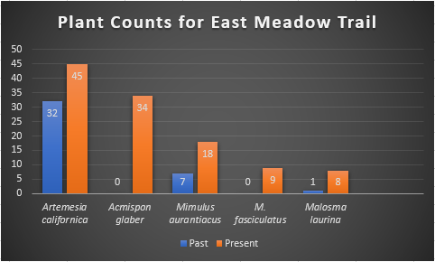
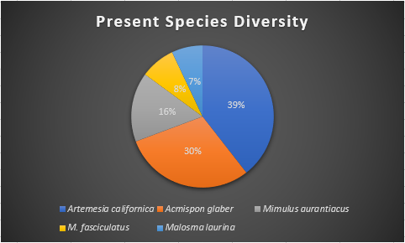

Discussion:
Through data analysis using Chi-Squared we were able to calculate that the alpha is a greater value than that of the P-value (0.05>0.00) and that X^2 Calculated is a greater value than our X^2 Critical value (25.901>9.488). Due to these results we are able to determine that we must accept our alternate hypothesis and reject our null hypothesis, indicating that there is statistical significance expressed by the past and present data. With an effect size (Cramer’s V) of 0.410 we are able to determine that the association of our results is weak, indicating that our data is scattered. This tells us that any small changes in the data may have significant effects on the results. The power represented in our data is 0.992, knowing that a power greater than 0.80 would likely avoid a type II error, we can determine that a type II error is not likely to occur in our alternate hypothesis. This means that we can trust the findings of the significant difference in our predecessor’s data and ours. Reflecting on our sample size we can infer that a greater sample size would strengthen the association of chaparral species in the unstable area.

Conclusion:
The comparison of past and present data tells us that we can reject the null hypothesis, which states there is no statistical significance between past and present data collected. We are able to establish that a Type II error is not likely to occur as the power, 0.992, is greater than .80. This suggests that rejecting the null hypothesis was the right thing to do. The resulting conclusion is that there is statistical significance between past and previous data collected at the unstable zone on the Northwest side of CSS “lump” in the east meadow at Charmlee park. The significance of the data was strong but because the strength of effect is weak, collecting more data in the future would aid in obtaining a more conclusive result. This will be much more achievable as the chaparral area continues to recover from the Woolsey fire of 2018.

Work Cited:

O'Leary, John F. “Post‐Fire Diversity Patterns in Two Subassociations of Californian Coastal Sage Scrub.” Wiley Online Library, John Wiley & Sons, Ltd, 24 Feb. 2009, onlinelibrary.wiley.com/doi/epdf/10.2307/3235656.

