Final Project: Charmlee Park Stable (Alpha) CSS Boundary
Geog 330
Fall 2021
By: Emiliee Estrada, Abygail Jimenez, Valerie Radford, Hailey Wick

Introduction:
Wildfires in the state of California were once a greatly debated topic in regards to the state’s climate. Were they anthropogenic, or had they occurred prior to the settlement of humans on the land? Currently, wildfires are considered commonplace and necessary for native Californian vegetation, but due to fire management in place, have been increasing at an alarming rate.
California is home to many forms of vegetation, including California Sage Scrub (CSS) and Chaparral. Both are fairly similar, and are often found in similar areas. The main difference between the two lies in the root systems, where the Chaparral vegetation has deep root systems and CSS has shallow roots. Another characteristic that notes the difference between the two would be that CSS exhibits drought deciduousness, while Chaparral does not. (Berger, Wolf, 3). Both shed organic material which is highly volatile, which may have contributed to the reach of the Woolsey fire.
The fire ignited on November 8, 2018 and continued to burn approximately 96,949 acres of land across both Los Angeles and Ventura counties. Among the areas affected by the wildfire was Charmlee Park in the city of Malibu, which experienced a massive decrease in CSS. We went out to collect data on the vegetation present along the stable south side of the CSS lump in the East Meadow in order to compare it to the data collected in spring of 2014 before the fire.
The null hypothesis for this experimental analysis would be that the stable boundary of California Sage Scrub did not demonstrate a significant difference in vegetation growth after the Woolsey Fire. The alternate hypothesis for this experimental analysis would be that there in fact was a significant difference in vegetation growth or that there was evidence of secondary succession occurring along the stable boundary of California Sage Scrub after the Woolsey Fire.

Data and Methods:
Primary and secondary data were both used for this analysis. The data acquired was primary data, collected on November 7, 2021. It was collected through the use of three individual GPS sources and a map of Charmlee Park in Malibu, California. The site is located by the East Meadow Trail and stable boundary, which was previously determined by students of Spring 2014.
Using a tape measure approximately twenty meters long, two team members stood at either end of the coordinates indicated in the data from our predecessors, while another walked down the measure and stopped at every meter to observe the species present at the mark. After determining the species, it was recorded at its corresponding measurement. This was repeated for eight individual transects.
A Chi square analysis was used, as it can handle frequency data. The effect size was calculated using Cohen’s w while the strength of association between the fire and appearances of new plant species along the stable boundary was calculated by Cramér’s V.

Results:
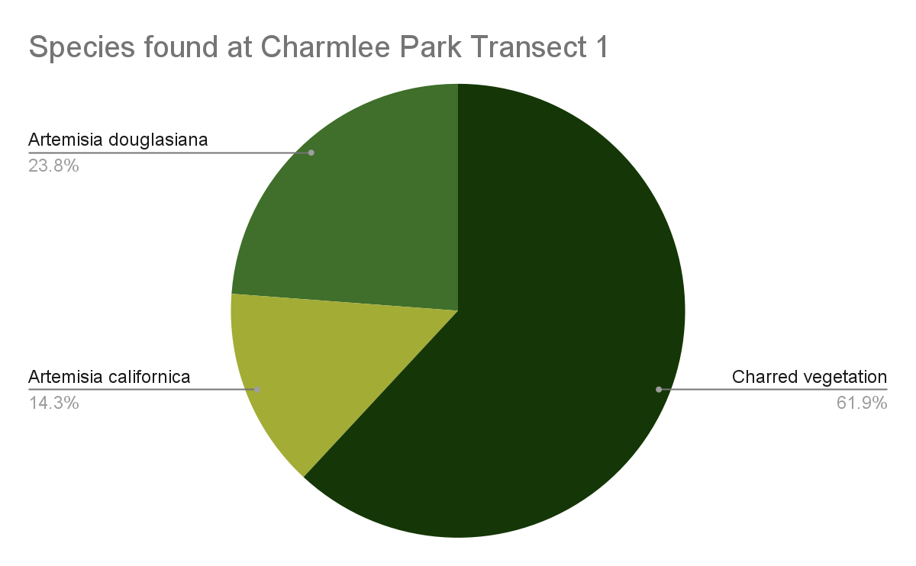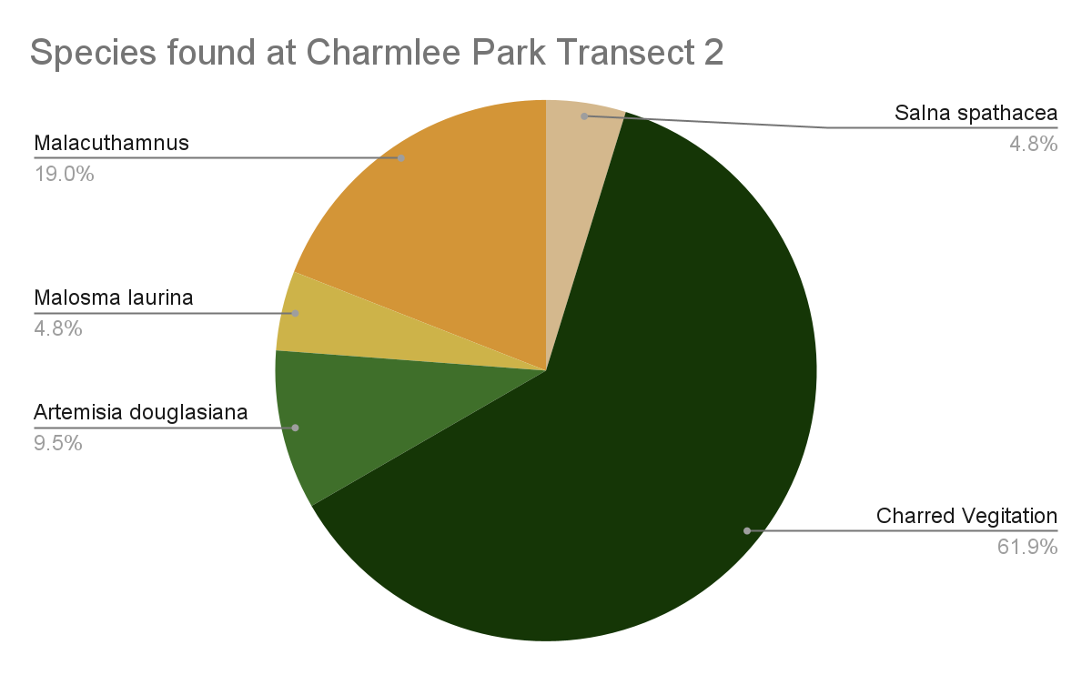
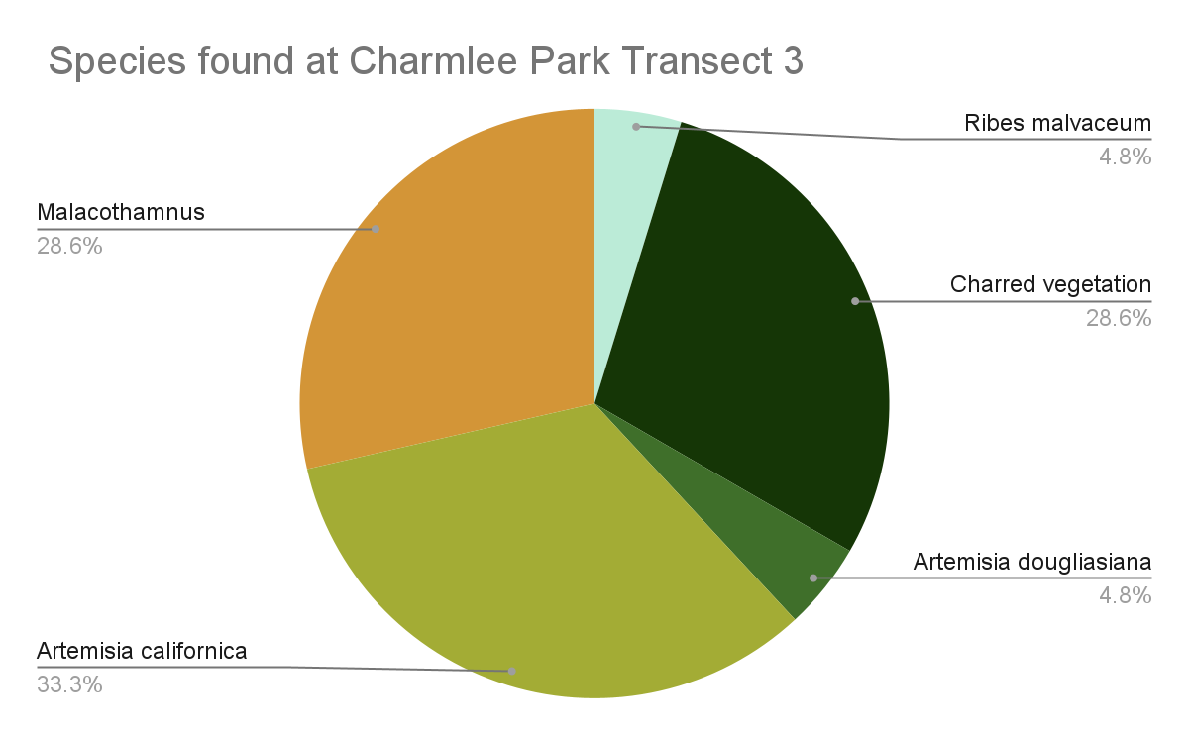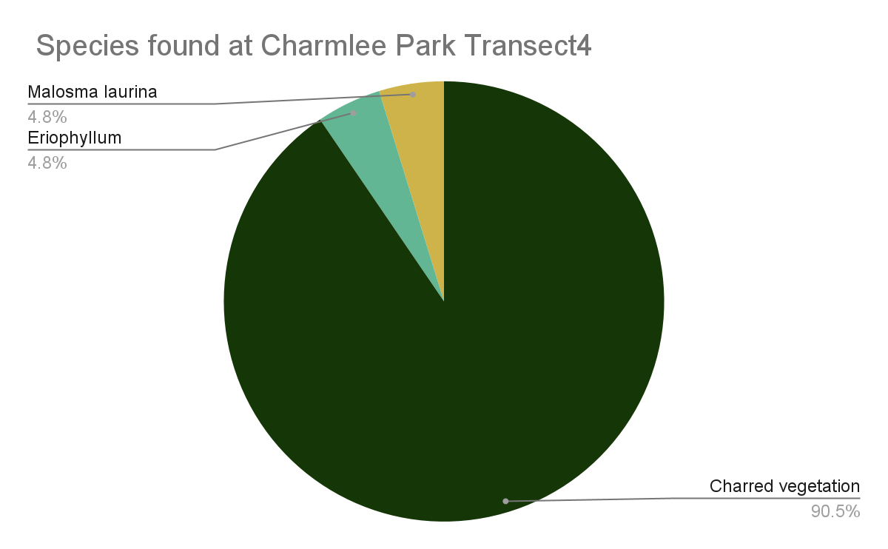
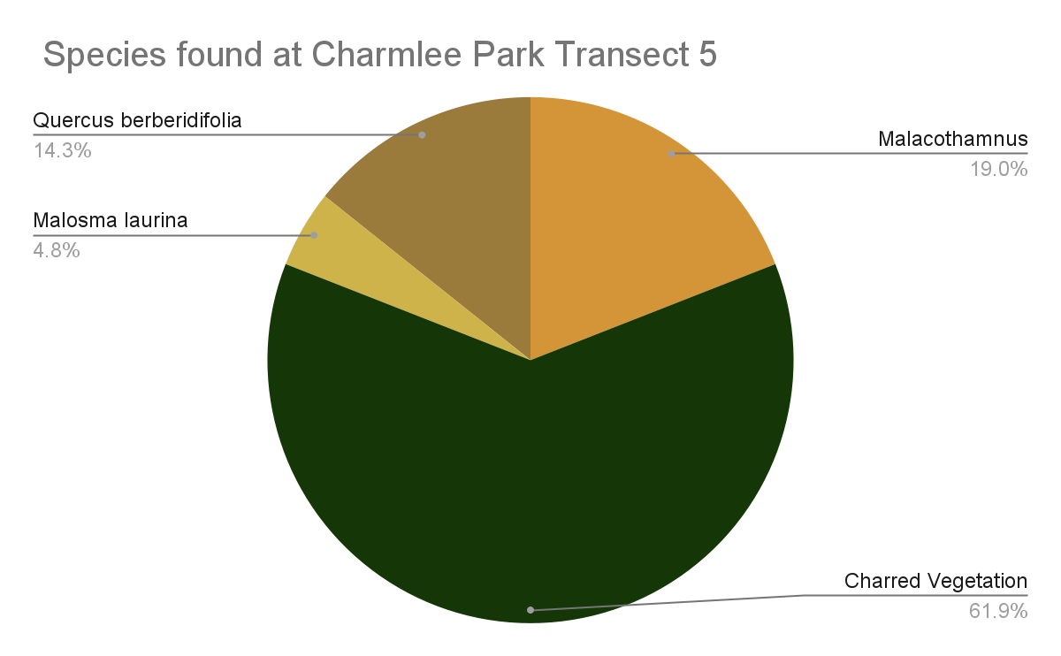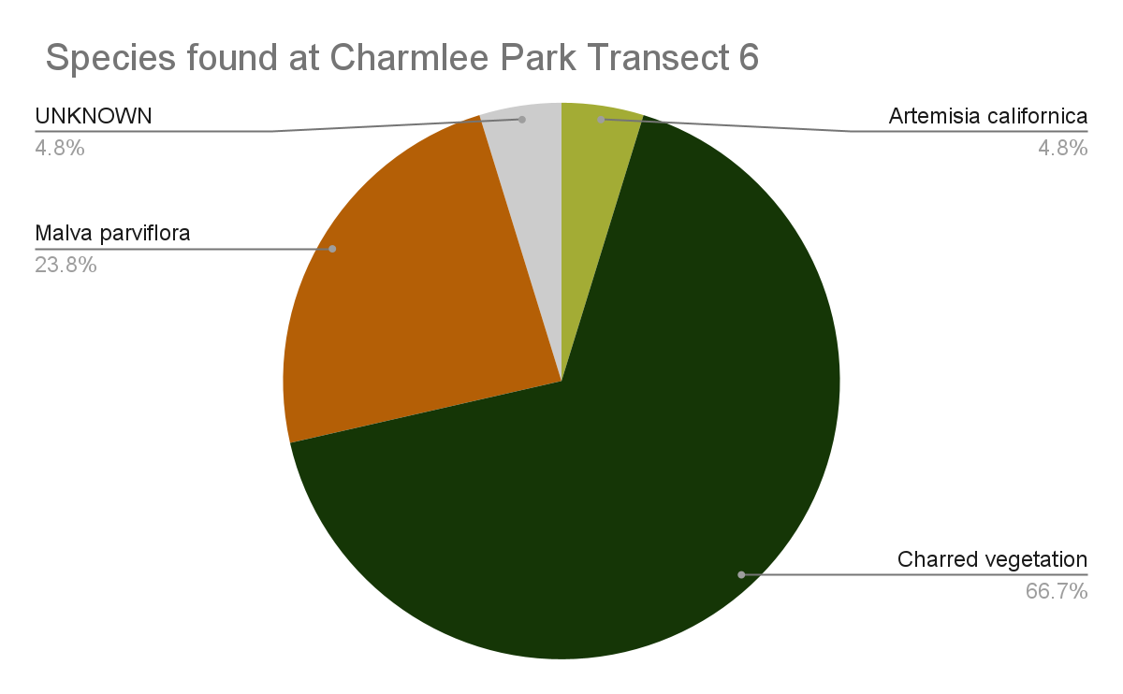
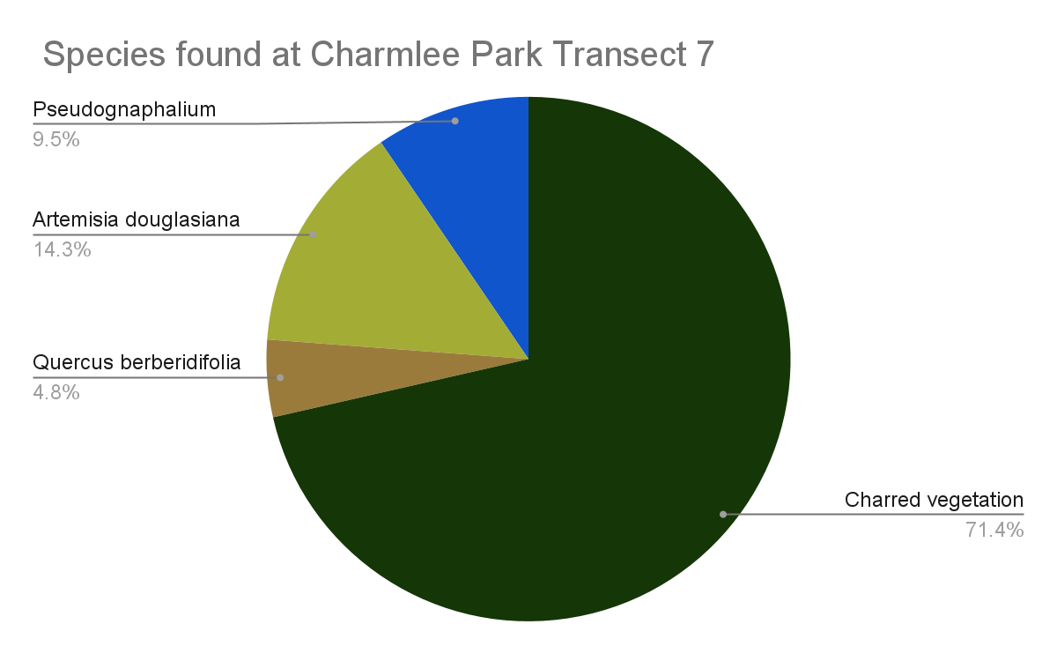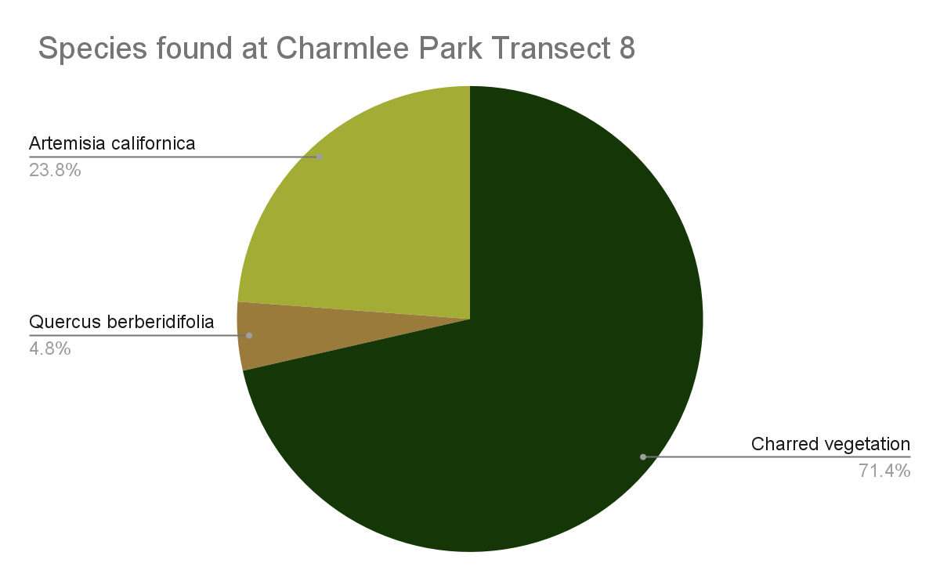

Cell | Observed (O) | O^2 | Expected (E) | O^2/E |  | - | -
a | 16 | 256 | 32.025 | 7.994 |  | - | -
b | 22 | 484 | 5.975 | 81.006 |  | X^2 calc | 70.229
c | 103 | 10609 | 86.805 | 122.216 |  | alpha | 0.05
d | 0 | 0 | 16.195 | 0 |  | df | 2
e | 15 | 225 | 15.17 | 14.832 |  | X^2 crit | 5.991
f | 3 | 9 | 2.83 | 3.18 |  | prob. | 0

K (min r or c) | 2
(effect size measure) Cramér's V | 0.665
(effect size measure) φc | 0.665
Cohen's w | 0.665
Noncentrality (λ) | 70.229
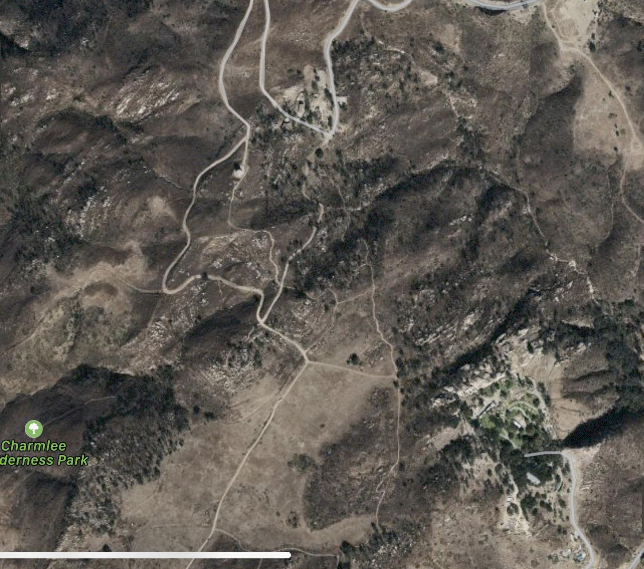

Figure 1: Satellite image of Charmlee Park
Source: Google Earth
Caption: This is a Satellite image of the Charmlee Park California Sage Scrub (CSS) stable (alpha) boundary where eight transects were taken and data was recorded.

Discussion:
With a greater calculated value of 70.229 and a smaller observed value of 5.991, we are able to reject the null hypothesis. Furthermore, with a P value of 0, saying that the likelihood of the null being true is nonexistent, we can verify that our hypothesis that the boundary of CSS will display a significant difference in vegetation after the fire was correct. The 0.665 effect size, indicating that we had a strong association, and having a power of 1, indicating that we are able to avoid making a type II error, confirm that we had enough data collected in order to validate our hypothesis. A majority of the species we found were fire-followers, annual or perennial herbs that grow mainly in the years after a fire has occurred. The Woolsey fire seems to have allowed those seeds to germinate, allowing us to see them in abundance alongside returning species of shrubs. The great number of Artemisia californica and Malacothamnus fasciculatus further indicate the ongoing restoration process of the burned CSS. Many of the shrubs that we encountered were sprouted straight from the burnt stumps of their parent plant, displaying one of CSS’s many adaptations to fire. This was also able to show us that the distrubed land would not be converted to grasslands, further depleting Southern California’s CSS patches, as a truly devastating and/or repetitive fire pattern would not allow stump sprouting or seed bank accumulation to occur. Our findings indicate a positive outlook for the future restoration of this CSS patch.

Conclusion:
The calculated power for this study was equal to 1, meaning that there is a statistically significant difference between the vegetation found at this location before and after the fire occurred. Though the statistics do not point to a requirement for more data to be collected, there should be more collection as time continues to pass and the restoration of the landscape continues. Further collection would keep track of the species currently present, and potentially make note of the species that have yet to grow. A possible source of error would be the general categorization of charred vegetation; as it was difficult to identify what species they may have once been. It is very possible they may have once been a species identified by our predecessors data, thet we failed to identify due to its physical damage.
For those who are responsible for collecting future data, obtaining multiple reliable forms of GPS would be ideal, as there may be inconsistencies across them. Another detail of importance would be that the trails are not properly marked, so keeping a map of the trail (digital or physical) will be of major assistance.

References

Westman, W.E. Diversity Relations and Succession in Californian Coastal Sage Scrub Ecology, Ecological Society of America, 62, 1.

O’Leary, J.F. Post-fire diversity patterns in two sub associations of Californian coastal sage scrub Journal of Vegetation Science, 1, 2.

Berger, Wolf. On “CHAPARRAL” versus “COASTAL SAGE SCRUB” in San Diego County Scripps Institution of Oceanography Technical Support.

