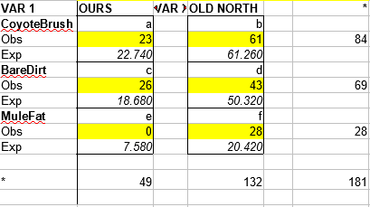
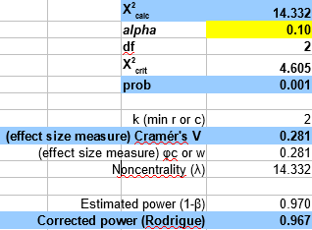
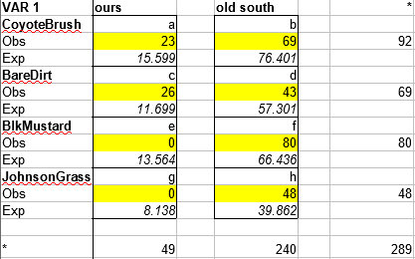
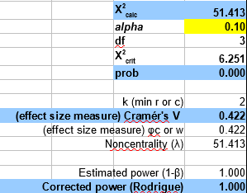
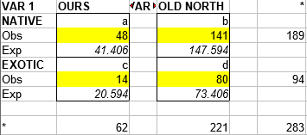
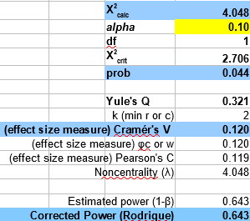
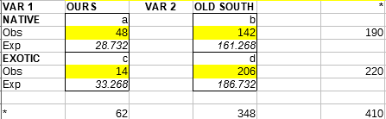
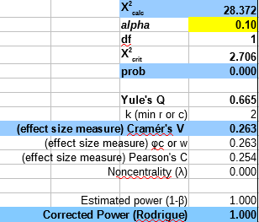
Veronica Allen
Zachary Hernandez
Tony Gonzalez
Curran Miller

Introduction:
For this exploratory study, we collected data from the Sepulveda Dam in order to look at the progress of restoration of CSS in the South Reserve of the dam. The Sepulveda Dam is located in the center of the San Fernando Valley, in Southern California. It is a project of the Army Corps of Engineers that was originally built in response to the floods of 1938 that killed over 115 people. The dam was built as a precautionary approach to prevent future damages from flooding of the Los Angeles River. While the dam has benefits such as flood control and recreation, its construction has threatened the surrounding landscape and ecosystem and may have created everlasting impacts.
In particular, the restoration of CSS, or California Sage Scrub, is of interest in this study. CSS is scrub vegetation that is composed of smaller shrubs and subshrubs, such as Baccharis pillularis, or commonly known as Coyote Brush. It is mostly dominated by drought-deciduous shrubs and exhibits a grey to tan color during summer months. It is found along the coast of Southern California, as well as inland in places such as the San Fernando Valley. CSS has been declining at a substantial rate, with only about 10-15% of original vegetation left. This decline is likely due to plowing, construction, grazing, clearing, fire, and air pollution. There have been efforts to restore this vegetation, some successful, like the Trump Golf Course, and many unsuccessful. The Army Corps of Engineers has begun the restoration of CSS on the Sepulveda Dam. The South Reserve was the first part of the Sepulveda Basin to be restored with California native plants. The original plan consisted of four main management areas: a grassland habitat, riparian woodland, coastal sage scrub, and aquatic habitat. These areas were planted from 1979-1984. In our study, we compared the primary data we collected in the South Reserve to secondary data collected by our predecessors in order to investigate two hypotheses; there is a difference in mix of dominant species between our observations and previously collected data, and that there is a significant difference in the mix of native species and exotic species for both the North and South Reserve.
Materials & Methods:
In order to collect data points along the South Reserve, we used a 10 meter transect line to conduct eight ten-meter transects throughout the South Reserve. We used a Garmin GPS and an iPhone GPS to record the latitude, longitude, and elevation at the start and end points of each transect and recorded these on a data sheet. To help identify the species, we referenced a species reference list given to us by Professor Rodrigue. After collecting data, we processed the results in OfficeCalc Libre using the chi-square method to get the chi-square critical and calculated value, and with these values we were able to obtain the effect size, probability, and corrected power.
Data & Results
For this study we felt it was appropriate to use an alpha standard level of 0.10 to avoid a Type I error of falsely rejecting the null hypothesis. A Chi-Square analysis was employed to evaluate comparison and association between the species observed in the South Reserve of the Sepulveda Dam and previous observations collected by our predecessors. Once our data was recorded, we logged them into a into an Open Office Libre spreadsheet that contained data from previous studies over a four period. We totaled the counts of every species that was identified and found an overwhelming amount of Baccharis pilularis, coyote brush, with twenty-three counts, and bare dirt with twenty-six count in our observation.
After calculating the total number of species from the North Reserve and our observations of the South Reserve we found eighty-four counts of Baccharis pilularis, sixty-nine counts of bare dirt, and twenty-eight counts of Baccharis salicifolia, mule fat, which was not present in our study area. Despite not having more than thirty counts for Baccharis salicifolia we felt it was necessary to use it in our three by three chi-square table. The column on the right identifies the total number of observations from the North Reserve from previous studies while the column on the left is our number of observations of the South Reserve in our study. Variables “a,” “c”, and “e” are Baccharis pilularis, bare dirt, and Baccharis salicifolia respectively. With an alpha of 0.10 the three by three chi-square table generated an X²_{cal} of 14.332 and an X²_{crit} of 4.605, indicating that there is a significant difference of dominant species between the North and the South Reserve. Our probability value of 0.001 was greater than our 0.10 alpha standard. Lastly, our Cramer’s V effect size was 0.281 and our corrected power was 0.967.
When comparing the mix of dominant species found in the South Reserve from previous studies versus versus our recent fieldwork of the South Reserve we found a total of ninety-two counts of Baccharis pilularis, sixty-nine counts of bar dirt, eighty counts of Brassica nigra, and lastly, forty-eight counts of Sorghum halepense. During our study we did not encounter any counts of both Brassica nigra and Sorghum halepense. We employed a two by four chi-square table for this analysis. The column on the left is the number of our species collected in our observations and the column on the right is the sum of species found in the South Reserve from our predecessors. We obtained an X²_{calc} of 51.413 which was significantly higher than our X²_{crit} of 6.251. Our 0.10 alpha was higher than our probability of less than 0.0001. The Cramer’s V effect size was 0.422 and our corrected power was 1.000.
For further analysis for the South Reserve of the Sepulveda Dam we looked at the mix of native and exotic species between the North Reserve and our observations. In total, we found 189 counts of native species and ninety-four counts of exotic species. Again, we felt it was necessary to use a chi-square table to conduct our analysis and use an alpha level of 0.10. We input the counts into a two by two chi-square table and obtained the following values: X²_{calc} of 4.048; X²_{crit} of 2.706; probability of 0.044; Cramer’s V effect size of 0.120; and corrected power of 0.643. Our calculated value was greater than our critical values indicating that there was a significant mix of native and exotic species between the data collected from our predecessors in the North Reserve and our study of the South Reserve.
Lastly, we conducted the same analysis previously discussed, but comparing the mix of native and exoitc species between our study and the past data collected from our predecessors of the South Reserve. In total, we found 190 counts of native species and 220 counts of exoitic species. The two by two chi-square table generated an X²_{calc} of 28.372 and an X²_{crit} of 2.706. Our alpha of 0.10 was greater than our probability of less than 0.0001. Our Cramer’s V effect size was 0.263 and our corrected power was 1.000.
Discussion:
Our analyses prompted us to reject the null hypothesis in all four tests that we performed. In our first test, we compared the South Reserve of the Sepulveda Dam Basin to the North Reserve. Where the North Reserve is considered to be a prime example of California Sage Scrub (CSS) restoration, the South Reserve has only recently begun to be restored in terms of CSS vegetation. Our analysis indicated that there is ongoing CSS restoration in the South Reserve of the basin. When compared to the North Reserve, the South Reserve study indicates that there has been improvements in the growth of CSS. Essentially, the South Reserve is starting to become more similar to the North Reserve when considering CSS vegetation. The next test we conducted compared our data in the South Reserve to the data collected by our CSULB predecessors at the same study site. Our analysis indicated that there have been significant improvements in the restoration of CSS in the South Reserve of the Sepulveda Dam Basin between the time our predecessors transected and our study. This shows that restoration efforts in the South Reserve are producing favorable results, and the status of CSS in this particular environment is improving. When comparing native species in this environment to exotic/invasive species, we analyzed our observations and those of the North Reserve. Our test showed that there has been a significant difference in the ratio of native plants to exotic/invasive species. Furthermore, when comparing our observations on the conditions of native plants and exotic/invasive species to the data published by our predecessors in the South Reserve, we can conclude that there have been significant changes in the content of this vegetation, and native species are beginning to flourish in this environment. These findings indicate that there are significantly more native plants than exotic/invasive species. This is a tell-tale sign of successful CSS restoration. A noteworthy result from our study is that there were less exotic/invasive species than native species, partially due to the thriving number of Baccharis pilularis (Coyote Brush). External factors such as plowing, trash/debris, vagrancy, and homeless encampments could be mitigated in order to foster the further growth of CSS in this environment.
Conclusion:
The purpose of this exploratory is to evaluate the progress of CSS restoration in the South Reserve of the Sepulveda Dam following the dam’s construction. We compared our collected data to secondary data from previous classes that studied the South Reserve to determine much the landscape has improved with regards to CSS compared to our predecessor’s data. By using the information gathered from the chi-square analysis, we concluded that our data is significant, therefore were able to reject the null hypothesis. The landscape in the South Reserve of the Sepulveda Dam was mainly occupied by Baccharis pillularis.
Because the North Reserve is a perfect example of CSS restoration, we compared our data to that of our predecessors and were able reject the null, implying that our data is significant. According to our results, there are specific plants found only in the South Reserve that are not found in the North Reserve such as Arundo donax and Phalaris aquatica. In total we found 7 plant species only distributed in the South Reserve. We concluded that this may be due to the plowing involved in constructing the dam, which disturbed the general area, allowing invasive species to grow and flourish. We also observed that Baccharis salicifolia is only found in the North by the riparian area, so both the South and the North reserves have species that are exclusive to each site.
Comparing our data to our predecessor’s data in the South Reserve, we found that there was more Baccharis pillularis in our transects than in that of the previous class, showing Coyote Brush as the dominant species in our findings. This may be because the plowing for construction cleared the landscape and allowed the Coyote brush to dominate. Also, when comparing our data to previous data from the South, we found that there were less exotic plant species than previous classes. This was either due to the season, where many of the exotic plant species die off, or because of the abundance of CSS Baccharis pillularis.
The area with the most diverse findings was the riparian area. This was not a surprise to us because we know that riparian habitats are characterized as highly dynamic due to flood and fire cycles and general geologic stability. This area is where we found most of our invasive species and a new species Silybum mariamum. We believe that this effect was caused by these plant species being so close to the water and possibly bringing in new plant species via water transportation.
Our recommendations for future CSULB groups examining the Sepulveda Dam South Reserve would be to only be transect and analyze the site every year and in the spring season, making it easier for future classmates to identify plants and focus on the riparian area, where we found the two new species, Silybum mariamum and Camissoniopsis robusta. We recommend every year because there might be new species introduced in that period of time and most of our data showed plant species identified were CSS. Also, every year to see if Baccharis salicifolia which is only found in the north, has finally developed in the South Reserve. The study should also only be done during spring semester due to seasonal conditions making the landscape dry and hard to identify plants. This factor could have affected the data because in our transects, most of what we identified was Baccharis pillularis and bare dirt.

