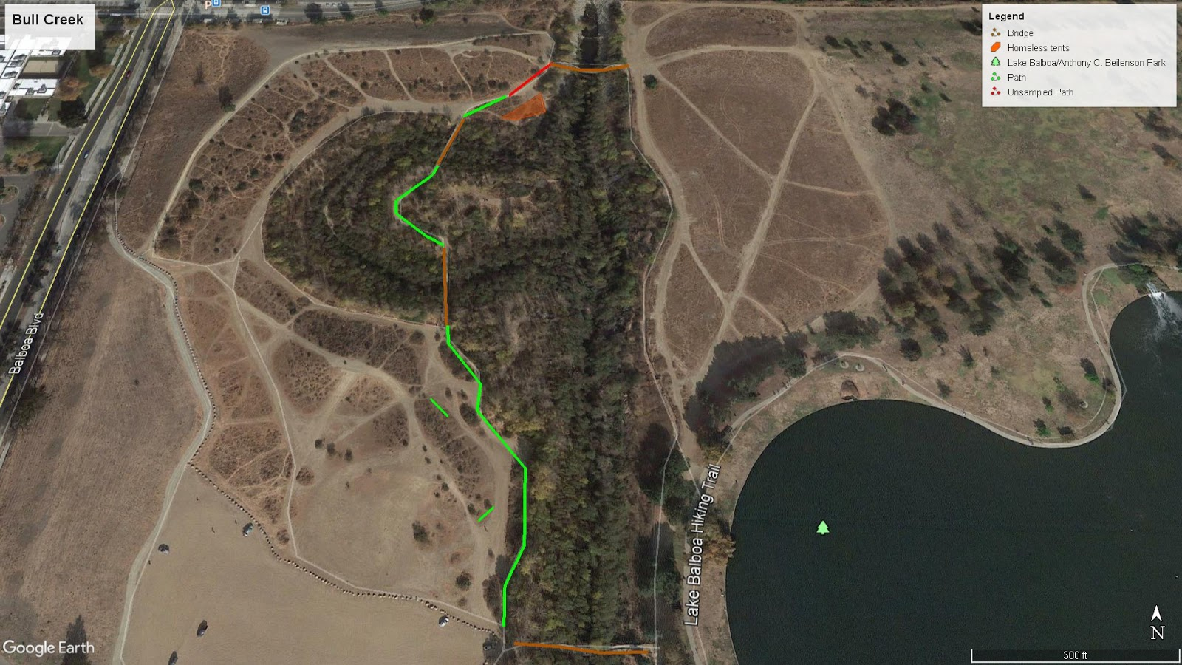
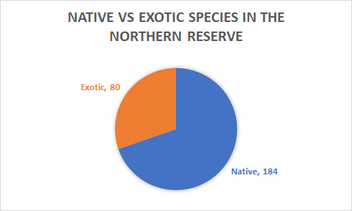
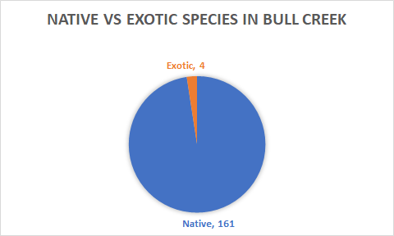
Angel Bautista
Zoi Konstantopoulou
Arturo Rosendo
Nicole Witzigman
GEOG/ES&P 330

Introduction
This project was conducted at Sepulveda Basin Wildlife Reserve and specifically at a location just west of the Balboa “Lake” called Bull Creek. In 2008 The city of Los Angeles and the Corps of Engineers developed a restoration plan for Bull Creek which aimed to restore native riparian vegetation. The focus of this paper was on riparian vegetation and the purpose was to interpret new data and compare data collected by students in the past at the Northern Reserve using a chi-square test. Riparian vegetation occurs in the interface between land and water bodies and are one of the fifteen terrestrial biomes on Earth. Even though riparian zones can be diverse, shared ecological characteristics of these ecosystems include nutrient and water cycling, hydraulic function and flora and fauna population. Our first null hypothesis was that there is no significant difference between the dominant species mix of the data our group collected and the data of our predecessors’. Our second null hypothesis was that there is no significant difference in native vs exotic species between our data and our predecessors’.
Data and Methods

We started transecting near the parking and worked our way north along the trail before we reached the first bridge. We obtained 5 transects in this first area and found mostly Baccharis salicifolia. We then moved past the first bridge and into the middle area between the two bridges where we collected a total of 5 transects. We found the most bare ground in this area, but not from a lack of species rather there was much space between each plant on both sides of the trail. This middle area was also the most diverse of the three and it is where we encountered the exotic Sorgum haleponse and the most tree species like Populus fremontii (Fremont cottonwood) and Salix exigua (Narrowleaf willow). The final area we transected was past the second bridge and where we found the most Salvia leucophylla (Purple sage). This also happened to be the only place where we found Heteromeles arbutifolia (Toyon). Unfortunately, we did not finish this path as we had planned because of the increasing homeless population.
This was a big problem when transecting that most likely has affected our outcomes because we did not fully survey the final path. While transecting we observed many homeless living in tents and under the bridges as well as walking in areas off the trail. We were forced to turn back after increasing amounts of encounter with them around the 11th transect. We started collecting more samples along the middle path and our start path, but on the opposite side of the trail we had originally sampled.
In order to determine if species mix and native versus non-native mix were significantly different, we used a chi square analysis. Since chi square checks for frequency between samples we used our collected Bull Creek samples and the Northern Reserve samples collected by our predecessors in Sepulveda Dam. We were only able to compare 3 species in our species analysis mix and they were Salvia leucophylla, Baccharis salicifolia, and bare ground. In Bull creek we collected 20, 45, and 81 samples. In the Northern Reserve our predecessors collected 4, 28 and 43 samples. For our native versus non-native mix analysis we used the raw counts of 161 native and 4 non-natives in Bull Creek versus North Reserves 184 native vs 80 non-natives.
Results
We were able to identify 10 unique species in the area and collected a total of 165 samples. However, what was most abundant in the area was bare ground followed by Baccharis salicifolia (mule fat) and Salvia leucophylla (Purple sage). All plant species in the area we collected our samples were native except for 1 species which was Sorghum haleponse. We encountered this species a total of 4 times during 2 separate transects in the area.
For our chi square analysis of the species mix between Bull Creek and the Northern Reserve, we got an X2calculated value of (3.859), an X2critical value of (4.605), a p-value of (0.145), and our alpha level set to (0.1). With the combination of the four values we are unable to reject our null hypothesis and conclude that there is no significant difference of species mix between Bull Creek and the Northern Reserve. From this analysis we were also given Cramer’s V. This value varies from 0 to 1, and the closer it is to 0, the less association the two variables have between each other. Our effect size value is (0.132) meaning that there is little association between our two variables. Finally, we are given the power of our analysis, and our corrected power value is (0.528). Our study is underpowered as any power under 0.80 is considered powerful.

X2calc | 3.859 | (effect size measure) Cramér's V | 0.132
alpha | 0.1 | Corrected power (Rodrigue) | 0.528
df | 2
X2crit | 4.605
prob | 0.145
From the data obtained from our transects we were able to identify amount of native species and exotic species found in Bull Creek. To compare our restoration site to the Northern Reserve, we analyzed our predecessors’ data and also looked for the amount of native and exotic species found in the Northern Reserve. In Bull Creek we had 161 native species occurrences and 4 exotic species occurrences. While in the Northern Reserve, the amount of native species occurrences totaled to 184 and 80 exotic species occurrences. Through a simple comparison, Bull Creek has a considerably less amount of exotic species and can be said that the restoration project is being successful in that end.
Additionally, we performed a chi square analysis to determine if there was a significance difference in the amount of native and exotic species between Bull Creek and the Northern Reserve sites. In this analysis, we obtained an X2calculated value of (50.118), an X2critical value of (2.706), a p-value of (0.0), and our alpha level set to (0.1). These values allow us to widely reject our null hypothesis, concluding there is a significant difference in the ratio of native and exotic species between Bull Creek and the Northern Reserve. To add on to this analysis, we got an effect size value of (0.342) and a corrected power value of (1.0).

X2calc | 50.118 | (effect size measure) Cramér's V | 0.342
alpha | 0.1 | Corrected Power (Rodrigue) | 1
df | 1
X2crit | 2.706
prob | 0

Discussion
The importance of our findings was illustrated above, that there is not much variation in the mix of dominant species or in native versus exotic species found at Bull Creek. In comparison to the Northern Reserve, there were not significant differences in the dominant species present, but there was significance involving natives and exotics as in the Northern Reserve there were many more exotics than were found in Bull Creek. This is most likely due to the differing progression of the restoration efforts. In Bull Creek, there was a large amount of riparian mule fat whereas in the Northern Reserve there was a lot of coyote brush. While the Northern Reserve includes both riparian vegetation and grassland areas, this study only focused on the grasslands at Bull Creek.
The significance of natives to exotics is important as it shows the strength and resilience of native vegetation when attacked by exotic species competing for space and resources. Having an overwhelming native population is a positive outcome and one that is desired for in many communities and it is hoped that this will not change over time, but is a pressing issue that should be further studied over different periods of time. For this reason, it is suggested that further research be done on the riparian vegetation in Bull Creek as to monitor the progression of native and exotic species. Furthermore, it is suggested that the next study that is done either compares both riparian and grassland vegetation from both the Northern Reserve and Bull Creek or just one or the other.
Conclusion
The first finding of our study was that there is no significant difference between species at Bull Creek and Northern Reserve. For our second test we reject the null hypothesis as the results indicated significant difference between native and exotic species between Bull Creek and Northern Reserve. We suggest further research in the area from our successors as more data is needed in order to further analyze and compare species variation at Bull Creek. Regarding our second test we recommended to use a larger sample size in the analysis of native vs exotic species in order to get more concrete results that can lead to further conclusions by our successors. As mentioned above, even though it seems that there is no threat of invasive species it is recommended that conservation actions are taken to protect the natural landscape of Bull Creek. The location was particularly dirty and polluted as we noticed a good amount of trash around the riparian vegetation. This creates the risk of plant deformation (if the trash is next to the plant, it can't grow equally to all directions it intended) and possibly poisoning.
Another final issue we would like to touch on is the homeless population in the area. We believe that their inhabitance maybe significantly impacting the restoration efforts in the area for a few reasons. First, most of the trash in the area that is accumulating is due to their inhabitance. Since there are not many designated areas to dispose of trash around the trails many of the homeless simply litter wherever they are living. Second, with them wondering off the trails in search of space to live they are compacting the soil in the area and creating alternative trails which disturbs the growth of species. Third, as with all humans they must urinate and defecate and with no nearby facilities they are most liking doing it all over the area. The urine will introduce an increase of nitrogen in the soil and human waste contains large amounts of bacteria which is very harmful for the plants. We believe all of these disturbances maybe one of the reasons why we found so much bare ground in the area or at least needs more research in order to understand the long term consequences of the homeless in the area.
References
http://www.sepulvedabasinwildlife.org/bullcreek.html
https://www.calflora.org/

