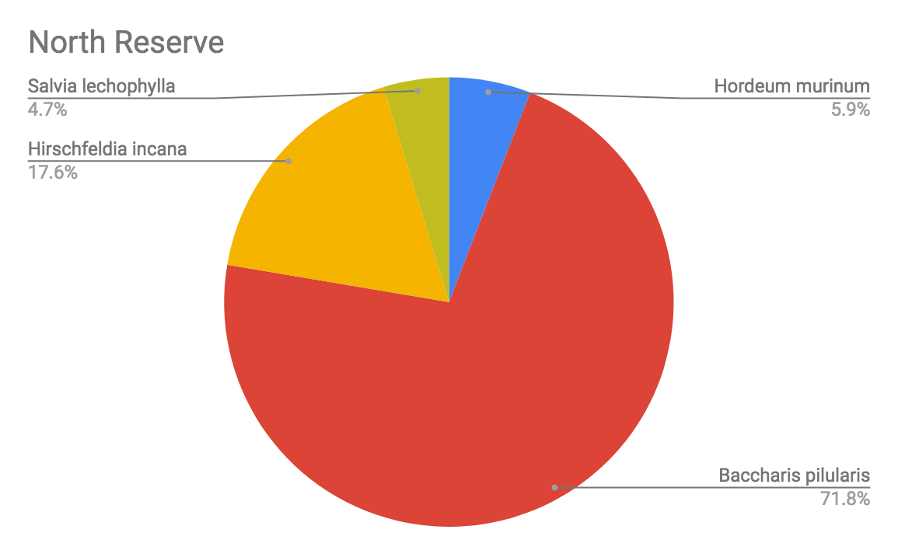
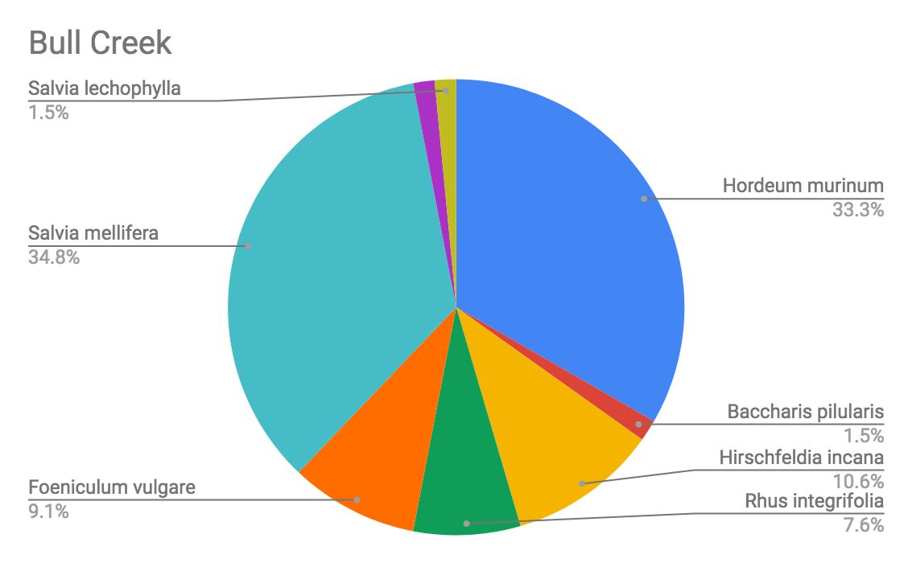
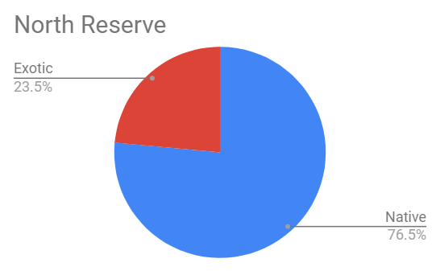
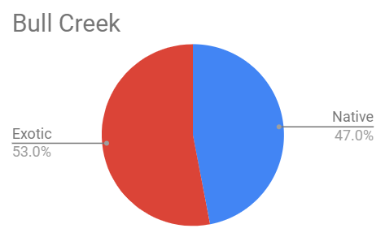
Collette Bradley
Laureen Carroll
Megan Honey
Noah Norcross
ESP 330
18 December 2018
A Comparison of CSS Restoration at Sepulveda Dam
Introduction
Background
The US Army Corps of Engineers started restoration of CSS around the Sepulveda Dam in 1989. The goal of the project was to populate the unused land around the dam with native vegetation. They did so at two sites, the North Reserve and Bull Creek, with North Reserve restoration beginning in 1989, and the Bull Creek restoration beginning in 2008. In the first year, non-native plants were reduced through mowing and mulching. In the second year, herbicides were utilized. After ridding the land of invasive species, native, “suitable, sustainable habitats,” such as oak woodland, grassland, and CSS were restored. (USACE, 2012). The purpose of our study is to compare the success of the restoration efforts at Bull Creek and the North Reserve.
Bull Creek emerges from a drainage channel that travels 3,000 feet across the reserve before flowing into to LA river. In the 1970s, Bull Creek was one of the few remnant, undisturbed riparian habitats in San Fernando Valley. Throughout the years, the channel has straightened, resulting in little support to maintain a sustainable riparian habitat. Due to degradation, the City of Los Angeles, in conjunction with the Corps of Engineers, developed a restoration plan for the creek. Restoration began in 2008 to restore native riparian and upland habitat to provide additional foraging, nesting, covering, and resting opportunities for wildlife native to the region.
Hypotheses, problems, and questions
This project had two questions and hypotheses because we compared both the species mix and the frequency of native and exotic species between Bull Creek and the more established North Reserve. In regards to species mix, our question was: is there a significant difference between the dominant species mix of Bull Creek and the North Reserve? Our null hypothesis was that there is no significant difference between the species mix of Bull Creek and the North Reserve. In regards to the frequency of native and exotic species, our question was: is there a significant difference between the presence of native and exotic species between the North Reserve and Bull Creek? Our null hypothesis is that there is no significant difference between the presence of native and exotic species between the North Reserve and Bull Creek.
Data and methods
Data collection methods
We conducted data collection on November 12, 2018 near Bull Creek at Sepulveda Dam. We surveyed by doing ten 10m transverse transects. We attempted to transect in equal distances along the trail west of the riparian vegetation-in order to increase species variety-and chose sites where vegetation was abundant. For each transect, we recorded the elevation (in meters) and coordinates (in decimal degrees) using GPS at the first point (0m) and the last (10m). For each meter mark of the transect tape, we identified the species underneath. If there were no species, we recorded bare ground, and if there were two species in the same place, we would record the bird’s eye view species. To help us identify the species, we used the Calflora website as well as the Sepulveda Dam species list posted on Dr. Rodrigue’s website. For species that we could not identify on site, we took physical samples and pictures and identified them in the lab.
Data processing and analysis methods

We started processing our data with the species mix question. First, we inputted our raw data from each transect into Excel, which included the elevation, coordinates, and species identified. Next, we created a separate sheet of aggregate data; we summed up the number of each species found in each transect. The next step was to add in the comparison with the North Reserve. Using our predecessors’ data, we entered the North Reserve’s species frequency for each species found in Bull Creek. Then, for each species, we summed up the total frequency of each species found in the North Reserve and Bull Creek. We chose the four most frequent species for our chi-squared analysis. We then inputted the four species frequency into the 2X4 chi-squared table provided by Dr. Rodrigue. This automatically gave us the output of necessary statistics.
Next, we processed our data to answer our question about the presence of native and exotic species. First, we labeled each species found in both Bull Creek and the North Reserve as exotic or native. Then, we summed up the total of exotic and native species for each sites. We then inputted this count into the 2x2 chi-squared table provided by Dr. Rodrigue.
For both studies, we used an alpha value of 0.10. We did this because since this is an exploratory study, we would rather have a false positive result than a false negative result.
Shortcomings and problems

We had a few problems that likely impacted the results of this study. Since we were redirected from our original site at Charmlee Park the day before we surveyed, we likely had not conducted adequate research on Bull Creek’s species and physical geography. Without this background research, we struggled to identify plants. Another shortcoming was the season-trying to survey in late fall is quite difficult because many of the plants in the area were not flowering or dead, so they were much more difficult to identify.
Results
Species mix site comparison
Surveying results-Species mix

From the charts, which show the initial species breakdown of Bull Creek and the North Reserve, there are clearly some major differences. The most evident is that Baccharis pilularis, a native plant also known as coyote brush, is dominant in the North Reserve, yet was very rare in Bull Creek. On the other hand, the invasive foxtail barley (Hordeum murinum) was prevalent in Bull Creek but much less so in the North Reserve.

Chi-squared comparison results: Species mix
X^2 Calculated | 92.882
X^2 Critical | 6.251
Alpha | 0.100
Degrees of Freedom | 3
Probability Value | 0.000
Estimated power | 1.000
Effect size | 0.833

The results for our species mix comparison are both significant and dramatic. Our X2 calculated value was greater than or X2 critical value, which indicates there is a significant difference between the species mix of Bull Creek and the North Reserve. Significance is also shown by our probability value, which is lower than our alpha value. In addition, our probability value is incredibly low-at 0.000-, meaning that there is almost no chance that our null hypothesis was correct. In addition, we also had an unusually high estimated power of 1.000, meaning that there is a very high probability that we avoided a false negative result. Our strong effect size also shows the dramatic difference between the species mix of Bull Creek and the North Reserve. With these results, we rejected our null hypothesis. There is a significant difference between the species mix of Bull Creek and the North Reserve.

Native/exotic species comparison results
Surveying results-native vs exotic

From the initial breakdown of native and exotic species, we can see that the North Reserve has a much higher frequency of native species-over 75%. On the other hand, Bull Creek is almost split down the middle, with a little more than half exotic and the rest native.
Chi-squared comparison results: Native vs Exotic

X^2 Calculated | 13.963
X^2 Critical | 2.706
Alpha | 0.100
Degrees of Freedom | 3
Probability Value | 0.000
Estimated Power | 0.982
Effect Size | 0.304

As with the previous test, our results are both significant and dramatic. Our X2 calculated value was greater than or X2 critical value, which indicates there is a significant difference between the presence of native and exotic species between Bull Creek and North Reserve. In addition, our probability value is less than our alpha, indicating significant results. As with our previous study, our probability value was 0.000, indicating a very low chance that our null hypothesis was correct. Once again, we have a high power, indicating a high probability that we avoided a false negative result. Our effect size is moderate, which indicates a clear difference between each site’s native species frequency. With these results, we reject the null hypothesis. There is a significant difference between the presence of native and exotic species between Bull Creek and North Reserve, with the presence of native species significantly higher in the North Reserve.
Discussion
Since there was a significant difference in the species mix of the North Reserve and Bull Creek, we can conclude that the restoration efforts had varying successes in the sites. However, this study alone does not tell us which site had a more successful restoration; to do that, we turn to our results of the native/exotic species comparison. Since the latter showed that the North Reserve had significantly more native species compared to Bull Creek, we can conclude that the restoration efforts at the North Reserve have been more successful. This is likely because the restoration project at the North Reserve started earlier than at Bull Creek, and so it is now at a stage in restoration that Bull Creek has not reached, but may in the future.
Conclusions
While our strong effect size and power in both comparisons mean it is unnecessary to collect more data, this study does bring up some points for future research of these sites. The first recommendation is to collect more recent data on the North Reserve. Our current study uses data collected in November of this year for Bull Creek and compares it with data from Sepulveda Dam North Reserve, which was last collected in Spring of 2017. This might not be as accurate, because the North could have gone through different stages of restoration within the gap. So, we could survey the North Reserve (conducting 10m transverse transects) and compare it with our Bull Creek data. Our second suggestion would be to survey when most species are at their bloom period. Since we conducted our survey in November, many of the plants sampled were not flowering or dead. This made identification much more difficult. Collecting data from both sites during bloom period-typically in winter and spring-may give us more accurate results. Lastly, future students using the North Reserve as a comparison should consider separating grassland and riparian data, as the current spreadsheet combines this data.
Sources
Calflora (2018). Retrieved from https://www.calflora.org/
US Army Corps of Engineers (2012). Finding of no significant impact and environmental assessment: Sepulveda Dam Basin. US Department of Defense. Retrieved from https://www.spl.usace.army.mil/Portals/17/docs/publicnotices/sepulveda_dam_vegetation_management.pdf

