Set Interface
Set interface extends Collection interface. In a set, no duplicates are allowed. Every element in a set must be unique. We can simply add elements to a set, and finally we will get a set of elements with duplicates removed automatically.

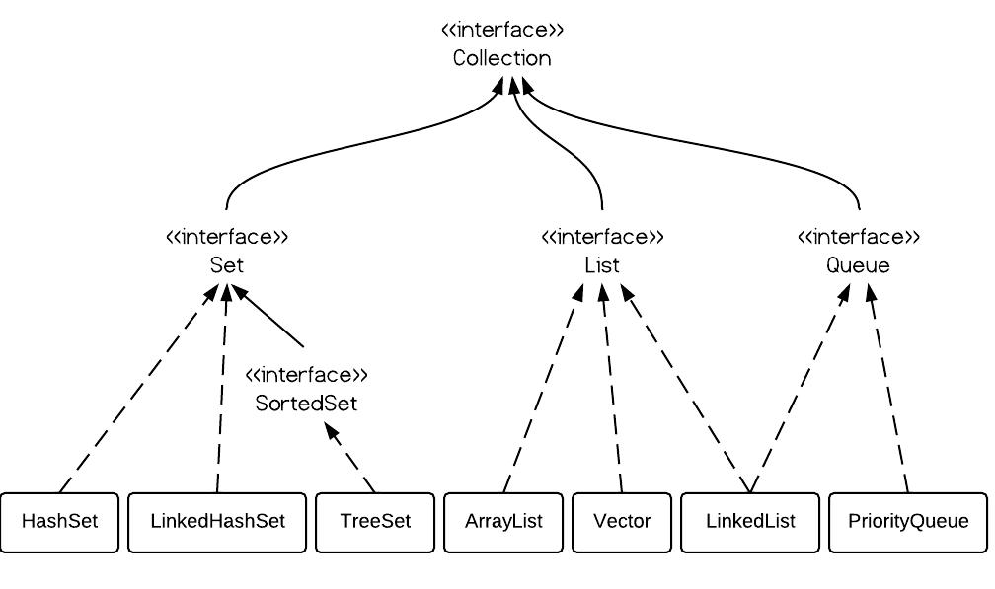

HashSet, LinkedHashSet and TreeSet are the implementations of Set interface which does not allow duplicate elements. In this tutorial we will see the differences between them.
Duplicate Elements
- All the Set implementations does not allow duplicate elements
Order of Elements
- HashSet does not guarantee any order
- LinkedHashSet maintain insertion order
- TreeSet maintain sorting order
Null Elements
- HashSet and LinkedHashSet allows only one null
- TreeSet does not allow null
Thread-Safe
- All three are not thread-safe
Iterator
- Fail-Fast Iterator is returned by HashSet, LinkedHashSet and TreeSet.
Check for Duplicate Elements
- HashSet and LinkedHashSet uses equals() method
- TreeSet uses compareTo() method
Differences between java.util.HashSet vs java.util.LinkedHashSet vs java.util.TreeSet in java>

 | Property | java.util.HashSet | java.util.LinkedHashSet | java.util.TreeSet
1 | Insertion order | java.util.HashSet does not maintains insertion order in java.  Example in java >  set.add("b");  set.add("c");  set.add("a");  Output >  No specific order | java.util.LinkedHashSet maintains insertion order in java.  Example in java >  set.add("b");  set.add("c");  set.add("a");  Output >  b  c  a | java.util.TreeSet is sorted by natural order in java.  Example in java >  set.add("b");  set.add("c");  set.add("a");  Output >  a  b  c
2 | Null elements | HashSet allows to store one null in java. | LinkedHashSet allows to store one null in java. | TreeSet does not allows to store any null in java.  Any attempt to add null throws runtimeException (NullPointerException).
3 | Data structure internally used for storing data | For storing elements HashSet internally uses HashMap. | For storing elements LinkedHashSet internally uses LinkedHashMap. | For storing elements TreeSet internally uses TreeMap.
4 | Introduced in which java version | java.util.HashSet was introduced in second version of java (1.2) i.e. JDK 2.0 | java.util.LinkedHashSet was introduced in second version of java (1.4) i.e. JDK 4.0 | java.util.TreeSet was introduced in second version of java (1.2) i.e. JDK 2.0
5 | Implements which interface | HashSet implements java.util.Set interface. | LinkedHashSet implements java.util.Set interface. | TreeSet implements java.util.Set  java.util.SortedSet  java.util.NavigableSet interface.

Similarity in java.util.HashSet vs java.util.LinkedHashSet vs java.util.TreeSet
 | Property | java.util.HashSet vs  java.util.LinkedHashSet vs  java.util.TreeSet
1 | Iterator | iterators returned by HashSet, LinkedHashSet and TreeSet all of them are fail-fast in java.
2 | Implements | HashSet, LinkedHashSet and TreeSet all implements java.util.Set interface in java.
3 | Duplicate elements | HashSet, LinkedHashSet and TreeSet all of them does not allow to store duplicate elements in java.

Map Overview
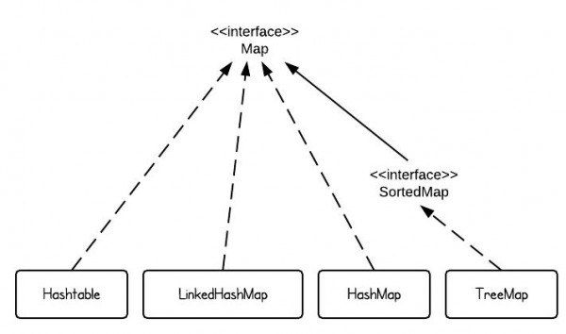
There are 4 commonly used implementations of Map in Java SE - HashMap, TreeMap, Hashtable and LinkedHashMap. If we use one sentence to describe each implementation, it would be the following:
- HashMap is implemented as a hash table, and there is no ordering on keys or values.
- TreeMap is implemented based on red-black tree structure, and it is ordered by the key.
- LinkedHashMap preserves the insertion order
- Hashtable is synchronized, in contrast to HashMap.
This gives us the reason that HashMap should be used if it is thread-safe, since Hashtable has overhead for synchronization.

Differences between java.util.HashMap vs java.util.Hashtable vs java.util.LinkedHashMap vs java.util.TreeMap

 | Property | HashMap | Hashtable | LinkedHashMap | TreeMap
1 | Insertion order | HashMap does not maintains insertion order in java. | Hashtable does not maintains insertion order in java. | LinkedHashMap maintains insertion order in java. | TreeMap is sorted by natural order of keys in java.
2 | Performance | HashMap is not synchronized, hence its operations are faster as compared to Hashtable. | Hashtable is synchronized, hence its operations are slower as compared HashMap.  If we are working not working in multithreading environment jdk recommends us to use HashMap. | LinkedHashMap must be used only when we want to maintain insertion order. Time and space overhead is there because for maintaining order it internally uses Doubly Linked list. | TreeMap must be used only when we want sorting based on natural order. Otherwise sorting operations cost performance. (Comparator is called for sorting purpose)
3 | Null keys and values | HashMap allows to store one null key and many null values i.e. many keys can have null value in java. | Hashtable does not allow to store null key or null value.  Any attempt to store null key or value throws runtimeException (NullPointerException) in java. | LinkedHashMap allows to store one null key and many null values i.e. any key can have null value in java. | TreeMap does not allow to store null key but allow many null values.  Any attempt to store null key throws runtimeException (NullPointerException) in java.
4 | Implements which interface | HashMap implements java.util.Map | Hashtable implements java.util.Map | LinkedHashMap implements java.util.Map | TreeMap implements  java.util.Map  java.util.SortedMap  java.util.NavigableMap
5 | Implementation uses? | HashMap use buckets | Hashtable use buckets | LinkedHashMap uses doubly linked lists | TreeMap uses Red black tree
6 | Complexity of put, get and remove methods | O(1) | O(1) | O(1)  overhead of updating Doubly Linked list for maintaining order it internally uses. | O(log(n))
7 | Introduced in which java version? | HashMap was introduced in second version of java i.e. JDK 2.0 | Hashtable was introduced in first version of java i.e. JDK 1.0  But it was refactored in java 2 i.e. JDK 1.2 to implement the Map interface, hence making it a member of member of the Java Collections Framework. | LinkedHashMap was introduced in fourth version of java i.e. JDK 4.0 | TreeMap was introduced in second version of java i.e. JDK 2.0

