Memento pattern
Memento pattern is used to restore state of an object to a previous state. Memento pattern falls under behavioral pattern category.

Design participants
The memento pattern has three participants.
- Originator – is the object that knows how to create and save it’s state for future. It provides methods createMemento() and restore(memento).
- Caretaker – performs an operation on the Originator while having the possibility to rollback. It keeps track of multiple mementos. Caretaker class refers to the Originator class for saving (createMemento()) and restoring (restore(memento)) originator’s internal state.
- Memento – the lock box that is written and read by the Originator, and shepherded by the Caretaker. In principle, a memento must be in immutable object so that no one can change it’s state once created.

Implementation
Memento pattern uses three actor classes. Memento contains state of an object to be restored. Originator creates and stores states in Memento objects and Caretaker object is responsible to restore object state from Memento. We have created classes Memento, Originator and CareTaker.
MementoPatternDemo, our demo class, will use CareTaker and Originatorobjects to show restoration of object states.
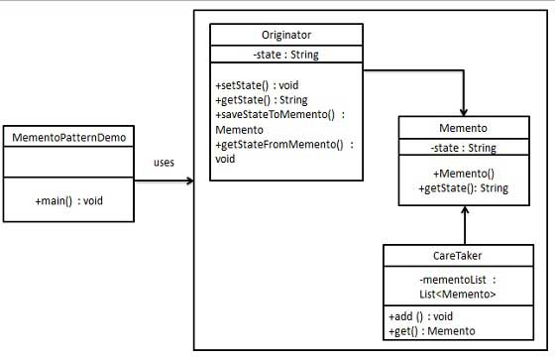

Step 1
Create Memento class.
Memento.java
public class Memento {
private String state;

public Memento(String state){
this.state = state;
}

public String getState(){
return state;
}
}

Step 2
Create Originator class
Originator.java
public class Originator {
private String state;

public void setState(String state){
this.state = state;
}

public String getState(){
return state;
}

public Memento saveStateToMemento(){
return new Memento(state);
}

public void getStateFromMemento(Memento memento){

state = memento.getState();
}
}

Step 3
Create CareTaker class
CareTaker.java
import java.util.ArrayList;
import java.util.List;

public class CareTaker {
private List<Memento> mementoList = new ArrayList<Memento>();

public void add(Memento state){
mementoList.add(state);
}

public Memento get(int index){
return mementoList.get(index);
}
}

Step 4
Use CareTaker and Originator objects.
MementoPatternDemo.java
public class MementoPatternDemo {
public static void main(String[] args) {

Originator originator = new Originator();
CareTaker careTaker = new CareTaker();

originator.setState("State #1");
originator.setState("State #2");
careTaker.add(originator.saveStateToMemento());

originator.setState("State #3");
careTaker.add(originator.saveStateToMemento());

originator.setState("State #4");
System.out.println("Current State: " + originator.getState());

originator.getStateFromMemento(careTaker.get(0));
System.out.println("First saved State: " + originator.getState());
originator.getStateFromMemento(careTaker.get(1));
System.out.println("Second saved State: " + originator.getState());
}
}

Verify the output.
Current State: State #4
First saved State: State #2
Second saved State: State #3

In this example, we are creating memento for an Article object which has three basic attributes – id, title and content. ArticleMemento class is used as memento for Article objects.

Article.java
public class Article //Originator
{
private long id;
private String title;
private String content;

public Article(long id, String title) {
super();
this.id = id;
this.title = title;
}

//Setters and getters

public ArticleMemento createMemento()
{
ArticleMemento m = new ArticleMemento(id, title, content);
return m;
}

public void restore(ArticleMemento m) {
this.id = m.getId();
this.title = m.getTitle();
this.content = m.getContent();
}

@Override
public String toString() {
return "Article [id=" + id + ", title=" + title + ", content=" + content + "]";
}
}

ArticleMemento.java
public final class ArticleMemento
{
private final long id;
private final String title;
private final String content;

public ArticleMemento(long id, String title, String content) {
this.id = id;
this.title = title;
this.content = content;
}

public long getId() {
return id;
}

public String getTitle() {
return title;
}

public String getContent() {
return content;
}
}

The Main class is acting as Caretaker which creates and restores the memento objects.
Main.java
public class Main
{
public static void main(String[] args)
{
Article article = new Article(1, "My Article");
article.setContent("ABC"); //original content
System.out.println(article);
ArticleMemento memento = article.createMemento(); //created immutable
//memento
article.setContent("123"); //changed content
System.out.println(article);

article.restore(memento); //UNDO change
System.out.println(article); //original content
}
}
Program Output.
Console
Article [id=1, title=My Article, content=ABC]
Article [id=1, title=My Article, content=123]
Article [id=1, title=My Article, content=ABC]

