Fragmentation and Reassembly (Practice Problem)
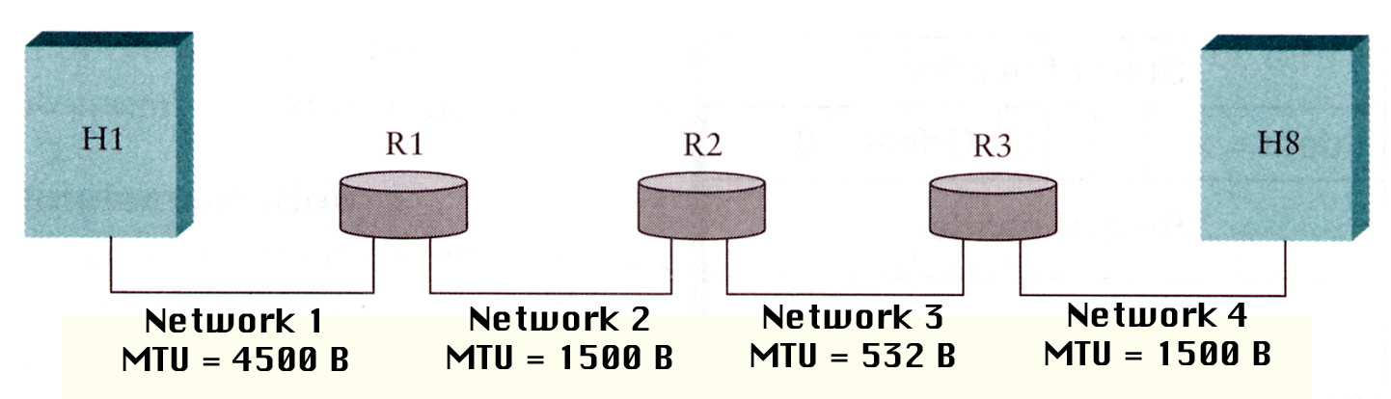
- Suppose Host H1 wants to send a 3020 byte IP datagram (including the 20 byte IPv4 header) with ID # 1101 to Host H8 using IPv4. Using the following table, show the fragments that will arrive at Host H8. Fill in the datagram ID, datagram size, offset, and flag for each fragment. You may not need to use all rows in the table.
Datagram ID # | Datagram Size | Offset | Flag
(b) If the original datagram is initially fragmented for the MTU of Network 3, would the number of fragments be reduced? Explain.

