CECS 572 Advanced Networking
CRC Supplement

A CRC "checksum" is the remainder of a binary division with no bit carry (XOR used instead of subtraction), of the message bit stream, by a predefined (short) bit stream of length r+1, which represents the coefficients of a polynomial. Before the division, r zeros are appended to the message stream. [Wikipedia]

EXAMPLE: To divide the polynomial 110011 (the data to be sent) by 111 (the generator polynomial) we simply apply the bit-wise exclusive-OR operation repeatedly as follows

divisor: r+1-bit
generator polynomial

101111 quotient of division (not used)
_________
111 |11001100 r zeros added
111
---------
0010 dividend: data to be transmitted
000
--------
0101
111
-------
0101
111
------
0100
111
-----
0110
111
----
001 r bit remainder:
used as CRC checksum

This is exactly like ordinary long division, only simpler, because at each stage we just need to check whether the leading bit of the current three bits is 0 or 1. If it's 0, we place a 0 in the quotient and exclusively OR the current bits with 000. If it's 1, we place a 1 in the quotient and exclusively OR the current bits with the divisor, which in this case is 111. As can be seen, the result of dividing 110011 by 111 is 101111. [Modified from www.mathpages.com]
More on CRC
(Modified from D. Comer, Computer Networks and Internets, 5th Edition)

Robustness of the CRC Approach

A generator polynomial of R+1 bits will detect:
- all single-bit errors
- all double-bit errors
- all odd-number of bit errors
- all error bursts < R+1 bits
- most error bursts >= R+1 bits

CRCs and Polynomial Representation

We can view the above process as a polynomial division:

- Think of each bit in a binary number as the coefficient of a term in a polynomial

For example, we can think of the divisor each bit of the divisor 1011 as coefficients in the following polynomial:

Similarly, each bit of the dividend 1010000 represents the polynomial:

Real World Code Polynomials (or generator polynomials):
Code polynomials are usually of degree 12, 16 or 32

Six polynomials are in widespread use:

- Ethernet and FDDI use CRC-32
- HDLC uses CRC-CCITT
- ATM uses CRC-8 and CRC-10
- Three polynomials are international standards: CRC-12, CRC-16, and CRC-CCITT

TABLE 7A. Common CRC polynomials

Building Blocks For Implementing CRC

- Exclusive or
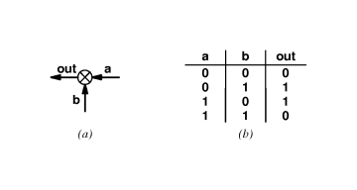
- Shift register

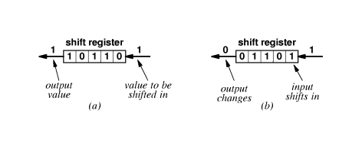
- a shows status before shift
- b shows status after shift
- Output same as top bit

Example Of CRC Hardware
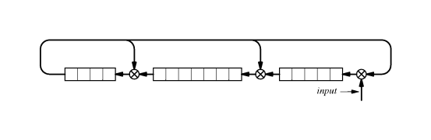
- Computes 16-bit CRC
- Registers initialized to zero
- Bits of message shifted in
- CRC found in registers

Illustration of Frame Using CRC
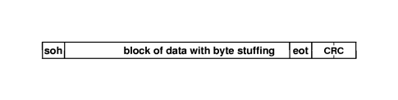
Note: The CRC covers data only

