CECS 572 Advanced Computer Networking

Assignment 7 -- Solutions
Answer the following questions from Kurose and Ross, Chapter 3:

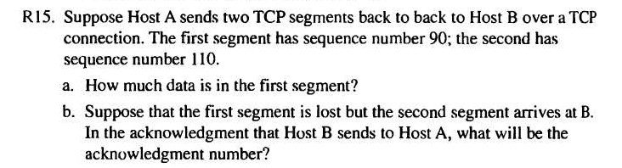
- Chapter 3 Review Questions

a) 20 bytes
b) ack number = 90

- Chapter 3 Problems
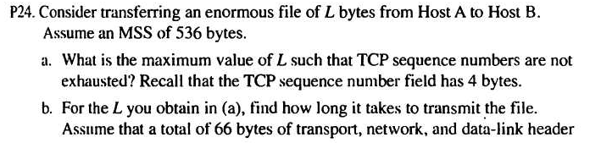

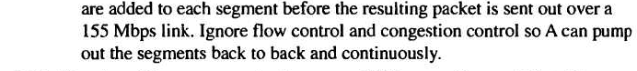

There are $2^{\text{32}}=\text{4,294,967,296}$ possible sequence numbers.

- The sequence number does not increment by one with each segment. Rather, it increments by the number of bytes of data sent. So the size of the MSS is irrelevant -- the maximum size file that can be sent from A to B is simply the number of bytes representable by $2^{\text{32}}≈4\text{.}\text{19 Gbytes}$.
- The number of segments is$\left\lceil \frac{2^{\text{32}}}{\text{536}}\right\rceil =\text{8,012,999}$. 66 bytes of header get added to each segment giving a total of 528,857,934 bytes of header. The total number of bytes transmitted is $2^{\text{32}}+\text{528,857,934 }=4\text{.}\text{824}×{\text{10}}^{9}$ bytes.
Thus it would take 249 seconds to transmit the file over a 155~Mbps link.

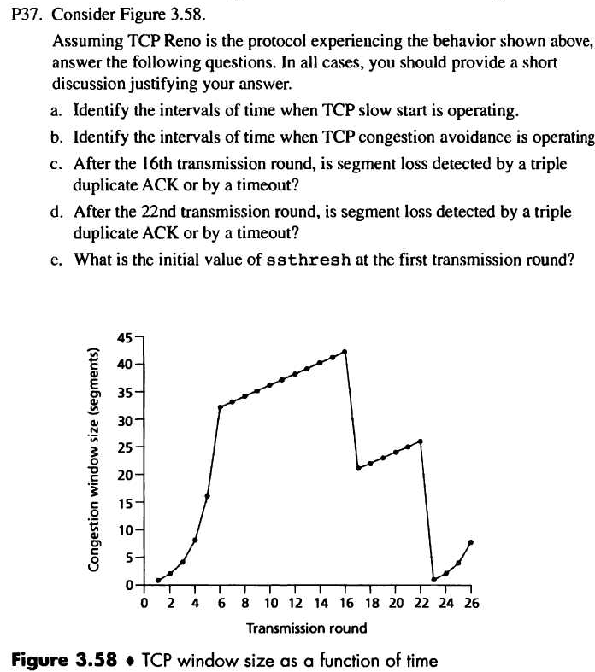

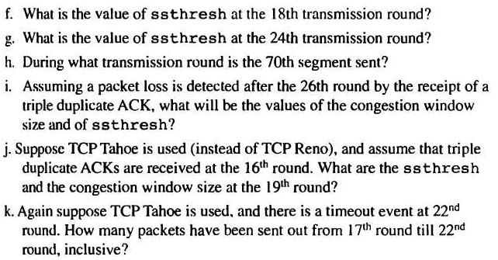

  - TCP slowstart is operating in the intervals [1,6] and [23,26]
  - TCP congestion avoidance is operating in the intervals [6,16] and [17,22]
  - After the 16th transmission round, packet loss is recognized by a triple duplicate ACK. If there was a timeout, the congestion window size would have dropped to 1.
  - After the 22nd transmission round, segment loss is detected due to timeout, and hence the congestion window size is set to 1.
  - The threshold is initially 32, since it is at this window size that slow start stops and congestion avoidance begins.
  - The threshold is set to half the value of the congestion window when packet loss is detected. When loss is detected during transmission round 16, the congestion windows size is 42. Hence the threshold is 21 during the 18th transmission round.
  - The threshold is set to half the value of the congestion window when packet loss is detected. When loss is detected during transmission round 22, the congestion windows size is 29. Hence the threshold is 14 (taking lower floor of 14.5) during the 24th transmission round.
  - During the 1st transmission round, packet 1 is sent; packet 2-3 are sent in the 2nd transmission round; packets 4-7 are sent in the 3rd transmission round; packets 8-15 are sent in the 4th transmission round; packets 16-31 are sent in the 5th transmission round; packets 32-63 are sent in the 6th transmission round; packets 64 – 96 are sent in the 7th transmission round. Thus packet 70 is sent in the 7th transmission round.
  - The threshold will be set to half the current value of the congestion window (8) when the loss occurred and congestion window will be set to the new threshold value + 3 MSS . Thus the new values of the threshold and window will be 4 and 7 respectively.
  - threshold is 21, and congestion window size is 1.
  - round 17, 1 packet; round 18, 2 packets; round 19, 4 packets; round 20, 8 packets; round 21, 16 packets; round 22, 21 packets. So, the total number is 52.
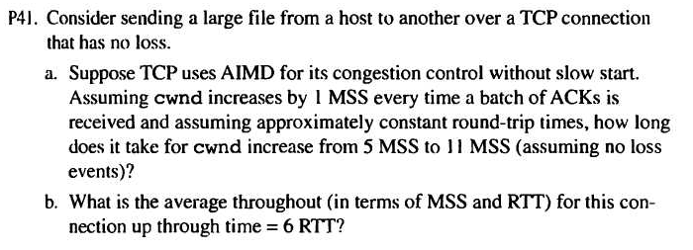

- It takes 1 RTT to increase CongWin to 6 MSS; 2 RTTs to increase to 7 MSS; 3 RTTs to increase to 8 MSS; 4 RTTs to increase to 9 MSS; 5 RTTs to increase to 10 MSS; 6 RTTs to increase to 11 MSS; and 7 RTTs to increase to 12MSS.

- In the first RTT 5 MSS was sent; in the second RTT 6 MSS was sent; in the third RTT 7 MSS was sent; in the fourth RTT 8 MSS was sent; in the fifth RTT, 9 MSS was sent; and in the sixth RTT, 10 MSS was sent. Thus, up to time 6 RTT, 5+6+7+8+9+10 = 45 MSS were sent (and acknowledged). Thus, we can say that the average throughput up to time 6 RTT was (45 MSS)/(6 RTT) = 7.5 MSS/RTT.

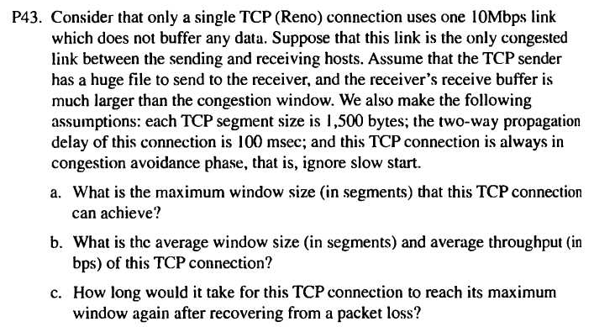

- Let W denote the max window size measured in segments. Then, W*MSS/RTT = 10Mbps, as packets will be dropped if the maximum sending rate exceeds link capacity. Thus, we have W*1500*8/0.15=10*10^6, then W is about 125 segments.

- As congestion window size varies from W/2 to W, then the average window size is 0.75W=94 (ceiling of 93.75) segments. Average throughput is 94*1500*8/0.15 =7.52Mbps.

- 94/2 *0.15 = 7.05 seconds, as the number of RTTs (that this TCP connections needs in order to increase its window size from W/2 to W) is given by W/2. Recall the window size increases by one in each RTT.

