CECS 572 Advanced Computer Networking

Assignment 4

To be completed by Wednesday, October 1, 2014

In this problem, Movie Director Steven Spielberg at DreamWorks Studios, Glendale, CA, contacts Elvis Presley at Graceland, Memphis, Tenessee, to offer him a movie deal. (You may assume that Mr. Spielberg knows that Elvis is alive and well and living at Graceland!) The voice data (similar to VoIP) is being sent over a packet-switched network from Mr. Spielberg in Glendale to Elvis Presley at Graceland.

- Assume that Mr. Spielberg’s computer converts the analog voice signal using PCM encoding at a rate of 64 kbps. This voice conversion happens in real-time as Mr. Spielberg speaks.
- Next, Mr. Spielberg’s computer groups the encoded bits into 480-Byte packets for transmission.
- Assume that there is only one possible point-to-point link between Mr. Spielberg’s Computer in Glendale and Elvis’ Computer at Graceland. The link has the following characteristics:
-- a transmission rate of 44,700,000 bps (bits per second)
-- the length of the link is 1,800 miles (2,900 kilometers)
-- the propagation speed across the link is 2 x10⁸ m/s
- As soon as Mr. Spielberg’s computer gathers a full packet, it sends it to Elvis’ computer. As soon as Elvis’s computer receives the entire packet, it is converted back into an analog signal at the PCM decoding rate of 64 kbps.

- Calculate the amount of time required to generate a full packet using PCM.
- Calculate the amount of time required to transmit a packet onto the network.
- Calculate the propagation delay from Glendale, CA, to Memphis, TN.
- Calculate the total time that elapses from the time the first bit is created (from the analog signal at Mr. Spielberg’s computer) until the bit is decoded (as part of the analog signal delivered to Elvis). Note: We consider the bit decoded when the entire packet in which it was sent is decoded.

Answer the following questions from Kurose and Ross, Chapter 3:

- Chapter 3 Review Questions
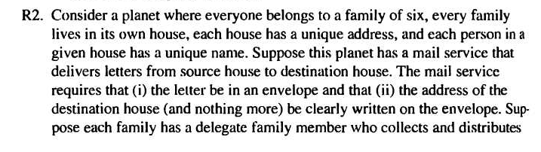

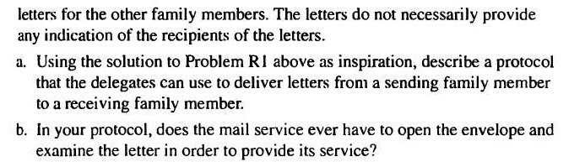

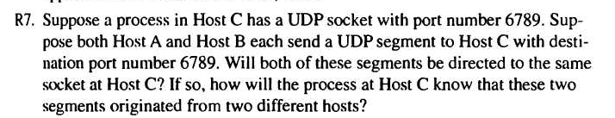

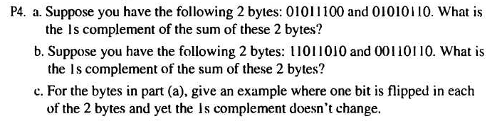
- Chapter 3 Problems

