CECS 572 Advanced Computer Networking

Assignment 2

To be completed by Wednesday, September 17, 2014
(Solutions will be made available via BeachBoard)
Answer the following questions from Kurose and Ross, Chapter 1:

- Chapter 1 Review Questions
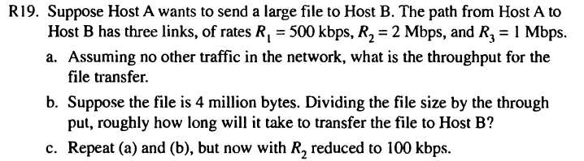

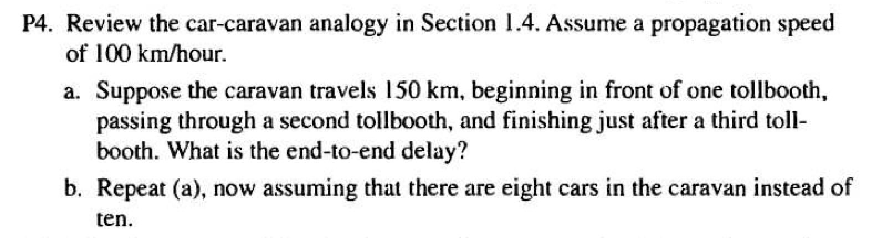
B. Chapter 1 Problems

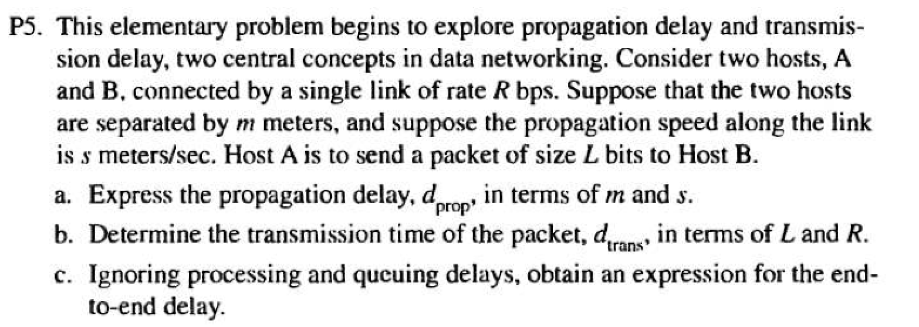

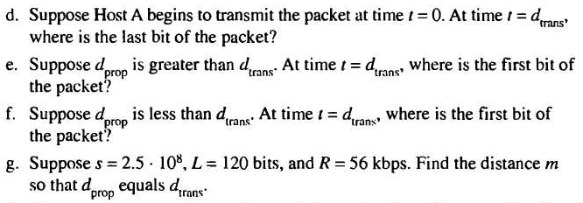

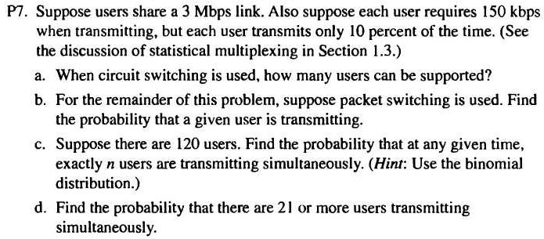

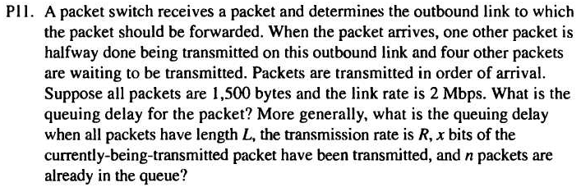

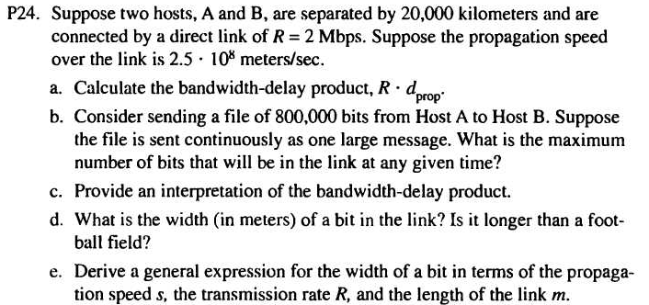

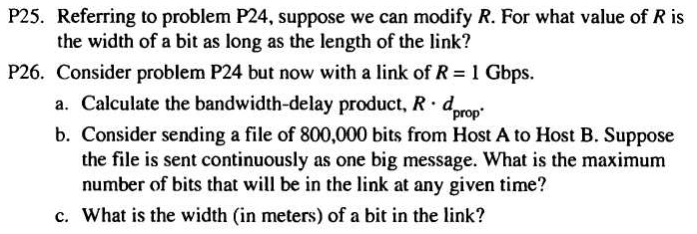

C. Read: “An Interview with Leonard Kleinrock,” pp. 80-81.
Nothing to turn in.

