CECS 572 Advanced Computer Networking

Assignment 1

To be completed by Wednesday, September 10, 2014
(Solutions will be made available via BeachBoard)

Answer the following questions from Kurose and Ross, 6/e, Chapter 1:

- Chapter 1 Review Questions

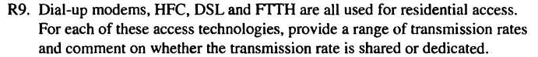

Additionally: Use a web-based tool or app to test the actual speed of your home access technology and compare it to the rates guaranteed by your ISP.
