Introductory Lectures: The Nature and History of Cognitive Science
It All Starts With Questions
All human beings spend some time wondering about the nature of the world, their own nature, and how the two fit together. Asking questions marks the beginning of rational inquiry. However, questioning in itself is not inquiry. Inquiry requires adopting a framework within which one can use answers to certain questions as a basis for answering others. For example, science has been made possible by adopting a framework in which researchers address questions regarding the nature of elements and phenomena in the world through controlled, repeatable experimentation. As we will see, cognitive science seeks to answer many questions, working within a framework that adopts answers to certain other questions. The answers proposed by cognitive scientists to central questions regarding the mind have emerged from the development and interactions of its individual disciplines. These answers distinguish cognitive science’s approach to the mind from the approaches of its historical predecessors. The most fundamental and oldest questions regarding the mind concern its essential nature—what is the mind-- and its relationship to the physical world.
Mentality:
What is it to have a mind?
Are the mind and the body distinct entities?
How do the mind and the body interact?
What elements of the body are associated with the mind?
Closely related to questions about the mind’s essential nature are questions about the nature of conscious mental experiences and their relationship to mental functioning.
Consciousness:
What is the nature and role of consciousness in mental abilities?
Does consciousness drive or even exhaust mental abilities?
How do conscious qualitative experiences arise in the brain (or do they)?
Is conscious experience divisible or a unified whole?
Like our conscious sensations, thinking and problem solving are among the most salient features of the mind. Some of the most central questions for cognitive scientists have been how best to characterize and understand thinking and problem solving.
Cognition:
What is cognition?
What role should cognitive capacities play in a scientific account of the mind?
What is the nature of cognitive capacities?
Do animals and humans have similar or even identical mental capacities or processes?
Like our problem solving abilities, many of our conscious experiences and mental processes seem to have intentionality. That is, our mental states and processes are about (refer to) objects, properties, and events in the world.
Intentionality:
How does the world ‘get into’ the mind?
How does the mind gain, store and organize, and ultimately utilize knowledge about the world?
Finally, cognitive scientists propose answers to questions about how to answer our questions about the mind and its relationship to the physical world.
Methodology:
How ought one study and explain mental abilities?
Need one posit mental entities to explain the mind?
Cognitive Science is Interdisciplinary
It is platitudinous to say that cognitive science is an interdisciplinary field. In this first set of lectures I try to spell out what makes cognitive science an interdisciplinary field. Specifically, I will suggest that the various disciplines of cognitive science have converged upon a general explanatory schema with regard to particular set of phenomena. These lectures provide students will a relatively superficial history of that convergence for the oldest and most central disciplines within cognitive science; philosophy, psychology, linguistics, neuroscience, computer science, and mathematics. Students should not suppose that these are the only disciplines within cognitive science, nor should they suppose that all the work in these disciplines falls under the rubric of cognitive science. For example, cognitive anthropology cognitive ethology, comparative psychology, and neuroeconomics also explore human and/or animal cognition. Similarly, not all areas of computer science, or for that matter, artificial intelligence, seek to explain human cognition. Finally, students should not assume that the below-﻿outlined convergence towards an explanatory schema is completely homogenous within cognitive science, or that theorists agree about every aspect of the schema. All introductory courses necessarily tradeoff a degree of descriptive accuracy in order to enhance the simplicity and comprehensiveness of the material presented. This course is no different in that respect.
The purpose of these historical reviews is twofold. First, a historical review allows students to better understand the core fundamentals of cognitive science. Second, few students come to a cognitive science course with significant knowledge of even a few of the disciplines within the field. Reviewing, even superficially, the history of these disciplines gives students a rudimentary introduction to each. It also illustrates how interaction between these disciplines shapes and advances each. This second goal, though it might seem less central, is actually the most important. Perhaps the greatest difficulty in studying, and even in contributing to, cognitive science is developing and maintaining an adequate knowledge of these fields. One must not only acquire a great deal of knowledge, but one must cultivate the ability to determine what pieces of information are relevant and what pieces are irrelevant. As we shall see during the course, the collection, evaluation, and application of large amounts of information is very difficult for human beings.

Convergence Towards What?
Cognitive scientists, as the name suggests, focus much of their efforts on understanding explaining cognition, especially human cognition. One of the central theses adopted by a majority of researchers in cognitive science characterizes the nature of cognition and prescribes a particular schema for explaining cognitive abilities. The characterization of cognition driving a vast majority of research in cognitive science has several similar, though not necessarily equivalent, elaborations. For instance, Paul Thagard¹ explicates cognition using the acronym CRUM, the Computational Representation Understanding of Mind. Jerry Fodor^{2, 3} and others use the acronyms RTM for Representational Theory of Mind and LOT for the Language of Thought. I prefer the characterization Robert Cummins⁴ offers: CTC/RTI, for the Computational Theory of Cognition and the Representational Theory of Intentionality. But, what do all of these acronyms mean?
To cognize is to become cognizant of something, especially to perceive, become consciously aware, or, most importantly for this course, to know. The core phenomena that cognitive science has traditionally sought to explain are instances of cognition, and cognitive science characterizes cognition as a process in which information about the object, property, or event become known because the cognizer represents that object, property, or event. Thus, one can formulate the central explanatory principles of cognitive science as follows:
The Computational Theory of Cognition holds that cognition is the computation of complex functions on representational states, where computation consists in performing information processing operations defined over the syntactic structures (kinds) of representational states.
The Representational Theory of Intentionality asserts that mental states are about the world (have content) in virtue of a representation relation holding between the represented element of the world and the particular kind of mental state.
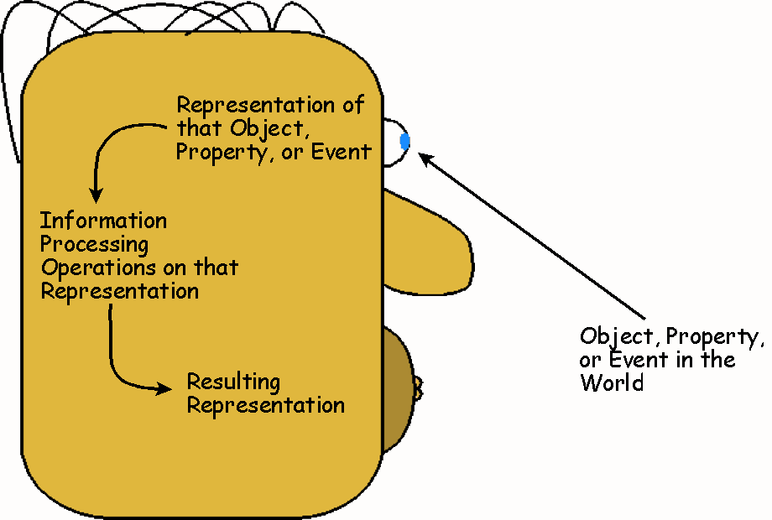
No doubt this characterization of cognition seems abstract and distant from your everyday experiences. An example or two should help to clarify the ideas.
The first diagram displays the basic relationships posited by cognitive scientists during an act of cognition. (left) The next diagram illustrates these relationships in action by diagramming the reflex arc. (below).

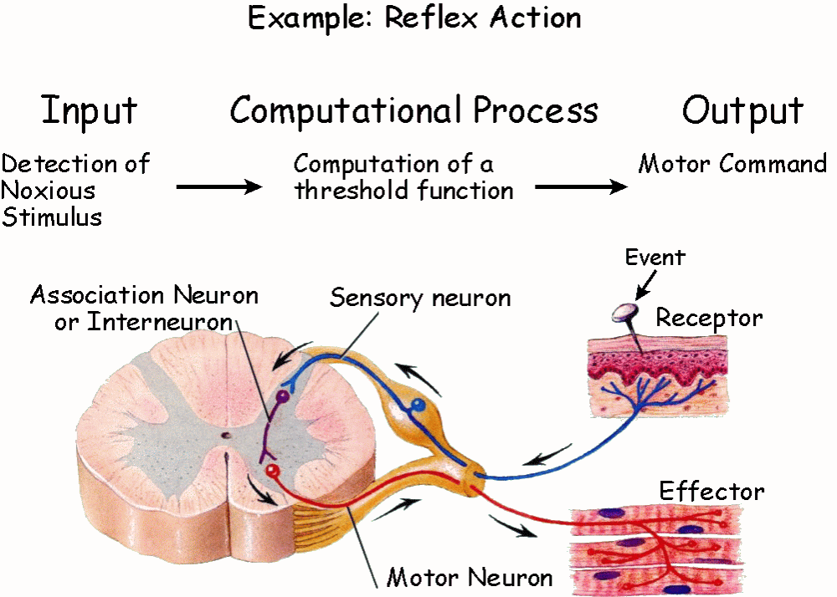

In large part, the entire course explores theorists’ attempts to expand upon and apply these two theses (CTC/RTI). In the next few lectures we will see how the various disciplines of cognitive science came to converge upon particular mental phenomena as the central and the primary areas of cognitive science research. More specifically, we explore how researchers came to conceive of perception, attention, memory, learning, problem solving, and language as information processing tasks, and paradigm cognitive processes.
1. Thagard, P. Mind: Introduction to Cognitive Science (MIT Press, Cambridge, MA, 2005).
2. Fodor, J. The Language of Thought (Harvard University Press, Cambridge, MA, 1975).
3. Fodor, J. RePresentations: Philosophical Essays on the Foundations of Cognitive Science (MIT Press, Cambridge, MA, 1981).
4. Cummins, R. Meaning and Meantal Representation (MIT Press, Cambridge, MA, 1989).

